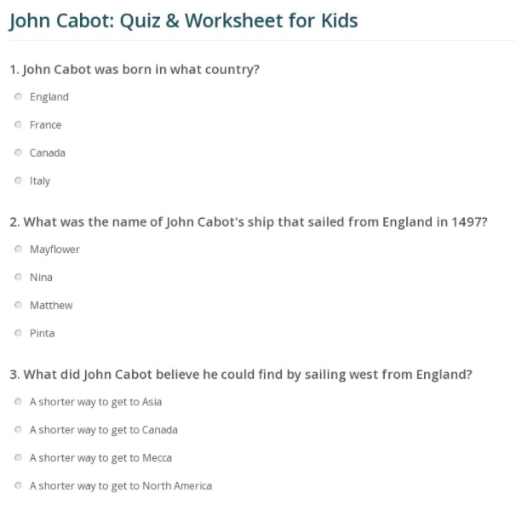
https://study.com/academy/practice/john-cabot-quiz-worksheet-for-kids.html

