Monday 11th May
Rapid Recap – Choose the appropriate challenge for you. Complete one of the boxes below.

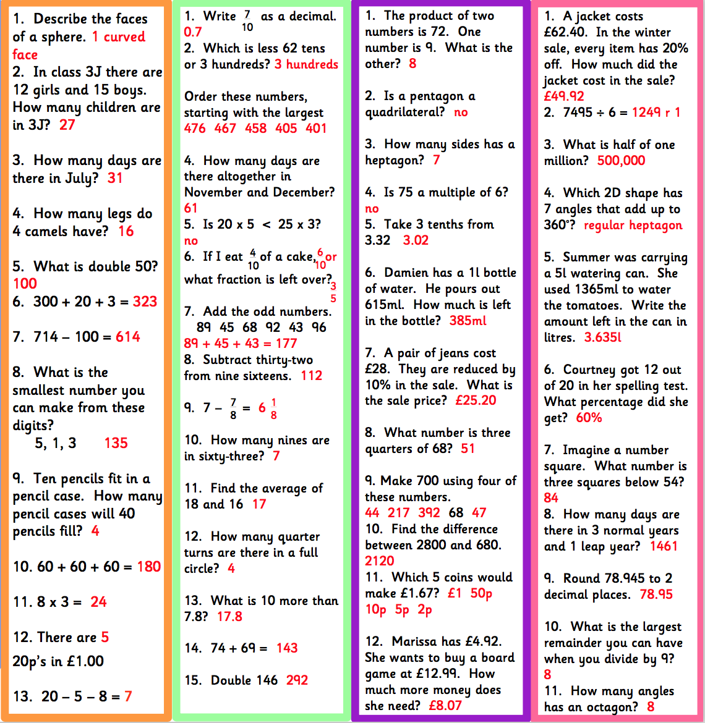

Convert Improper fractions to Mixed Number- These links demonstrate the method and may help with your home learning:

https://www.mathsisfun.com/improper-fractions.html

https://www.youtube.com/watch?v=zvLql0wBM4E

https://www.youtube.com/watch?v=-imFslMIN1g

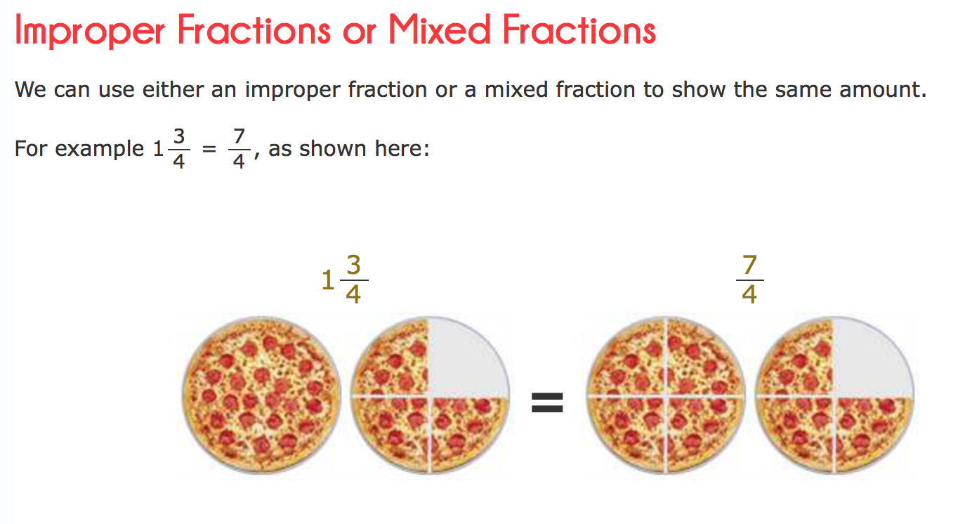 | 25/8 = 3 1/8  27/6 = 4 3/6  18/7 = 2 4/7  32/4 = 8
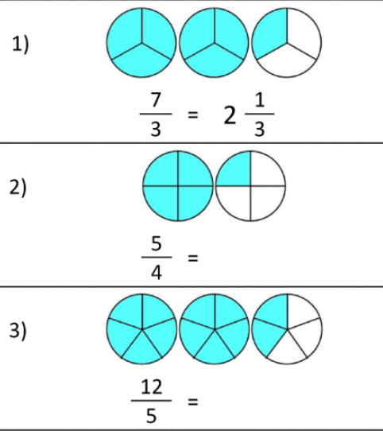  2 2/5  1 ¼ | 1) 16/6 = 2 4/6 2) 47/7 = 6 5/7  3) 24/5 = 4 4/5 4) 39/8 = 4 7/8  5) 50/7 = 7 1/7 6) 32/6 = 5 2/6
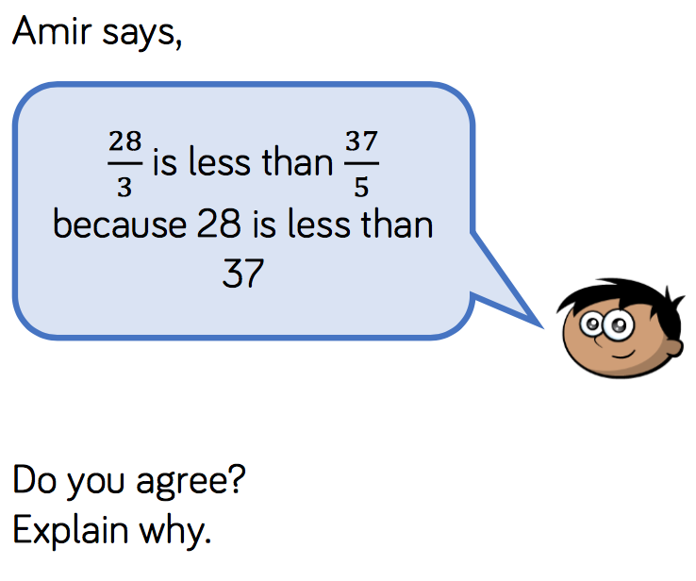  I disagree because 28/3 is equal to 9 1/3 and 37/5 is equal to 7 2/5  9 is more than 7 |  | 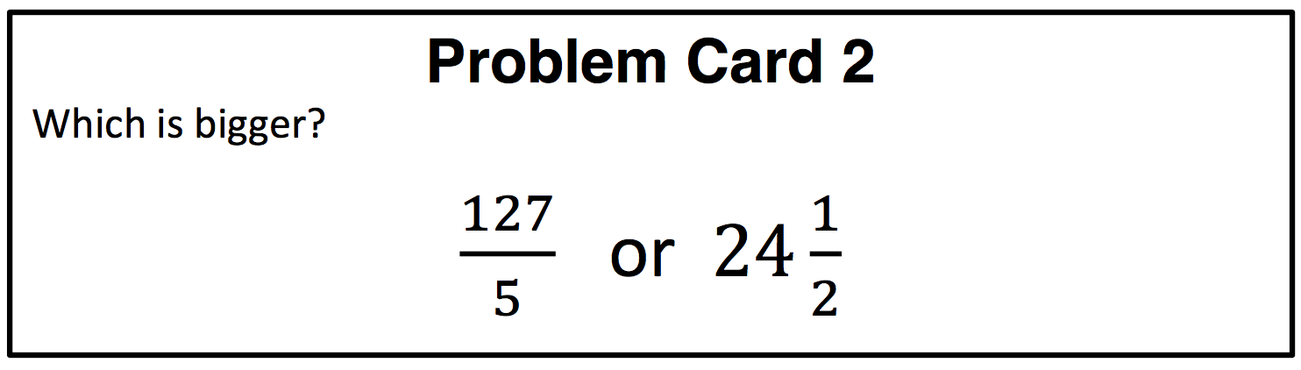  25 2/5 or 24 ½  127/5 is bigger
a = 4
b = 7
c = 1

Tuesday 12th May
Rapid Recap – Choose the appropriate challenge for you. Complete one of the boxes below.

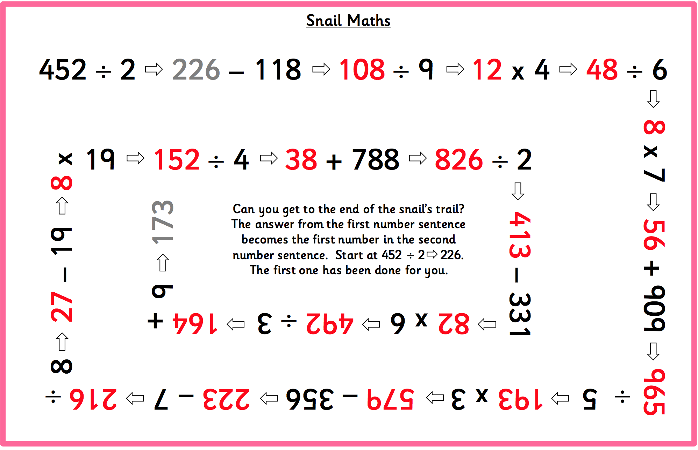

Converting Mixed Number Fractions to Improper Fractions – These links demonstrate the method and may help with your home learning.

https://www.youtube.com/watch?v=shpf9krdXQQ

https://www.khanacademy.org/math/arithmetic/fraction-arithmetic/arith-review-mixed-number/v/changing-a-mixed-number-to-an-improper-fraction

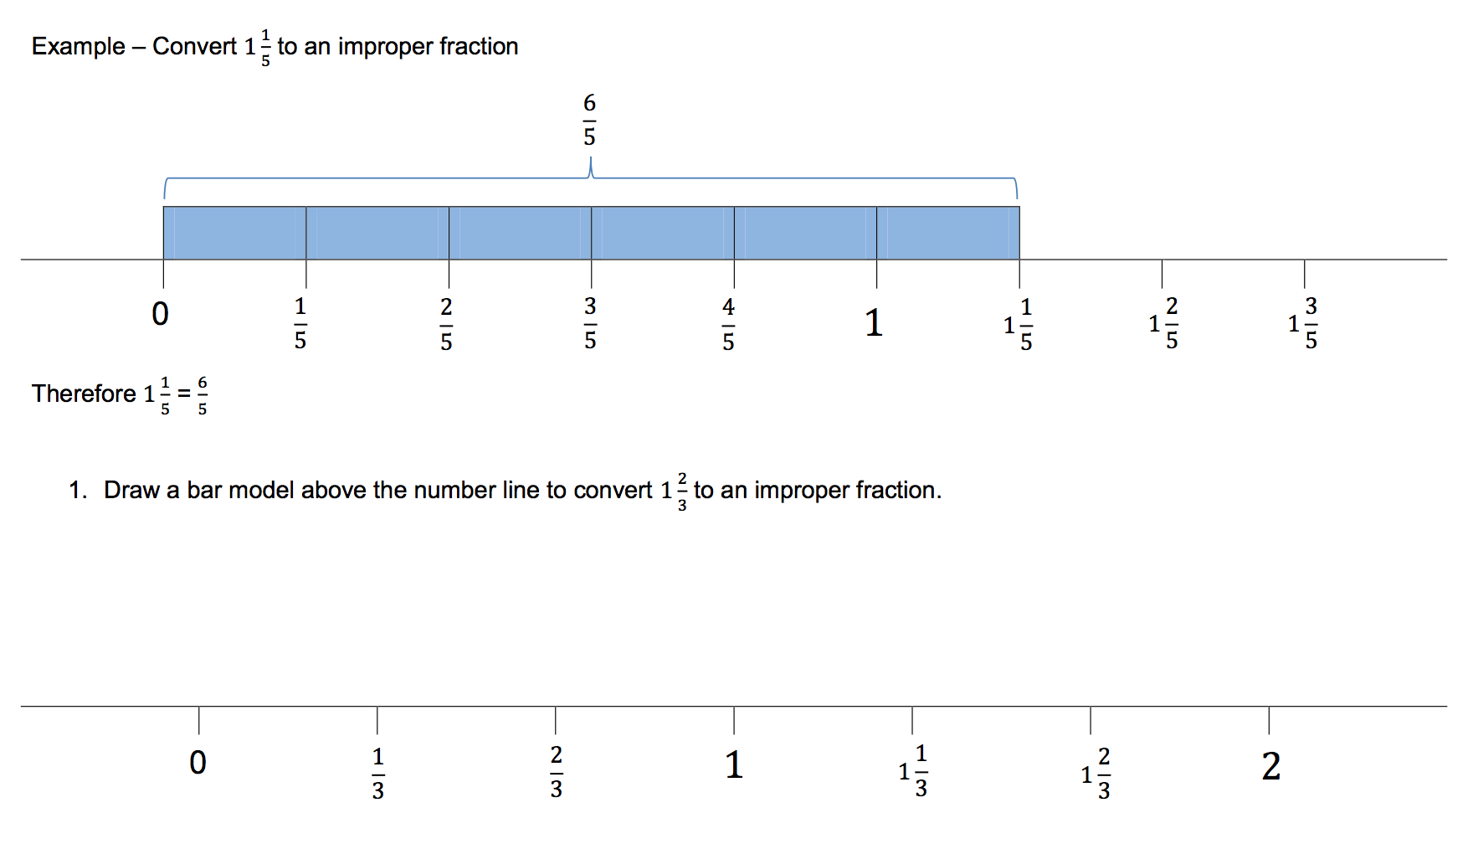
5/3
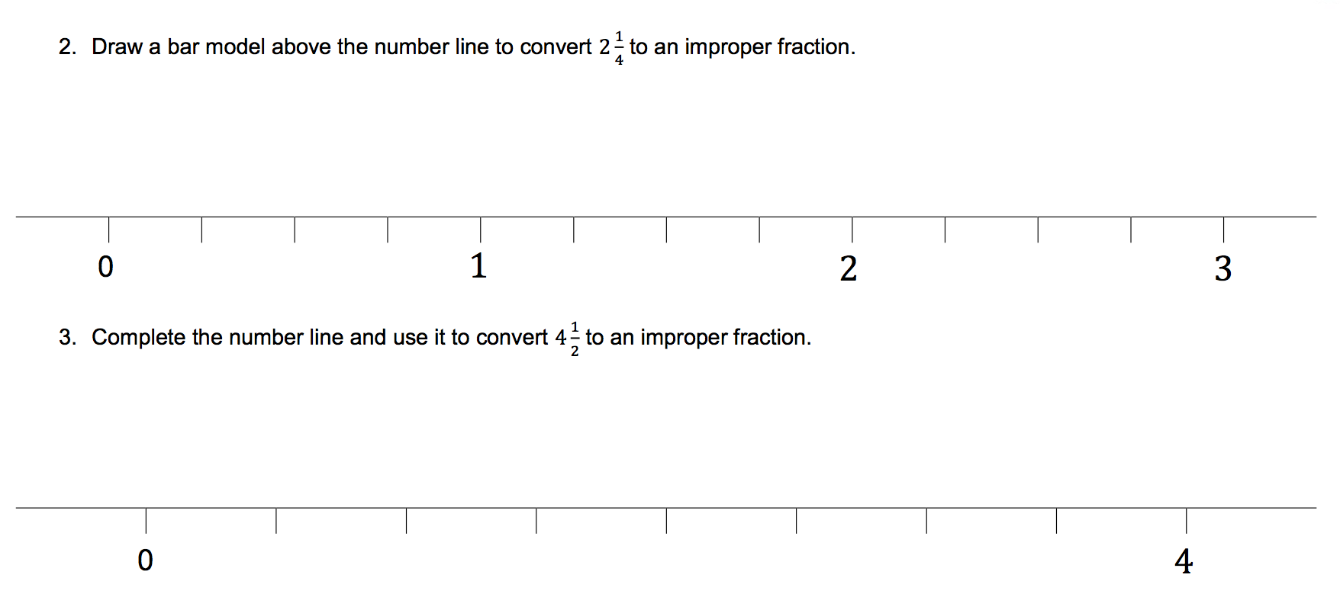
9/2
9/4

2 1/6 = 13/6  4 1/6 = 25/6  4 1/3 = 13/3  8 2/3 = 26/3 | 1) 4 ¾ = 19/4 2) 7 ¼ = 29/4  3) 8 4/9 = 76/9 4) 5 2/3 = 17/3  5) 8 ½ = 17/2 6) 5 1/3 = 16/3
1: Rodney is putting away test tubes in science class. He has 50 test tubes and 12 will fit on each rack. How many rack racks will Rodney fill? Write the answer as a mixed number and as an improper fraction 4 2/12 = 50/12

2: Joey ate 4 ¼ oranges and Billy ate 7 ½ oranges. They finished all the oranges that were in the bag. How many oranges were in the bag? 12 Oranges. If they cost 30p each, how much did the bag cost? 360p or £3.60

3: My dog is 5 ½ years old. My cat is 9/4 years younger than my dog. How old is my cat?
Cat = 2 ¼ years old
My cat is 3 ¼ years younger than my dog

Annie has multiplied the numerator and denominator by 3.  Mo has multiplied correctly, but then forgotten to add on the extra 2 parts.  Dexter has just placed 3 in front of the numerator. | 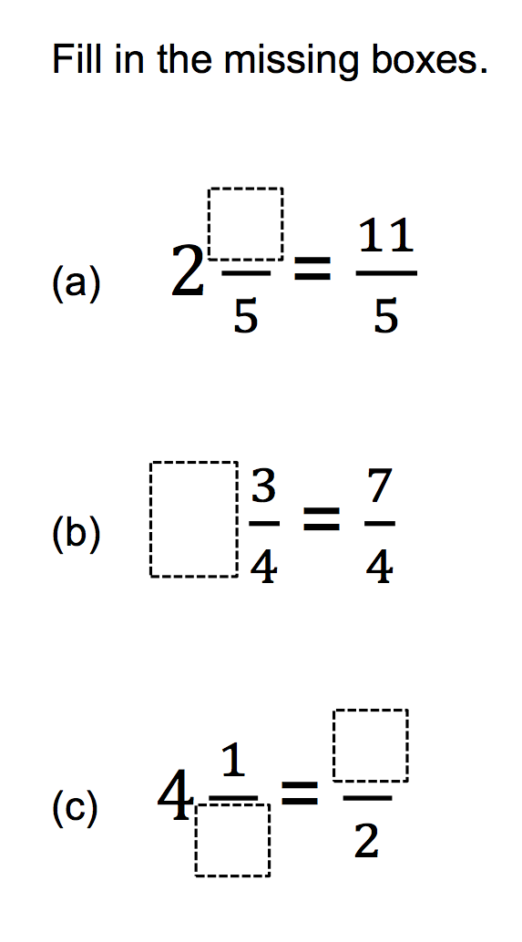  9  2  1  1

Wednesday 13th May
Rapid Recap

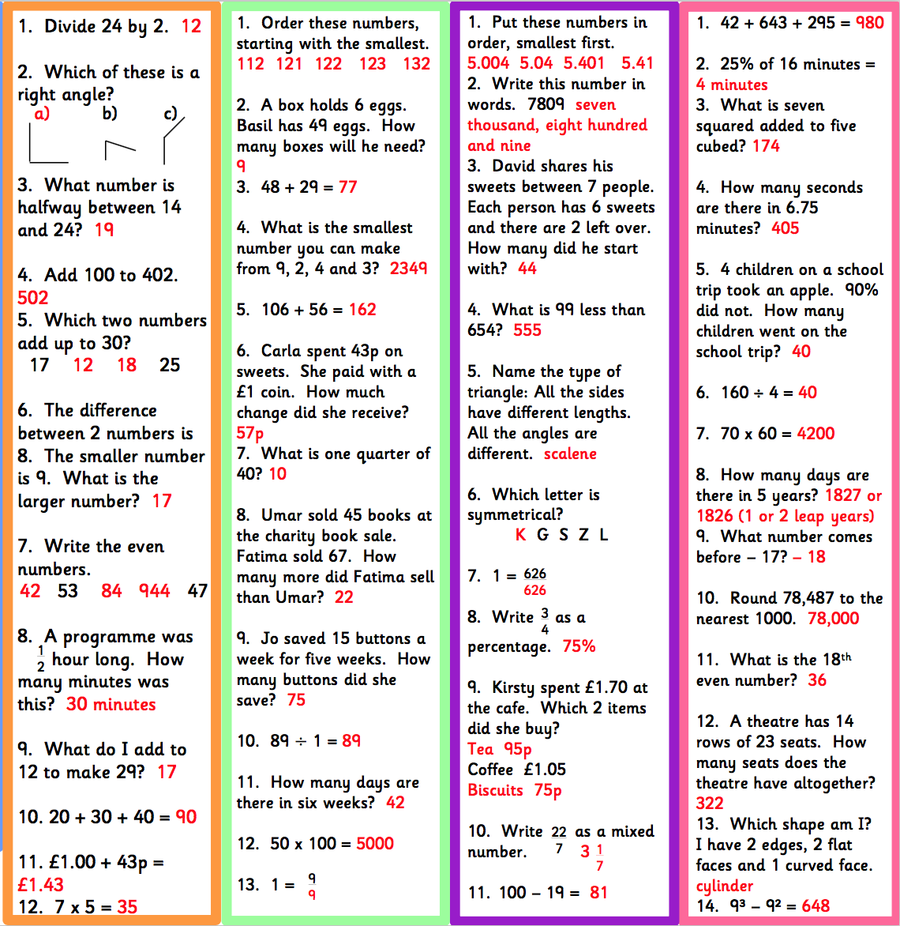

Comparing Fractions – These links demonstrate the method and may help with your home learning

https://www.youtube.com/watch?v=KNdUJQ_qd4U

https://www.khanacademy.org/math/arithmetic/fraction-arithmetic/arith-review-comparing-fractions/v/comparing-fractions

5/6 > 2/3  2/3 > 5/9  7/17 < 3/8 | Order the fractions from greatest to smallest:  1) 3/5, 3/7, 3/8  2) 5/6, 2/3, 7/12  3) 2/3, 3/5, 6/11
- Jeff won some money on the lottery. He generously gave $\frac{2}{5}$ of his winnings to his sister and $\frac{1}{3}$ to his son. Who did he give more money to? His Sister = 6/15 His son = 5/15
- At a dog show $\frac{3}{12}$ of the dogs are Labradors, and $\frac{1}{6}$ are Springer Spaniels. Which dog bread are there more of? Labradors = 3/12 Springer Spaniels = 2/12

- Two contestants are competing in a baked bean eating challenge. Rob has eaten $\frac{2}{7}$ , Asha has gobbled $\frac{1}{3}$ of hers. Who is currently leading the contest? Asha
Convert these fractions to give them common denominators. You will then find them easy to add together.

- Yasmine took $\frac{5}{12}$ of some marbles and Joe took $\frac{1}{4}$ of them. What fraction of marbles did they take between them? 8/12 or 3/4

- Someone has snuck into Peter's fridge and stolen $\frac{3}{10}$ of his ham pizza! He had already eaten $\frac{2}{5}$. How much pizza is still left? 3/10 is left, 7/10 has been eaten or stolen

Disagree. Because the 2 wholes are not equal. He could compare numerators or convert ¾ to 6/8. ¾ is greater. You can use a bar model to show this. | Use the digit cards  Find ways of completing this statement:  How many are there?  Can you include improper fractions?  Many different combinations

Thursday 14th May
Rapid Recap

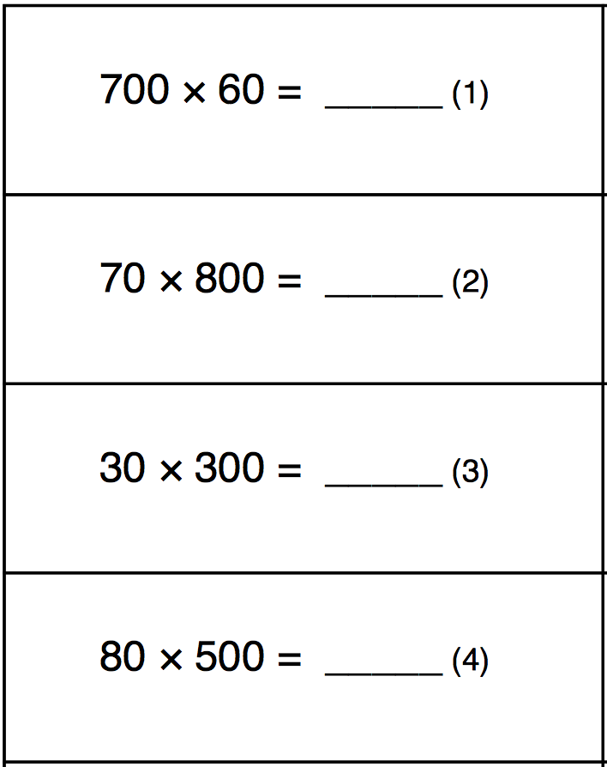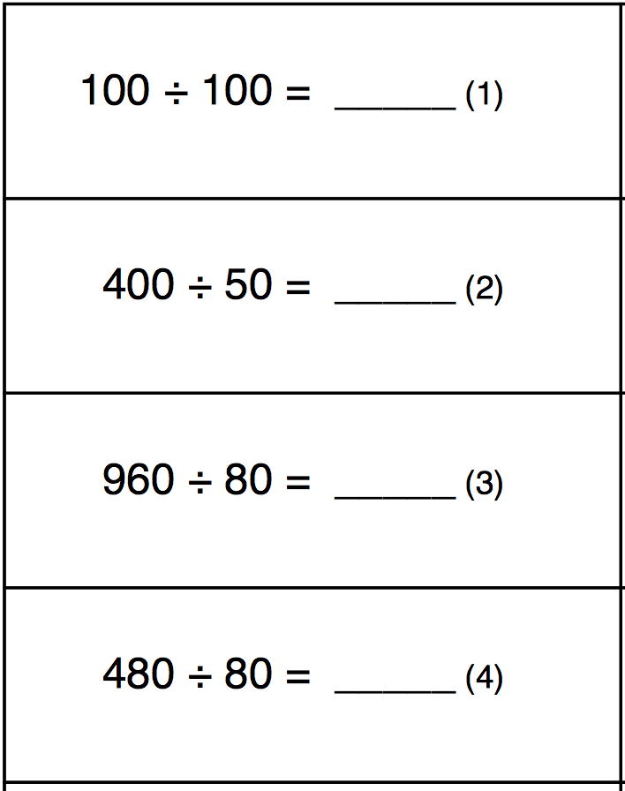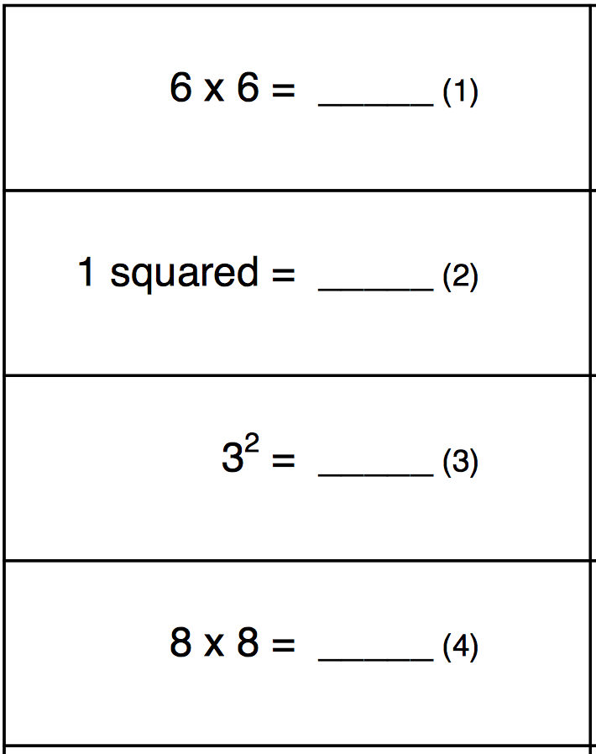
36

1

9

64
1

8

12

6
42000

56000

9000

40000

Adding Mixed numbers – These links demonstrate the method and may help with your home learning

https://www.mathsisfun.com/numbers/fractions-mixed-addition.html

https://www.youtube.com/watch?v=pynfj2bYRms

https://www.youtube.com/watch?v=gLWphGTjGHI

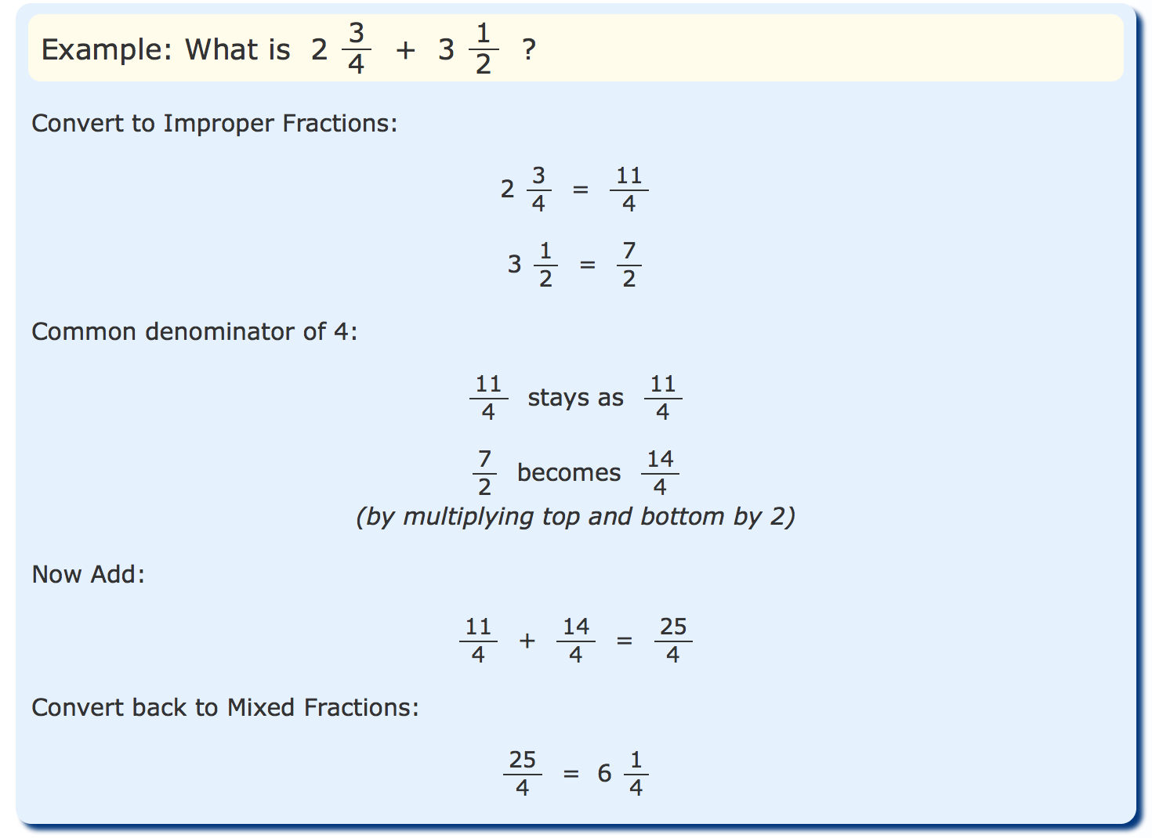
- 2 5/20 + 9 12/20 = 11 17/20  - 3 8/10 + 8 2/10 = 12  - 5 2/4 + 9 ¾ = 15 ¼  - 5 4/6 + 9 3/6 = 15 1/6  - 2 15/20 + 9 14/20 = 12 9/20 | 1: Mark ran 2 2/5 km and Shaun ran 3 1/4km. Find the difference in the distance that they ran. 17/20 km  2: Brandon and his son went fishing. Brandon caught 3 ³/₄ kg of fish while his son caught 2 ¹/₅ kg of fish. What is the total weight of the fishes that they caught? 5 19/20 kg  3: For the school’s sports day, a group of students prepared 21 ¹/₂ litres of lemonade. At the end of the day they had 2 ⁵/₈ litres left over. How many litres of lemonade were sold? 18 7/8
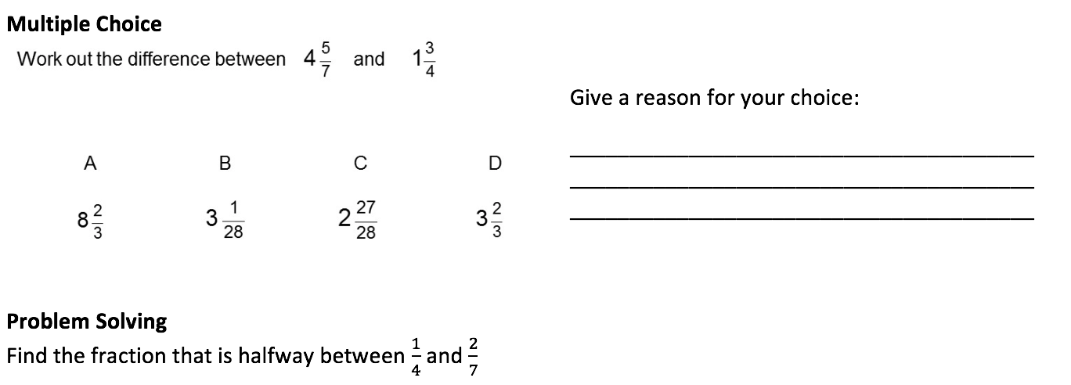
Any explanation that correlates with the working out.

¼ = 7/28 2/7 = 8/28
Multiply these fractions by 2 = 14/56 and 16/56.
The fraction that is halfway between the two is 15/56
(This is a higher level question that not all will answer)

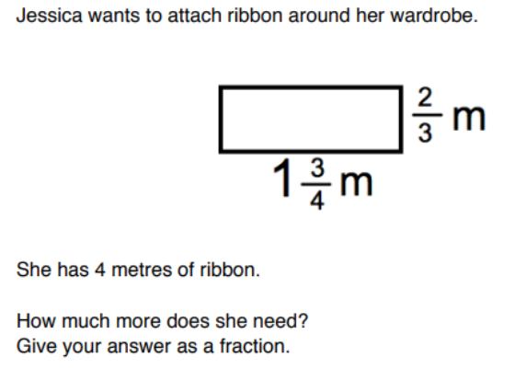 |  | 1 ¾ = 1 9/12  2/3 = 8/12  1 9/12 + 1 9/12 + 8/12 + 8/12 =  2 + 34/12 = 4 10/12  Jessica needs 10/12 more ribbon  Or  5/6 more ribbon

Friday 15th May

Rapid Recap

Mixed Numbers and Improper Fractions Codebreaker - Answers
A | B | C | D | E | F | G | H | I | J | K | L | M
$$3\frac{2}{5}$$ | $$2\frac{4}{5}$$ | $$\frac{19}{12}$$ | $$1\frac{5}{7}$$ | $$2\frac{1}{3}$$ | $$\frac{18}{7}$$ | $$\frac{13}{5}$$ | $$\frac{7}{4}$$ | $$5\frac{1}{2}$$ | $$4\frac{2}{3}$$ | $$\frac{16}{7}$$ | $$1\frac{7}{8}$$ | $$2\frac{7}{8}$$
N | O | P | Q | R | S | T | U | V | W | X | Y | Z
$$\frac{17}{6}$$ | $$2\frac{1}{4}$$ | $$\frac{10}{3}$$ | $$\frac{14}{11}$$ | $$\frac{23}{10}$$ | $$\frac{22}{5}$$ | $$1\frac{1}{2}$$ | $$2\frac{3}{5}$$ | $$4\frac{1}{4}$$ | $$\frac{13}{4}$$ | $$3\frac{2}{7}$$ | $$\frac{14}{9}$$ | $$\frac{11}{8}$$

Convert mixed to improper or vice versa (answers must be in their simplest form), link your answers to the table above to reveal why the police officer had a sheet of very thin paper:
$$\frac{3}{2}$$ | $$1\frac{3}{4}$$ | $$\frac{7}{3}$$ | $$1\frac{5}{9}$$ | $$3\frac{1}{4}$$ | $$\frac{17}{5}$$ | $$2\frac{5}{6}$$ | $$\frac{6}{4}$$
T | H | E | Y | W | A | N | T
$$\frac{14}{6}$$ | $$\frac{12}{7}$$ | $$\frac{9}{6}$$ | $$\frac{9}{4}$$ | $$\frac{15}{10}$$ | $$2\frac{3}{10}$$ | $$\frac{34}{10}$$ | $$1\frac{7}{12}$$
E | D | T | O | T | R | A | C
$$\frac{21}{9}$$ | $$4\frac{2}{5}$$ | $$\frac{18}{8}$$ | $$\frac{23}{8}$$ | $$\frac{28}{12}$$ | $$\frac{54}{24}$$ | $$2\frac{15}{18}$$ | $$\frac{35}{15}$$
E | S | O | M | E | O | N | E

Play TTRockstars – 30 minutes

