Maths Plan
Year 3 Monday 20th April 2020

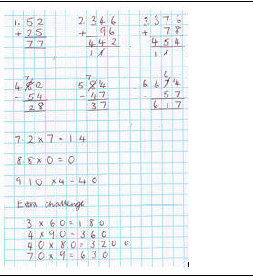

Maths Plan
Year 3 Tuesday 21st April 2020

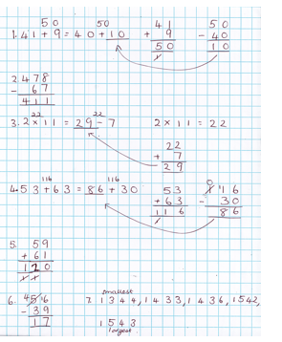

Maths Plan
Year 3 Thursday 23rd April 2020

Can you find fractions of amounts? ANSWERS

1a. I have divided the marbles into 5 equal groups.
1b. There are 4 marbles in each group.
1c. 1/5 of Eva’s marbles is 4.

2. 1/6 of 12 = 2
1/3 of 12 = 4
1/3 of 18 = 6
1/9 of 18 = 2

3. 1/3 of 36 = 12
1/3 of 45 = 15
1/5 of 65 = 13

