Maths Plan
Year 4 Monday 18th May 2020
- Remember any work you want to show me or to ask any questions- email to year4@becket.n-somerset.sch.uk
- Please continue to recap telling the time as much as possible.
- Visit TT rockstars to practise your times tables.
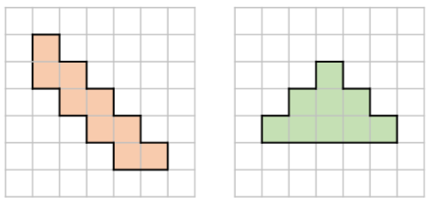Rapid Recap
Perimeter is the measurement of the outside edges of a 2d shape.
Area is the measurement of the inside of a shape. Can be measured by counting the squares inside a shape.
Each square= 1cm
Not to scale

Work out the perimeter and area of each shape.
Main Learning
This week, we are focussing our learning on co-ordinates. If you’ve ever played ‘Battleships’, this will definitely help you. The link below is a video that explains co-ordinates a bit more. There is also some learning to do interactively on there.
https://www.bbc.co.uk/bitesize/topics/zgthvcw/articles/z96k9qt
Remember, when working out position and co-ordinates, always do the x axis and then the y axis. I always remember this by saying: ‘Go along the corridor (x axis), then up the stairs (y axis)’

1.

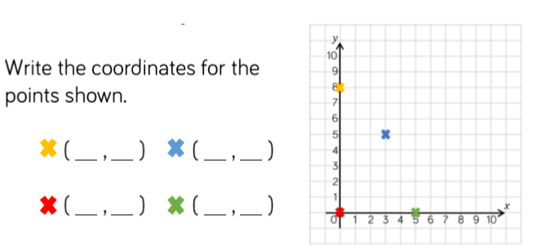

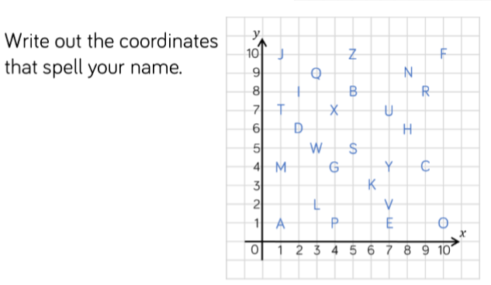2.

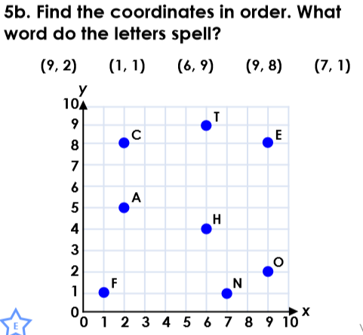3.

Maths Plan
Year 4 Tuesday 19th May 2020

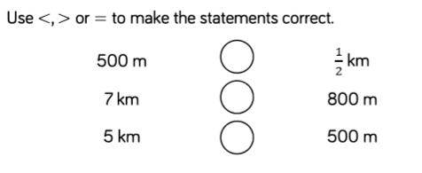Rapid Recap

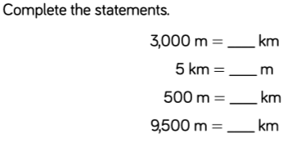
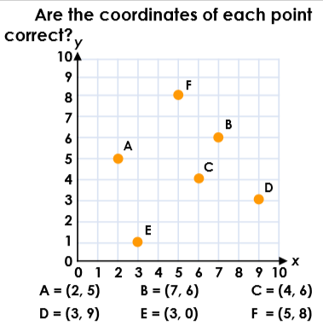Main Learning
2.
1.

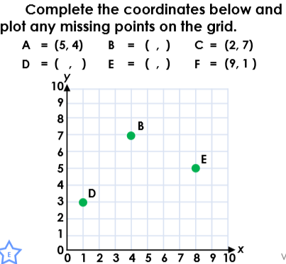

3.
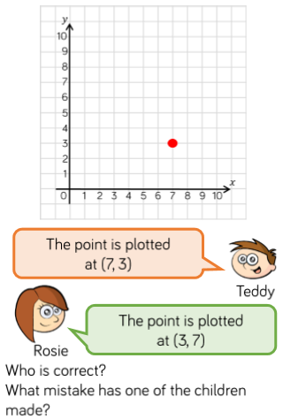

Maths Plan
Year 4 Wednesday 20th May 2020
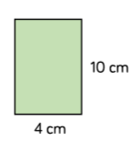Rapid Recap

Find the perimeter of these shapes
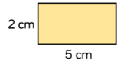

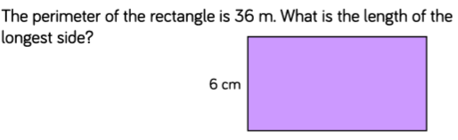

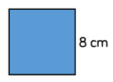

Main Learning
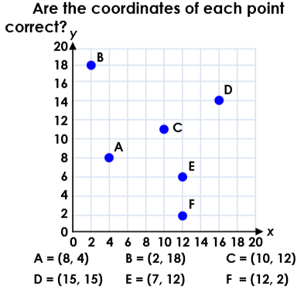

1.

Not to scale

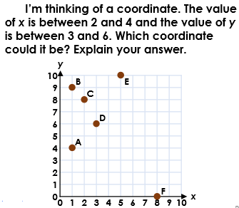

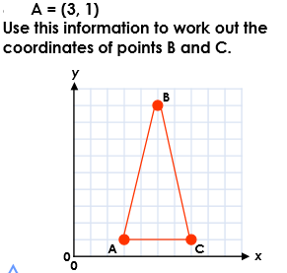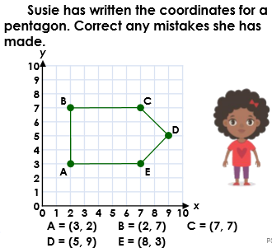
4.
3.
2.
Maths Plan
Year 4 Thursday 21st May 2020

Rapid Recap
Use the information you have on the shape to help you find the missing sides. Then, add the sides up to find the perimeter.

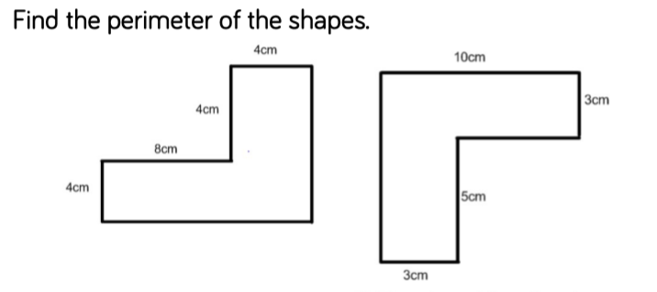
Main Learning
Using the language up, down, left and right, describe the movement of objects on co-ordinates grid.
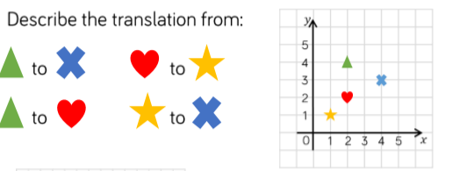Start with left and right, then up and down.

1.

Not to scale

3.

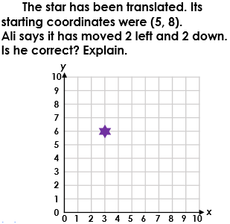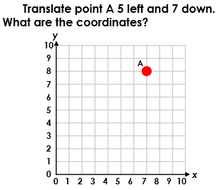

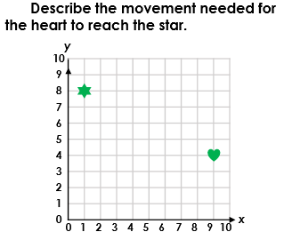
4.
2.

Maths Plan
Year 4 Friday 22nd May 2020

Rapid Recap
TT rockstars and telling the time practise.
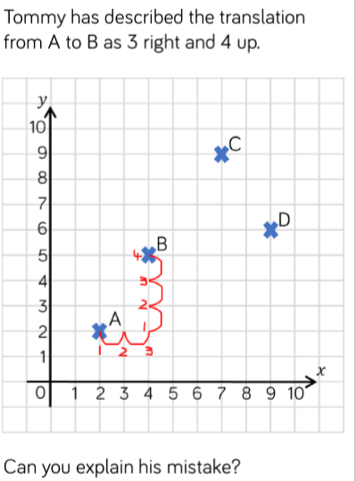
If you have it at home already, or can print out some squared paper, try putting your own shapes onto a grid using co-ordinates.
Or if you have battleships at home, play a game with a parent or sibling (or maybe a pet- you should definitely win then).
2.
1.
