Monday 4th May
Rapid Recap – Choose the appropriate challenge for you. Complete one of the boxes below.

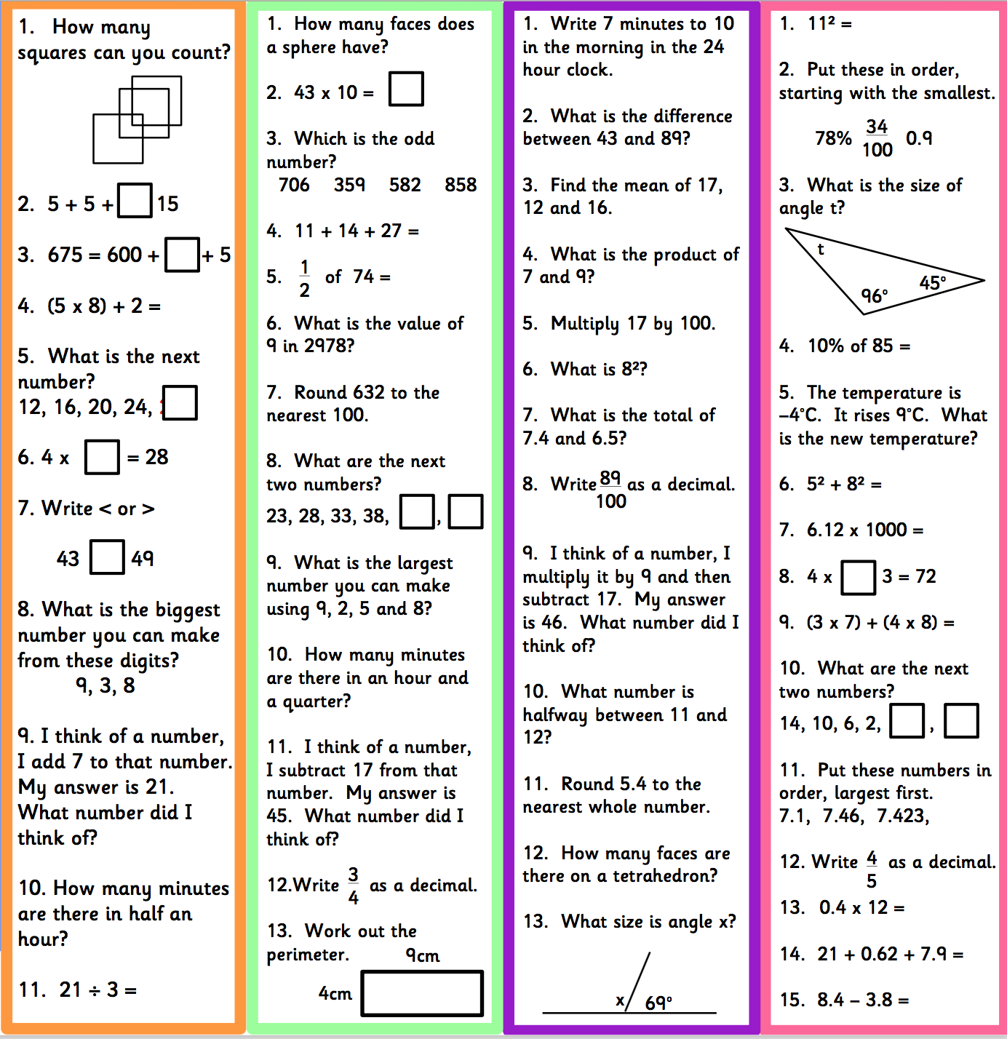

Add and subtract fractions with the same denominator - These links demonstrate the method and may help with your home learning:

https://www.bbc.co.uk/bitesize/topics/zhdwxnb/articles/z9n4k7h

https://www.khanacademy.org/math/arithmetic/fraction-arithmetic/arith-review-adding-subtracting-frac/v/adding-fractions-with-like-denominators

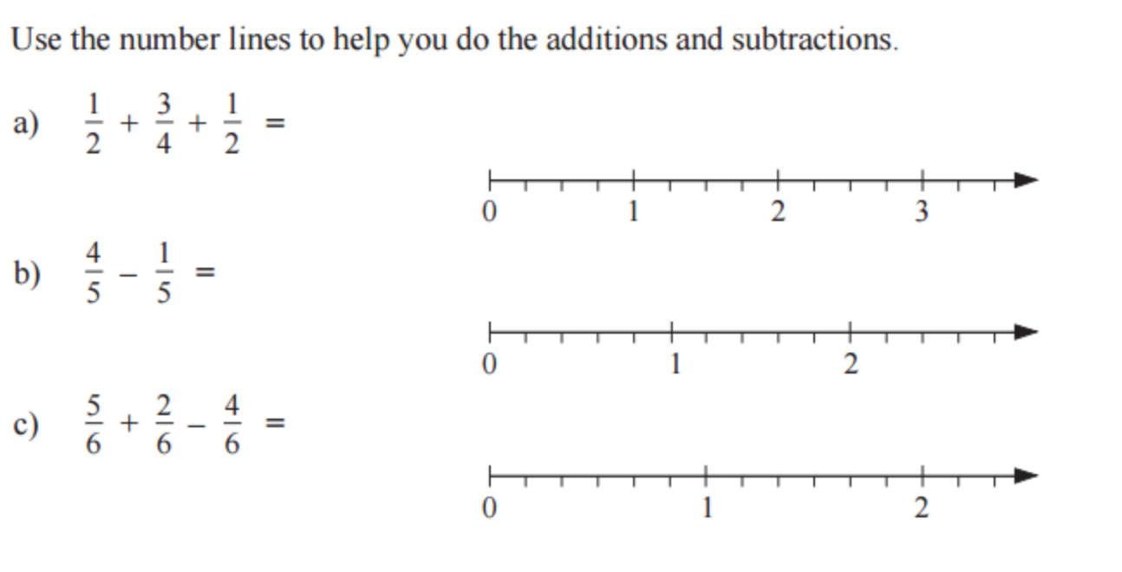 |  |  | 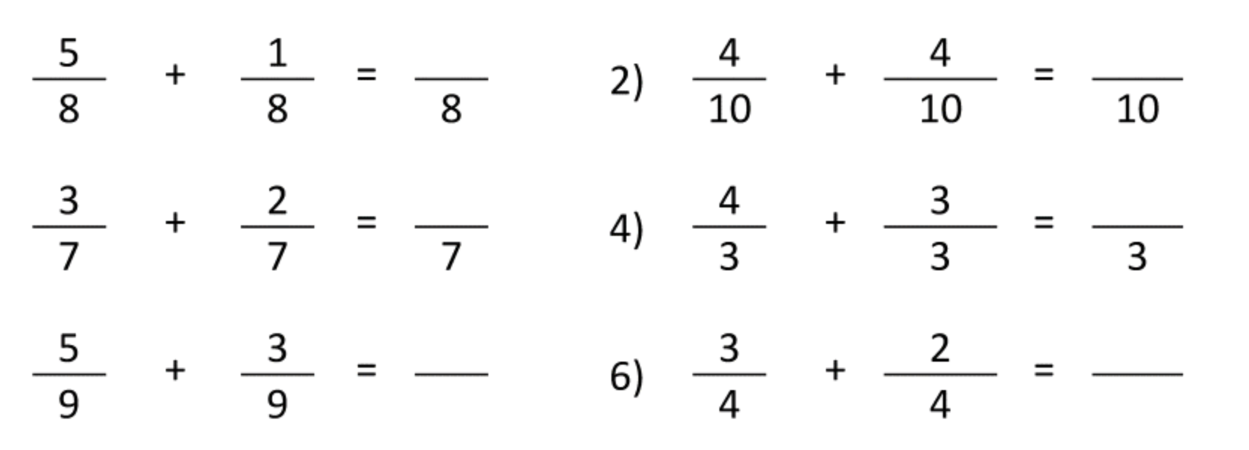
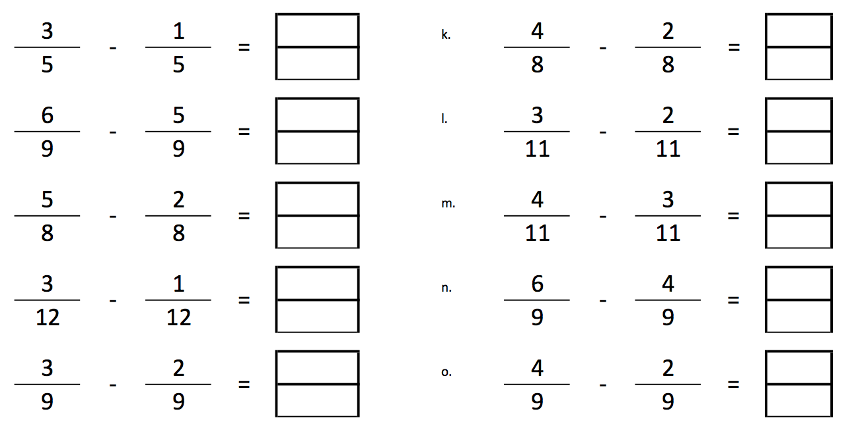 |  | 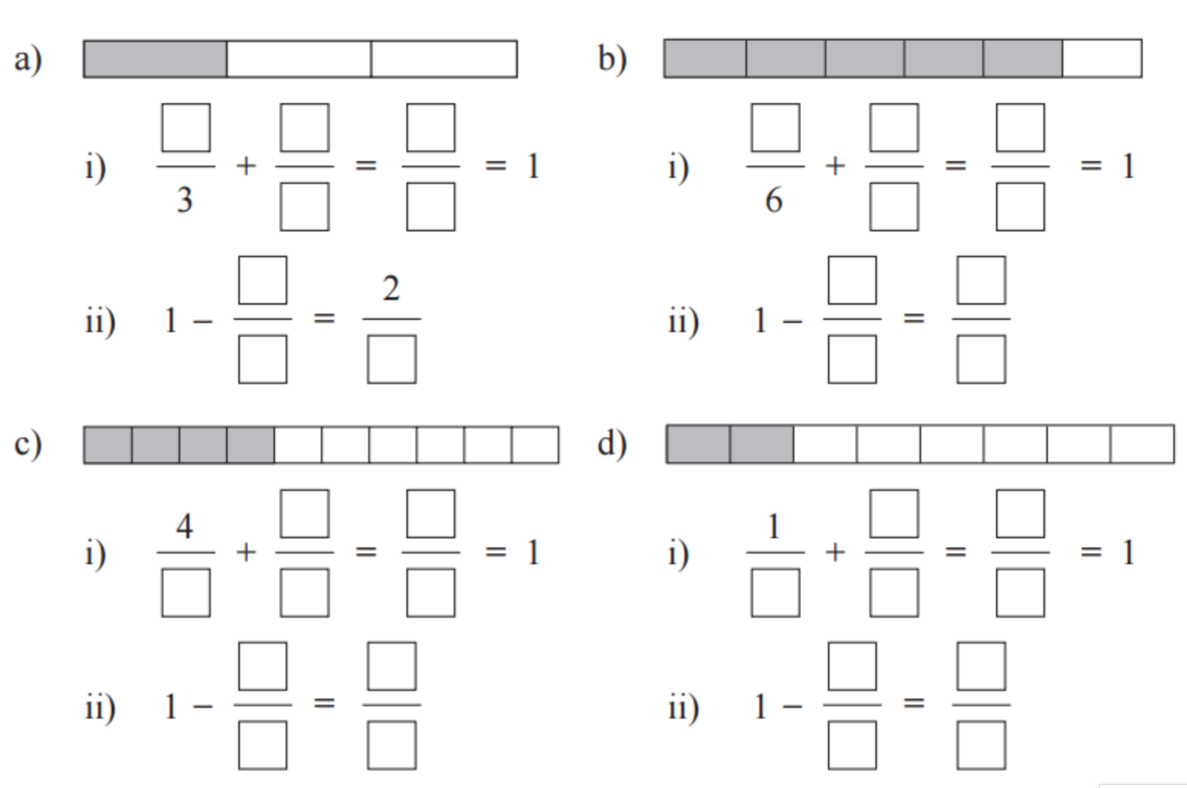
- Percy spent 3/8 of his money on food and another 2/8 of his money on a drink. What fraction did he spend in total?

- John spent 2/5 of his money on food and another 1/5 of his money on a drink. What fraction of his money did he have left?

- Sally has a piece of cloth. She used 1/5 of the cloth to make a pillow cover and another 2/5 of the cloth to make a tablecloth.
What fraction of the cloth was used altogether for the pillow cover and tablecloth?
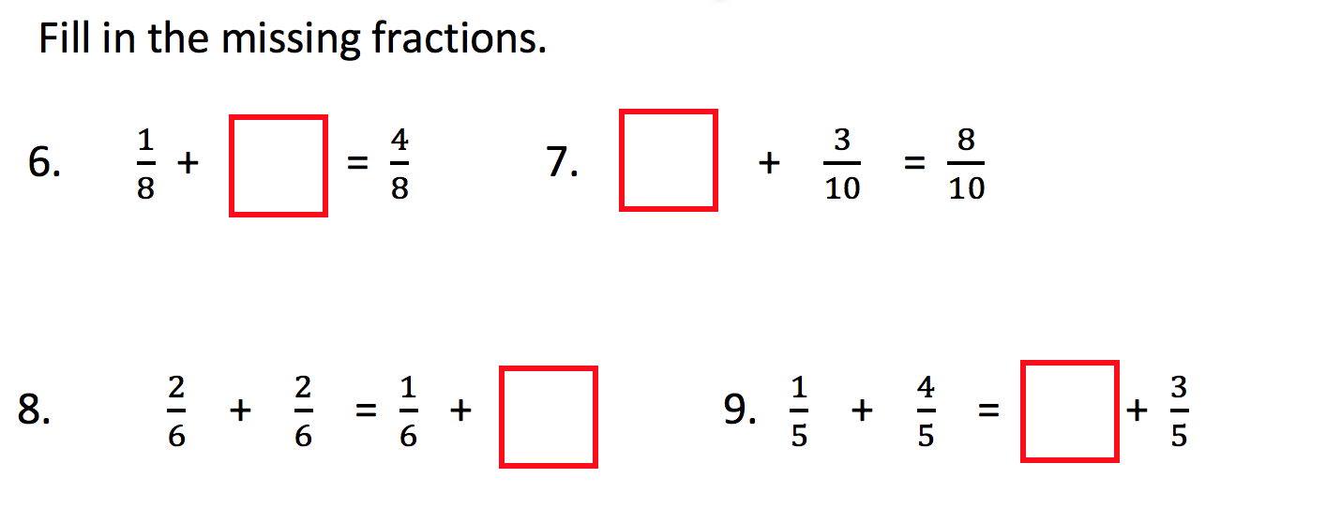 | 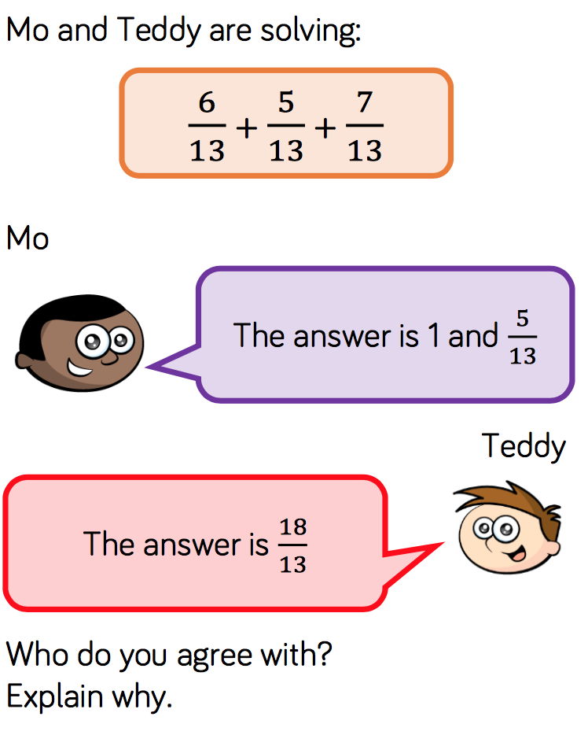

Tuesday 5th May
Rapid Recap – Choose the appropriate challenge for you. Complete one of the boxes below.

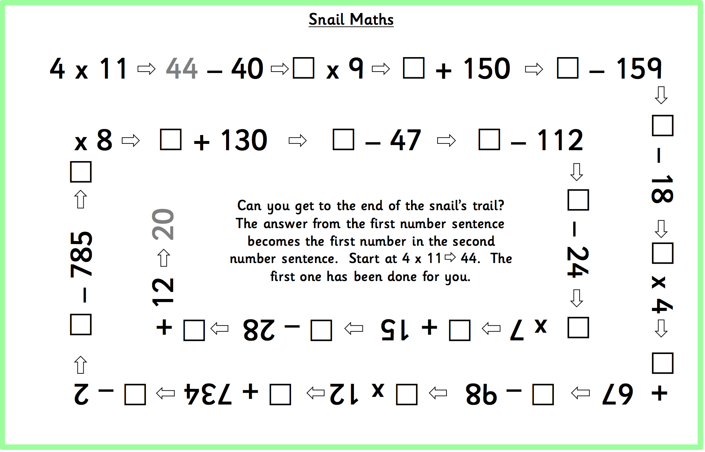

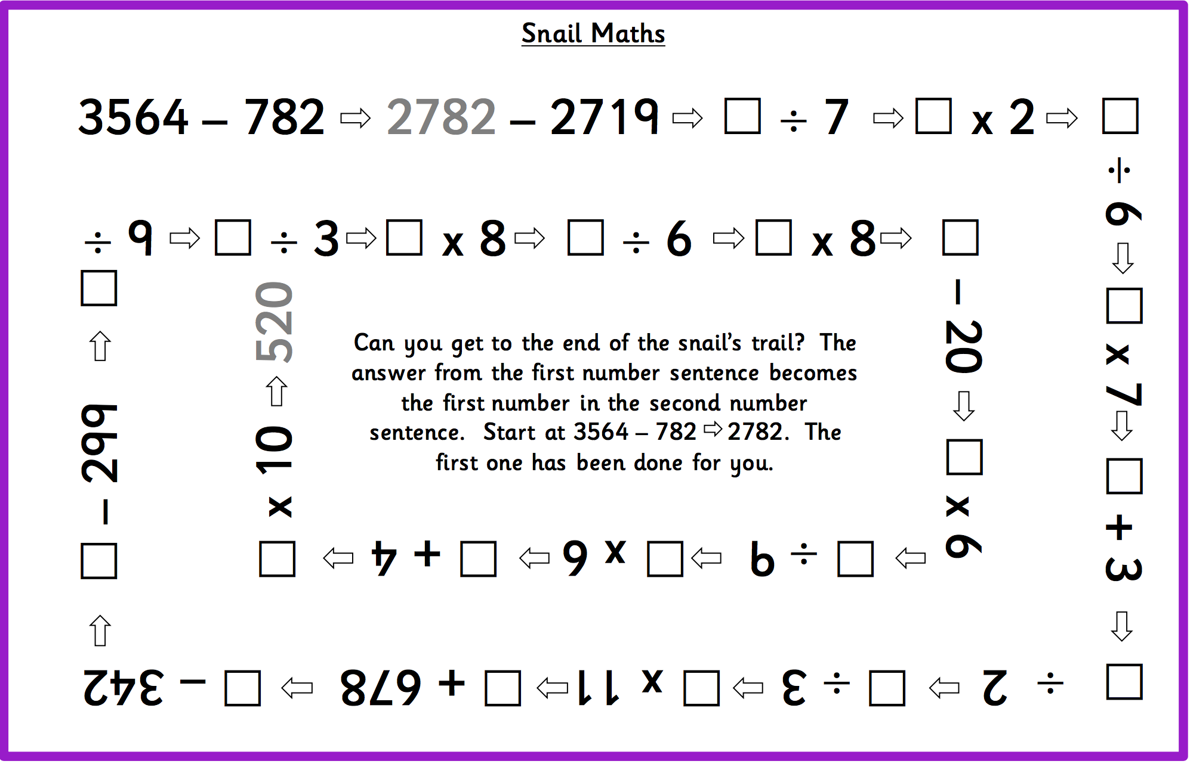

Making Equivalent Fractions – These links demonstrate the method and may help with your home learning.

https://www.youtube.com/watch?v=qcHHhd6HizI

https://www.bbc.co.uk/bitesize/topics/zsxhfg8/articles/zwjwgdm

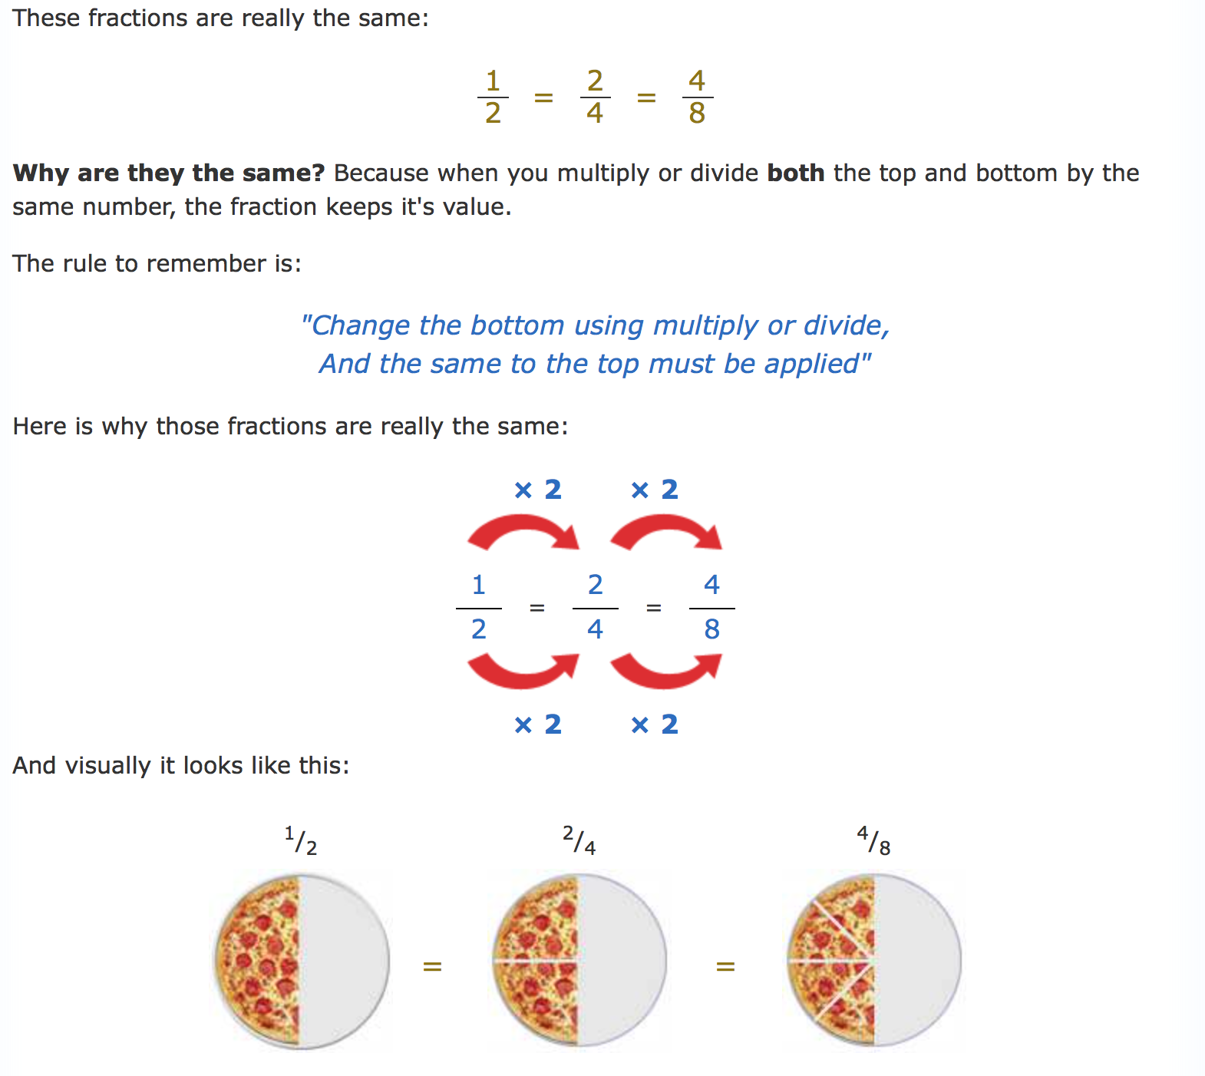 | 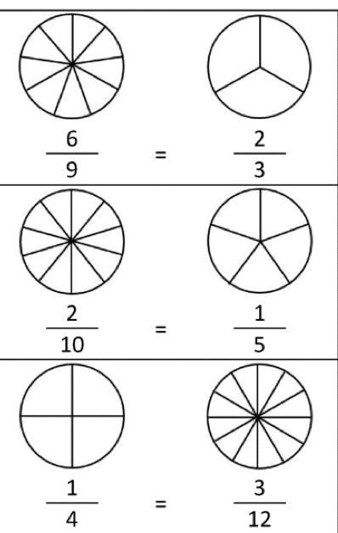
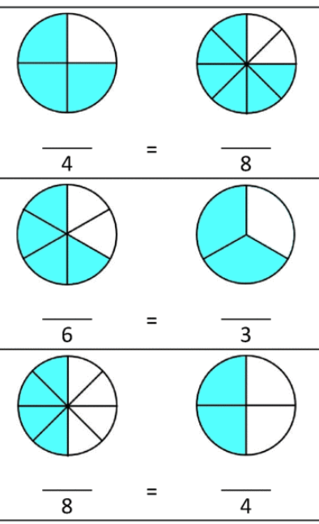 | 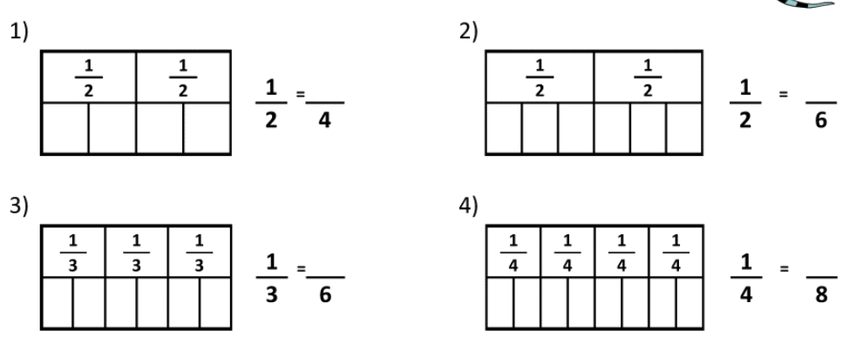
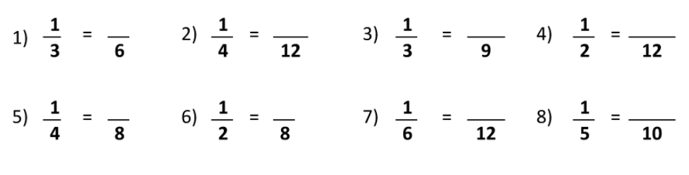
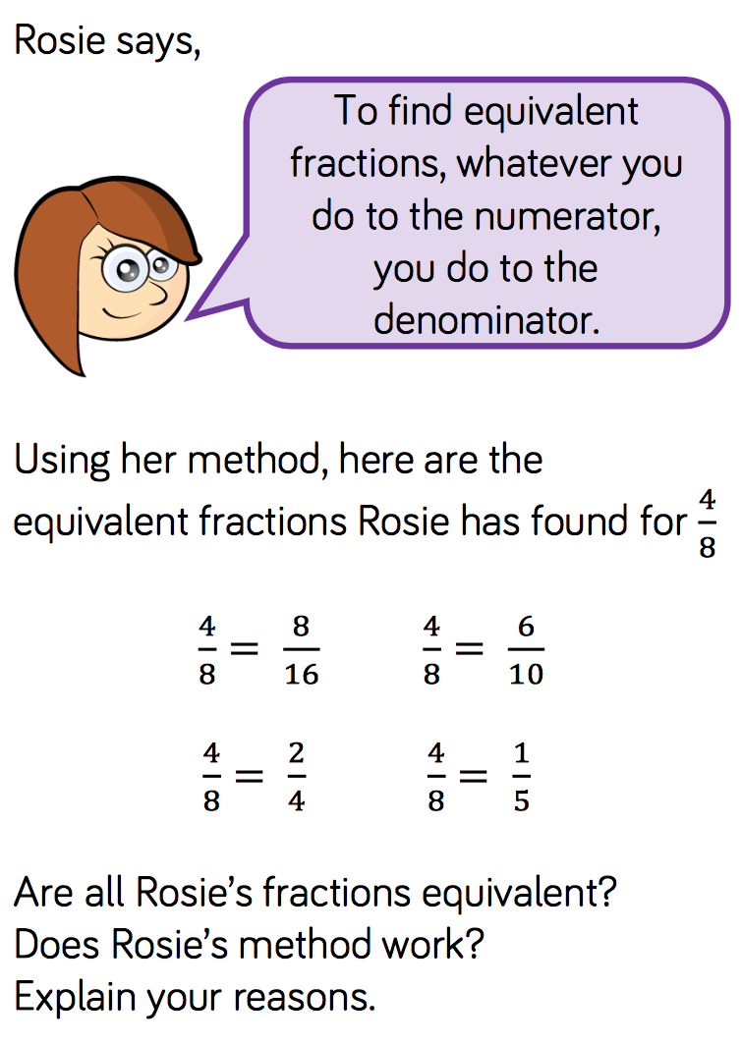 | 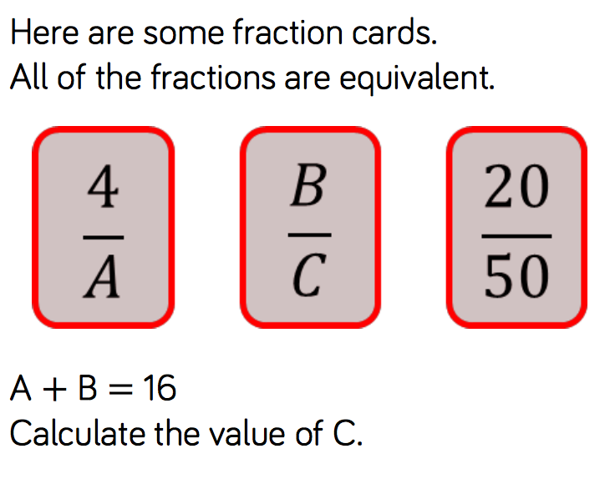

Wednesday 6th May
Rapid Recap

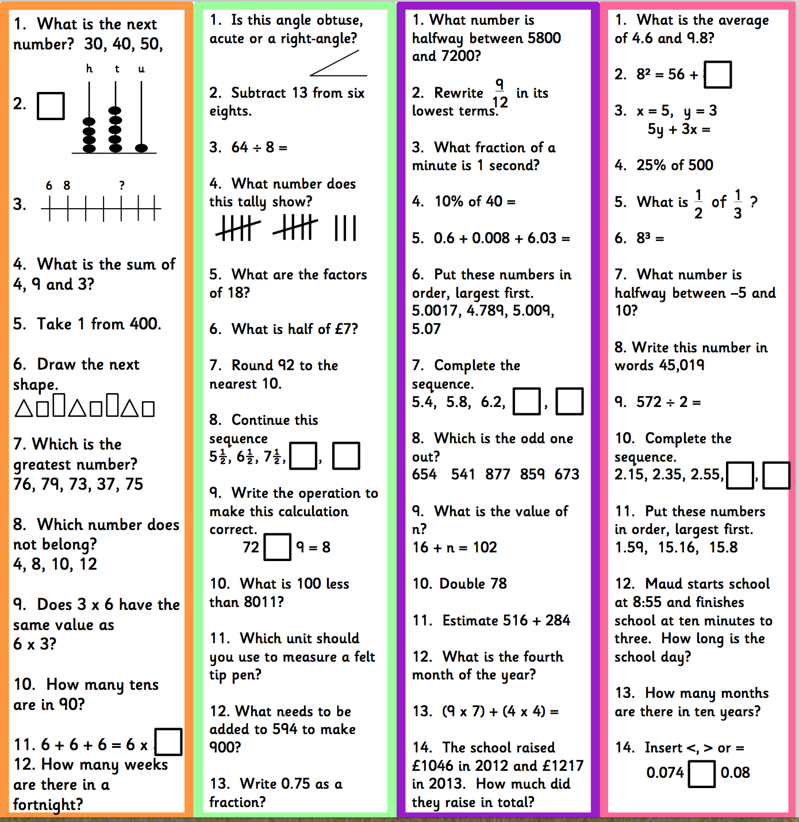

Adding and subtracting Fractions – These links demonstrate the method and may help with your home learning

https://www.youtube.com/watch?v=tDQipFjAoT8

https://www.bbc.co.uk/bitesize/topics/zhdwxnb/articles/z9n4k7h

We must find the lowest common denominator (The smallest number that is in both times tables, in this case 2 and 3). The smallest number that is in both the 2 and 3 times tables is 6.
1 x 3 = 3 1 x 2 = 2
2 x 3 = 6 3 x 2 = 6
Both these fractions now have the same denominator. We can now do:
3 + 2 = 5
6 + 6 = 6

Choose the correct challenge for you:
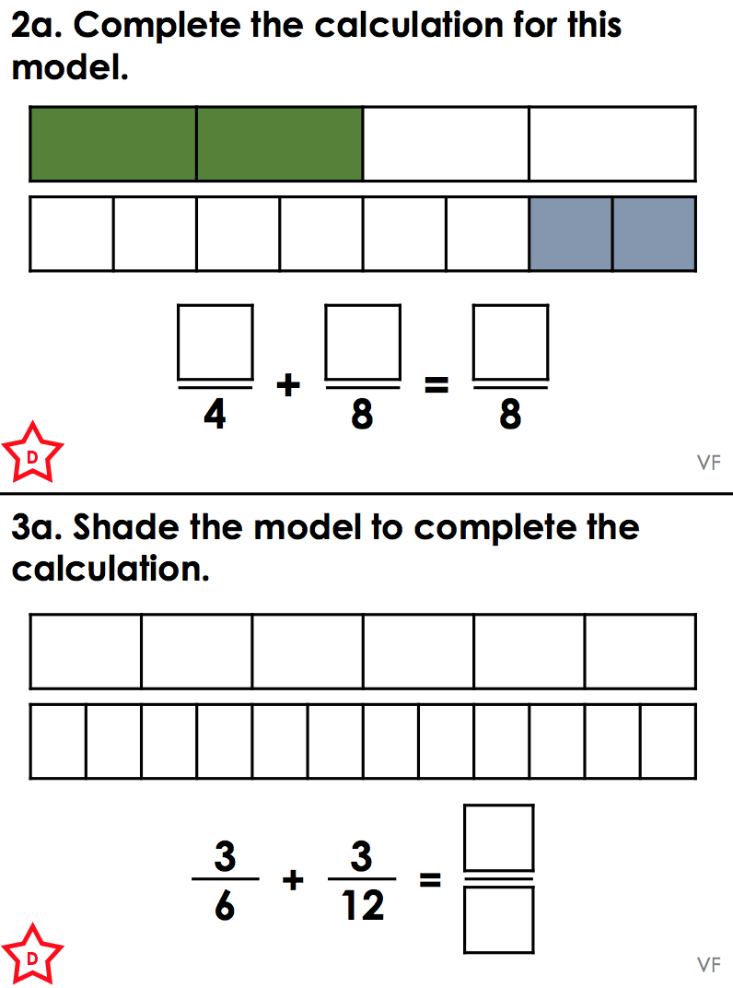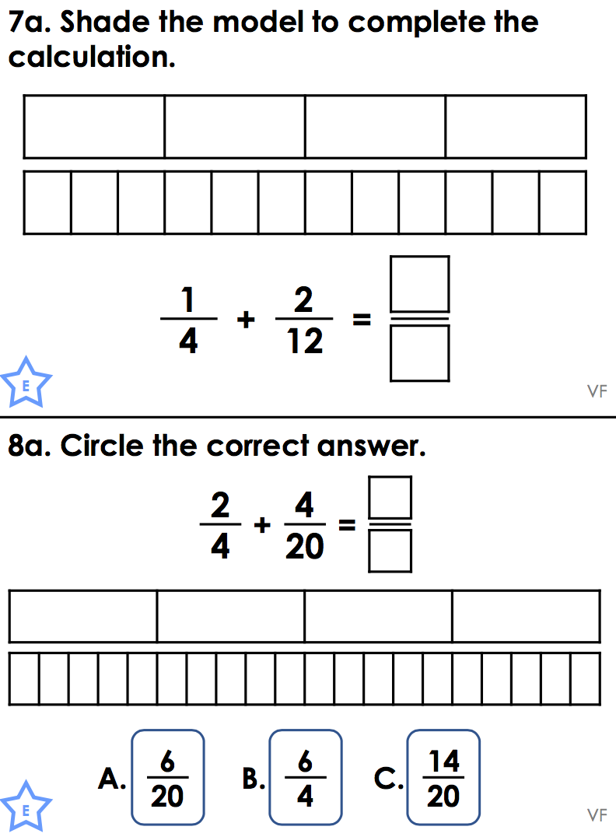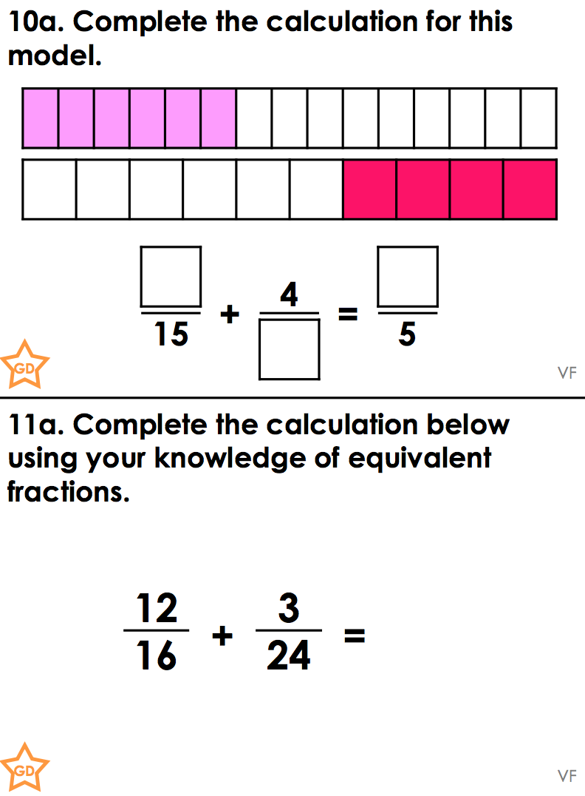
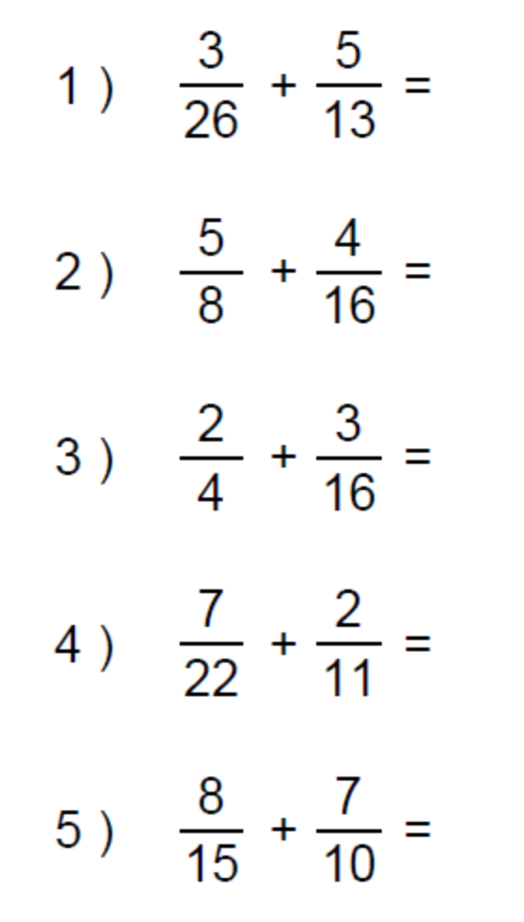 | Add the 2 fraction below to move your way up the pyramid  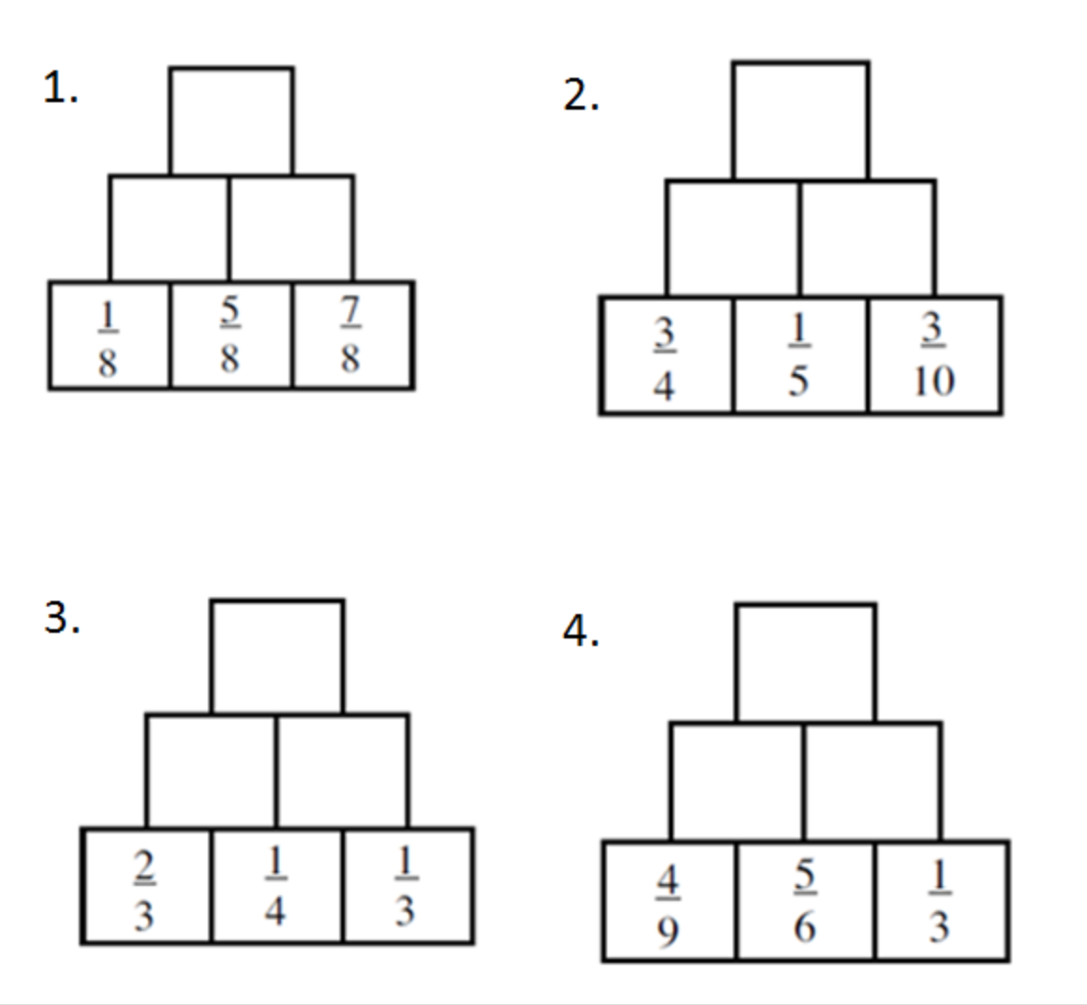  6  8

Thursday 7th May
Rapid Recap

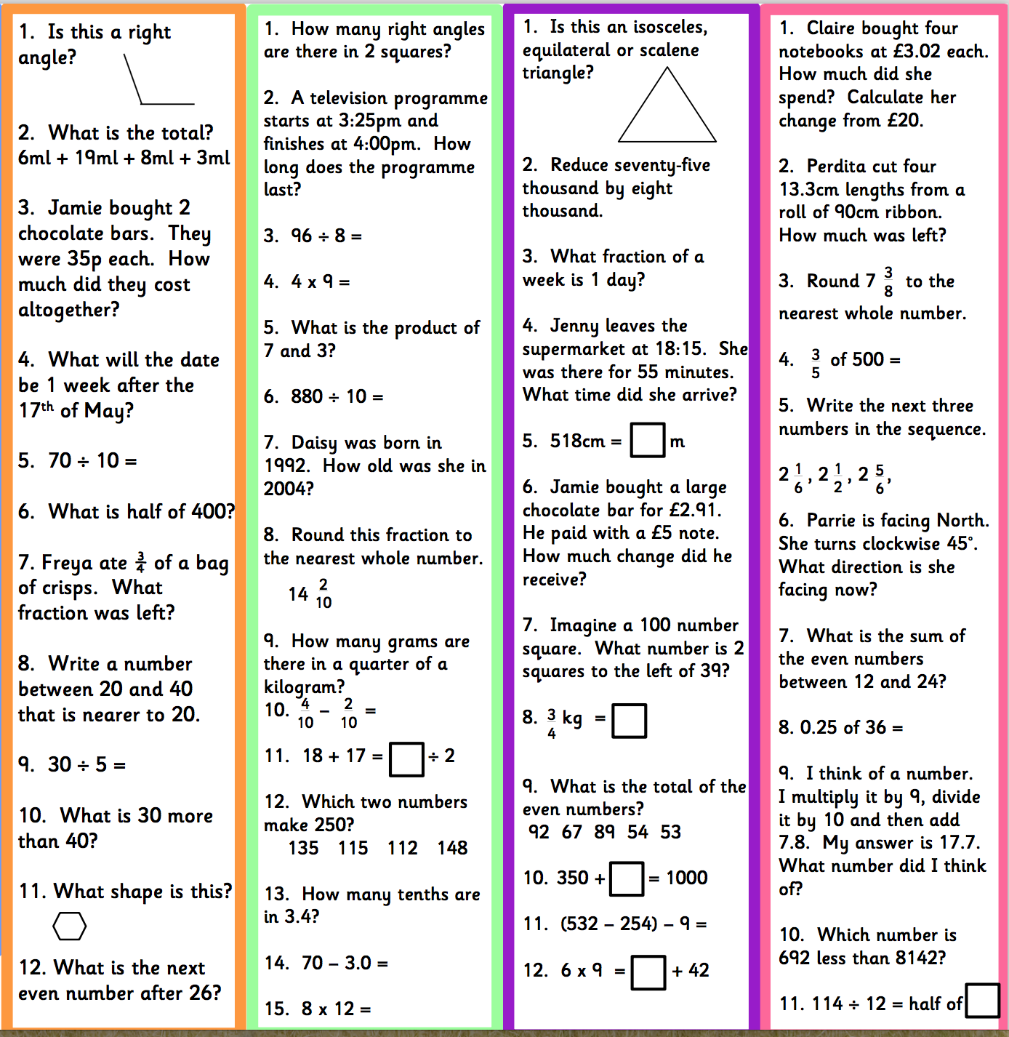

Adding and subtracting Fractions – These links demonstrate the method and may help with your home learning

https://www.youtube.com/watch?v=tDQipFjAoT8

https://www.bbc.co.uk/bitesize/topics/zhdwxnb/articles/z9n4k7h

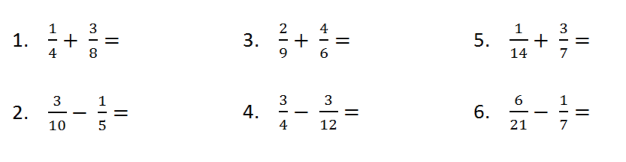
- Percy spent 1/4 of his money on food and another 2/8 of his money on a drink. What fraction did he spend in total?
- John spent 1/5 of his money on food and another 7/10 of his money on a drink. What fraction of his money did he have left?
- Sally has a piece of cloth. She used 1/2 of the cloth to make a pillow cover and another 2/5 of the cloth to make a tablecloth.
What fraction of the cloth was used altogether for the pillow cover and tablecloth?
- Sally has a piece of cloth. She used 1/2 of the cloth to make a pillow cover and another 1/3 of the cloth to make a tablecloth.
What fraction of the cloth does she have left over?
- You go out for a long walk. You walk 1/2 mile and then sit down to take a rest. Then you walk 1/3 of a mile. How far did you walk altogether?
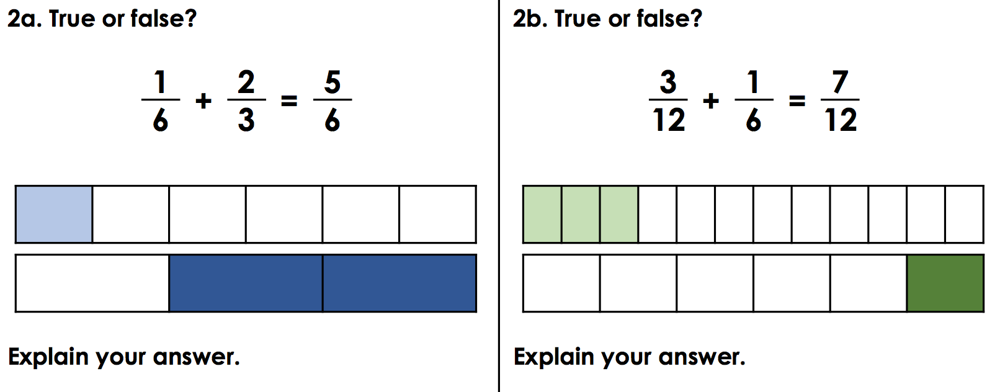
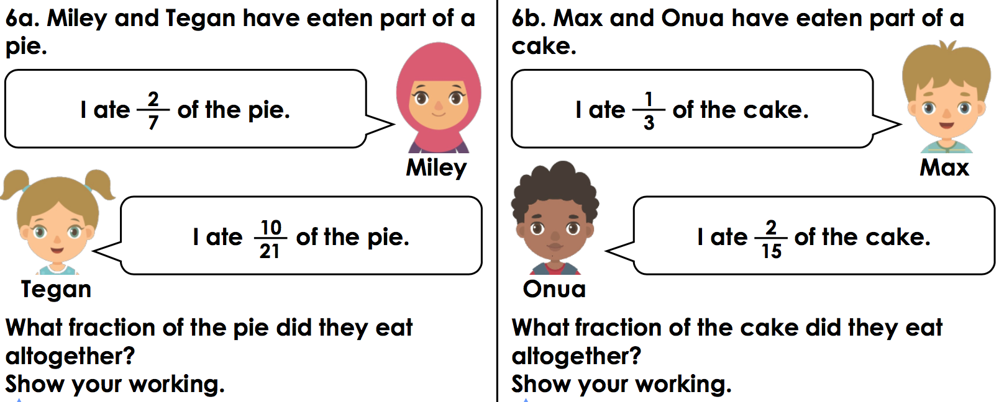
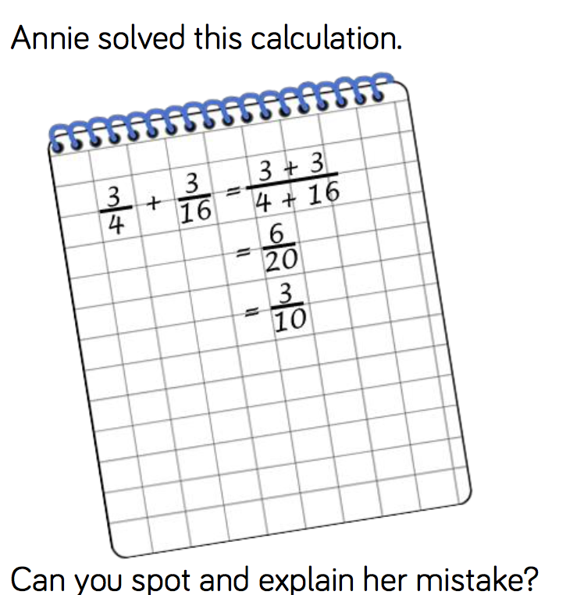

Friday 8th May

Play TTRockstars – 30 minutes

