Maths Plan
Year 6 Monday 20th April 2020

Maths: Rapid Recap
- 76.4 – 0.254 = | (4) Simplify 2x + x + 3y – y =
- 38 x 365 = | (5) 3/4 – 1/3 = 9/12 - 4/12 =
- 3.2 x 1,000 = | (6) 34% of 350 =
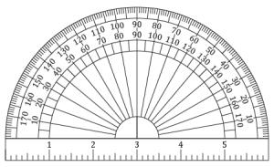
Maths: Introducing Angles
A reminder of the names of each type of angle: https://www.bbc.co.uk/bitesize/topics/zb6tyrd/articles/zg68k7h
Maths antics also has a video that explains types of angle and how to estimate angles. From 6 minutes 30 seconds, it also reminds us of how to use a protractor: https://www.youtube.com/watch?v=_n3KZR1DSEo

Look at each angle in turn: a) decide whether the angle is acute, obtuse or a right angle, b) estimate the amount of turn in degrees.

angle ____________ angle_____________
estimate _____________ estimate ___________

angle _______________ angle _________________
estimate _____________ estimate _______________

angle ______________ angle _______________
estimate ____________ estimate ____________
Reasoning:
- Sam says that it is not possible to have three acute angles inside a triangle. Is he right?
- Helen says that a right angle is a type of acute angle. Is she right?

Maths Plan
Year 6 Tuesday 21st April 2020

Maths: Rapid Recap
- 35% of 70 = | - 3/5 + 2/9 =
- 102 less than 1020 = | - 38 minutes before 6.02am =
- 3.48 x 1000 = | - 17 x 5643 =
Maths: Angles around a point
So, there are two key pieces of information to remember here: a whole turn is 360⁰ and a straight line is half of that amount which is 180⁰. It’s also useful to remember that a right angle is 90⁰ and three quarters of a turn is 270⁰. Remember that 90⁰ is represented as a square instead of an arc
To calculate the missing angle, you need to work out what’s left to make your total. So, in this calculation. The last part of this video (from 6:30), explain this quite clearly: https://www.youtube.com/watch?v=_n3KZR1DSEo
So, essentially, you need to work out number bonds to 90, 180 or 360.
Bonds to 90:  - 54 + ____ = 90  - 28 + ____ = 90  - _____ + 20 + 30 = 90  - _____ + 16 + 24 = 90 | Bonds to 180:  - 100 + ____ = 180  - 20 + ____ = 180  - 70 + 12 + ____ = 180  - ____ + 3 + 90 = 180 | Bonds to 360:  - 200 + ____ = 360  - 300 + 12 + ___ = 360  - ___ + 20 + 200 = 360  - 92 + 91 + 90 + ___ = 360
These are the key calculations that you need to understand to be able to then calculate the missing angles represented in the images below. Work out the missing angles:
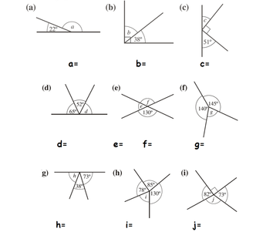
Reasoning. Make sure that your answers are clear with an example to prove your point where possible (make sure that it really does prove the point):
- Helen says that if there are five angles that make up a complete 360⁰ turn, no more than three can be right angles. Is she right?

- Captain Pugwash’s ship is facing North. He turns moves 1 nautical mile north and then turns sharply 270⁰. He carries on for another nautical mile and turns 270⁰ again. After another mile he turns 270⁰ one more time. After another nautical mile, is he back where he started?
Extra questions:
There are some good additional questions here: https://www.mathsisfun.com/angle360.html

Maths Plan
Year 6 Wednesday 22nd April 2020

Maths: Rapid Recap
Name the shapes below:
Maths: Angles of a triangle
So, the internal (inside) angles of a triangle add up to make 180⁰, whatever the type of triangle. This is like the practice we had yesterday with number bonds to 90.
An equilateral triangle has three equal angles, so 60⁰ + 60⁰ + 60⁰ = 180⁰.
An isosceles triangle has two angles and two sides that are the same, so for example 20⁰ + 20⁰ + 140⁰ = 180⁰, or 70⁰ + 70⁰ + 40⁰ = 180⁰.
A scalene triangle has three different angles and three different side lengths.
For each triangle below, identify the missing angle and which type of triangle it is:
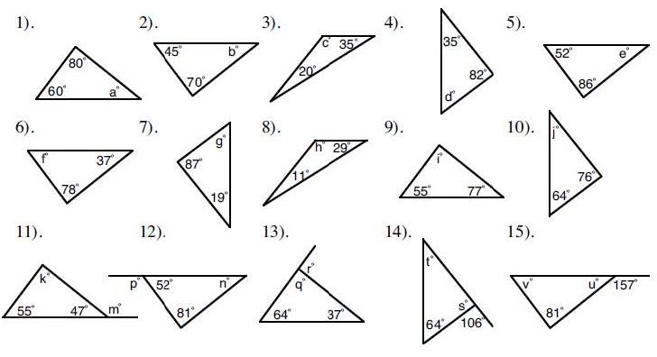
Reasoning questions:
(10) Is it possible for an isosceles triangle to have a right angle?
(11) One of the angles in an isosceles triangle is 50⁰. What are the two other possible pairs of angles that could be in the triangle?

Maths Plan
Year 6 Thursday 23rd April 2020

Maths: Rapid Recap
Convert the following fractions into mixed numbers:
- 23/5 = | - 2/3 + 2/4 =
- 40/13 = | - 2/3 + 2/4 + 2/5 =
- 14/30 + 34/30 = | - 15/9 – 1/7 =
Maths: Angles in 2d shapes and with parallel lines
Firstly, if you are unsure about the learning we have covered from Monday to Wednesday, go back and work out the answers again today. If you would like additional questions of this type, this is a good resource: https://www.mathsisfun.com/angle180.html
Where a line bisects (crosses) two parallel lines, the angles are identical. The same is true of opposite angles with two straight lines crossing:
This BBC Bitesize page explains the way that the angles can be measured and gives questions to test your understanding:
https://www.bbc.co.uk/bitesize/guides/zk8j6sg/revision/1
There are some great additional questions here:
https://mathsmadeeasy.co.uk/gcse-maths-revision/geometry-problems-foundation-gcse-revision-and-worksheets/

Maths Plan
Year 6 Friday 24th April 2020

Maths: Rapid Recap
- Adrian is making bread. He has bought 1.5kg of flour. He uses 375g. How much is left?
- As he puts the remaining flour into the cupboard, he drops the bag. Half of what is left, falls on the floor. How much is on the floor?
Maths: Fraction Friday: Fraction and Percentage equivalence
There are some key equivalents that you need to learn by rote (just know them):
1/2 = 50% | 1/4 = 25% | 3/4 = 75% | 1/5 = 20%
1/3 = 33.3•% | 2/3 = 66.6•% | 1/8 = 12.5% | 1 = 100%
Percentage of a shape:
These are useful for working out the percentage of a shape which is shaded. So, for example, in this shape, 2/8 of the shape is shaded. This is the same as 1/4 which is 25%.
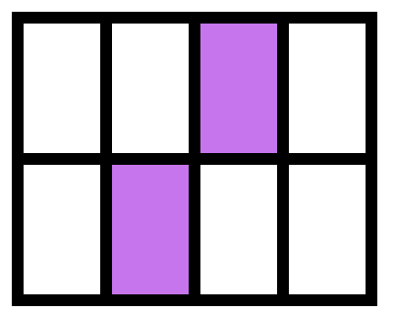
Can you calculate the area of the shapes below as percentages? Use a calculator for f, i and k (not h) and round to two decimal places.
Percentage increases and decreases:
If a price increase by 10%, it is now 110% of the original price (the whole price plus another 10%). If it decreases by 10%, it is now 90% of the original price.
- Increase 90p by 10%
- Decrease 3.2kg by 10%
- Increase £1.50 by 20%
- Petrol cost £1.20 a litre. It increases in price by 10%. How much does it cost now?
- A dress cost £24. It is reduced by 25% in a sale. How much is it worth now?
- In a box of cars, 9 are blue. This is 30% of the total number of cars in the box. How many cars were in the box originally (you may want to draw this to help you work it out).
If there are questions here that you need to understand more about, the Maths is Fun site gives good examples. Alternatively, email me and I’ll get back to you.

