RE- Islam and Christianity Symbols and meanings
Cut out images and stick under the correct column
Islam | Christianity

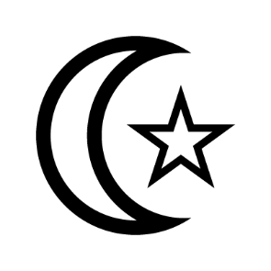  Star and crescent | 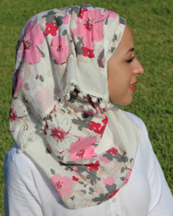  The hijab  (like a head scarf) | 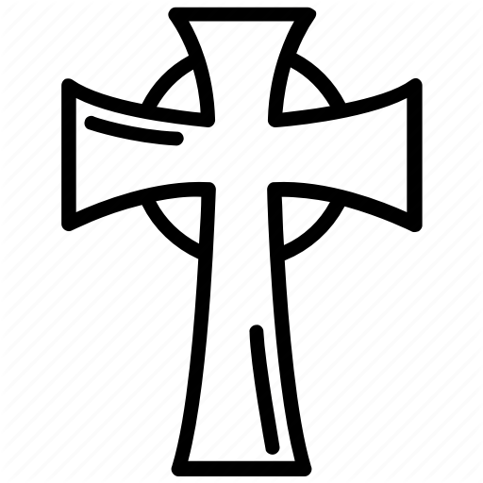  The cross | 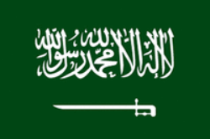  Saudi Arabia flag  Green for good health  White for faith
Christian fish | 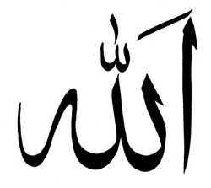  Allah in Arabic | 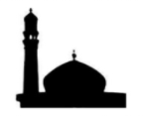  Islamic architecture | 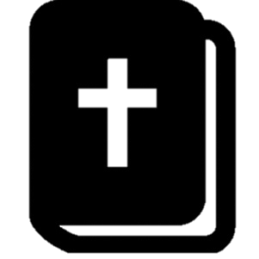  The Bible

