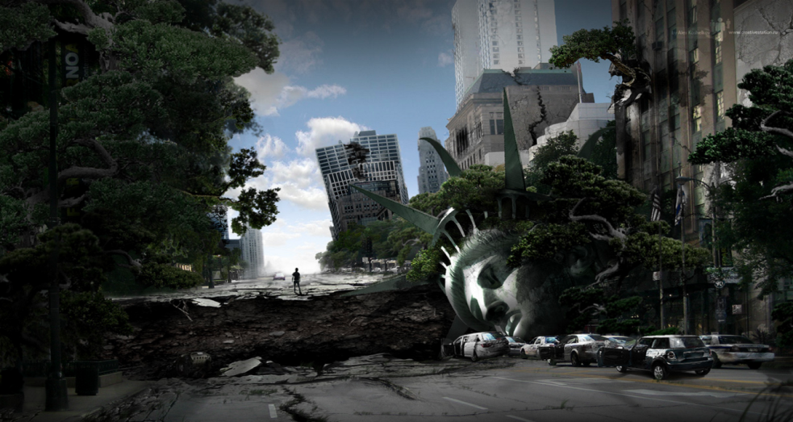
“New York is falling!” The words rang in Jim’s head. They were he last words to crackle out of the radio before it stopped broadcasting. That had been three days ago. Jim had not heard any words since then. It had been three days since Jim had left the building after the last broadcast, since he had been stuck in his apartment for three days he had ran out of supplies for simple survival. Jim made his way safely making sure he doesn’t fall in any holes or bang into anything, to what used to be a shop, which is now a neglected, abandoned, derelict building, thankfully the board around the back of the building has fallen off the window so he can smash through the window. Jim franticly jogged behind the dilapidated building and smashed through the window, there was no alarm, no people crowding around the coffee isle there was nothing not even an alarm all there was only food, toys, clothes and some drinks, of course that wasn’t going to last Jim his whole life but it was better than nothing. Out of nowhere was a loud crash; was there another building collapsing? Was there another earthquake? Or did another person survive the earthquake? Jim was highly confused he had thought that he was the only person left alive although, there is a chance that he could be wrong since he had not left his apartment for three days so there is a slight possibility that another has lived, although it was a big earthquake, so it would be hard. Jim walked through the isle franticly, he had only seen things like this in movies and they didn’t seem scary but now, Jim’s heart was pounding in fear and curiosity it almost sounded like you could hear his breathing from a mile away but of course that was only to Jim, he stopped at the isle next to the one where he heard the crash (isle 15 pasta and sauces). Jim looked around the corner hesitantly; around the corner was a female, around twenty-one-ish? Close to Jims’ age. It seemed that she was grabbing some oil? There was a moment of silence for about a minute or so before she walked up to him somehow knowing he was there. “This level is hard.” She spoke in a gentle, soothing voice. “What do you mean?” Jim spoke confused. “This is virtual reality?” She said again confused on what Jim meant. “Wait, what’s the date?” Jim asked worryingly. “2056, why do you ask?” The girl asked. “I thought it was real life, I started playing in 2028…!” Jim exclaimed. “What do you mean? This has to be a joke!” The female shouted worryingly. “I thought I took it off and went to sleep, and when I woke up it was like this. I guess time goes fast in virtual reality…” Jim mumbled.

