Maths Plan
Year 4 Monday 11th May 2020
- Remember any work you want to show me or to ask any questions- email to year4@becket.n-somerset.sch.uk
- Please continue to recap telling the time.
Rapid Recap
https://www.youtube.com/watch?v=cYJqbwykcJk
Recapping from a couple of weeks ago, I have attached the video that shows you how to find fractions of amounts if it has escaped your memory. Watch from 3 minutes onwards for non-unit fractions.
Finding fractions of amounts with non-unit fractions (numerator is a number other than 1)
1. Find $\frac{4}{8}$ of 56 3. Find $\frac{3}{4}$ of 48
2. Find $\frac{3}{5}$ of 60 4. Find $\frac{3}{6}$ of 54
Main learning:
We are continuing our learning of money this week. We are going to round money to nearest pound and estimate amounts, and using the operations addition and subtraction with money amounts.
First, we are going to round money amounts to the nearest whole pound. We have already learnt how to round numbers to the nearest 10, 100 and 1000, so we can use that knowledge to help us with this knowledge.
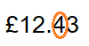When we want round an amount to the nearest pound, we look at the 10p column (it’s called the tenths column).
If the 10p column (tenths column) is a weak number (1, 2, 3, 4 or 0) we round down. If the 10p column (tenths column) is a strong number (5, 6, 7, 8, 9) then round up to the next pound.
So, my amount that I am going to round the nearest whole pound is £12.43 I will either round to £12.00 or £13.00. As my tenths column is 4 (it is a weak number), I round down to £12.00 as it is closer to £12.00 than it is £13.00.
1. Round these amounts to the nearest whole pound.
a. £2.20 b. £7.43 c. £13.84 d. £33.78 e. £42.09 f. £76.56 g. £48.19
2. 3.

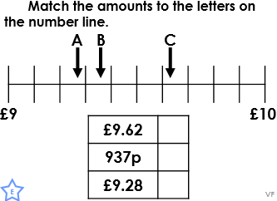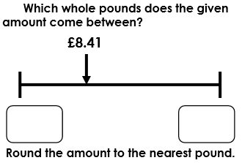

4.

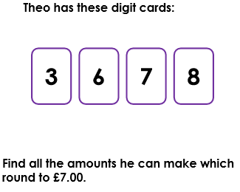
Extra daily challenge:
You can only use the number cards once per amount.

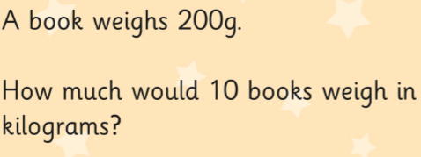

Maths Plan
Year 4 Tuesday 12th May 2020

Rapid Recap
Spend 5-10 minutes recapping telling the time using the analogue and digital time.
Main learning
We are going to use our learning from yesterday to help us estimate how much something might cost. Estimate means: a sensible guess/prediction. We estimate amounts all the time. I’m sure your parents, aunts, uncles, grandparents do it all the time when they are out shopping too-working out how much everything will cost.
Use your rounding learning to round these amounts to then estimate how much the items will cost.
1.
2.

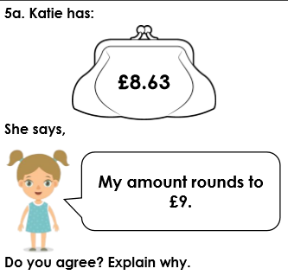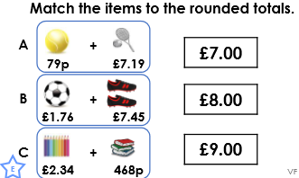
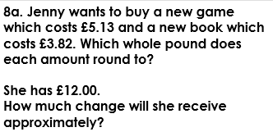3.

4.

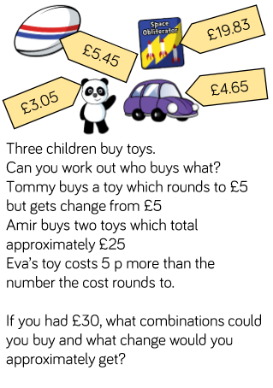5.

Extra Challenge:

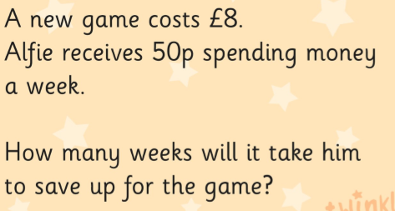

Maths Plan
Year 4 Wednesday 13th May 2020
Rapid Recap

Practise counting up and down in 100s, 50s and 25s. Get an adult to time you for two minutes. How far can you get counting up? Start from 5000, how far down can you get in two minutes?

Main Learning

Today, we are learning how to add exact amounts to find the exact answer. Using the column method, add up these amounts of money. We have done this in year 3. Remember it’s exactly the same as adding with normal, non decimal numbers, but you just have a decimal. Start with the 1p column (it’s called the hundredths column).
E.g.
£4.56 +
£5.65
10.21
1 1

1. =£3.34 + £2.25 2. £2.76 + £3.13= 3. £4.57 + £3.55= 4. =£6.66 + £7.09

5. £13.64 + £15.45= 6. =£23.56 + £55.45 7. £76.34 + £22.49= 8. £103.64 + £45.88=

To make it easier when adding more than two numbers/amounts, by doing it in steps. Try adding two amounts first and then adding the other amount to the total of the first amounts.
9. £13.76 + £12.33 +£20.50= 10. =£21.09 + £41.77 +£44.18

If you have a calculator, use that to check your answers.

11. Lisa goes to the shop and buys a jumper for £5.99, a pair of trainers for £24.50 and a watch for £12.30. How much did she spend altogether?

12. Make up your own word problem that involves adding money and work out the answer.

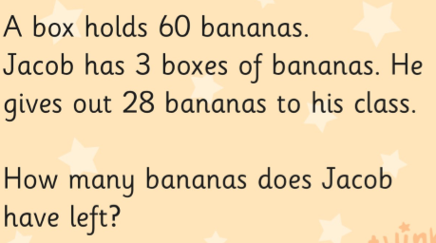Extra Challenge

Maths Plan
Year 4 Thursday 14th May 2020

Rapid Recap
1. How many cm in a m? 100 2. How many mm in a cm? 10 3. How many m in a km? 1000 4. How many ml in a l? 1000 5. How many g in a kg? 1000 6. What is 300cm in m? 3m 7. What is 12km in m? 12,000m 8. What is 150mm in cm? 15cm 9. How many cm is 40m? 4000cm

Main learning
Today, we are focussing on subtracting amounts to find the exact answer. We subtract money when we want to find the change or to find the difference between money (maybe to see who has more money between two people).
Again, using the column method, work out these amounts.
1. £12.66 - £2.32= 2. =£15.37 - £ 4.28 3. £34.56- 23.01= 4. £45.88 - £38.77=
5. £65.34-£33.87= 6. = £54.66 - £25.39 7. =£10.00- £5.76 8. £20.00 - £17.66=
9. £50.00- 35.67=
Again, when subtracting more than one number/amount, do it in steps to make it easier.
10. =£56.98- 12.43 – 22.78 11. £60.00 - £27.46 - £24.79=

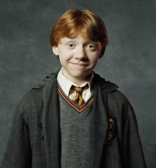
11. Harry has £84.63. He spends £27.42 on a new broom for Ron. How much does he have left?
12. Ron has £57.24. He spends £38.93 on a new cage for his rat. How much does he have left?
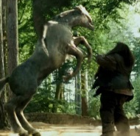
13. Hermione has a £50 note. She spends £42.67 on a new cauldron for her potions class. How much change does she get?
14. Hagrid has £75.60. Dumbledore has £54.50. How much more does Hagrid have compared to Dumbledore?

Extra Challenge

Maths Plan
Year 4 Friday 15th May 2020

Rapid Recap
1. How many seconds in a minute? 2. How many minutes in an hour? 3. How many hours in a day? 4. How many days in a year (non leap year)? 5. How many days in a leap year (like this year 2020)? 6. How many weeks in a year? 7. How many months in a year? 8. How many days in a week?

- Spend today’s session playing money games on Topmarks and TT rockstars
https://www.topmarks.co.uk/maths-games/7-11-years/money
Some a quite easy, so make sure you try the games ‘The change game’ and ‘Gong shopping problem solving’ for a bit more of a challenge.

- You could also set up your own shop at home and family members need to come and buy things from your shop. You will need to price up the items and then work out the change from the money they give you (no calculators allowed though).

