Maths Plan
Year 3 Monday 11th May 2020

- 52 + 67 = 119
- 251 + 77 = 328
- 378 + 48 = 426
- 154 - 65 = 89
- 231 – 46 = 185
- 689 - 45 = 644
- 2 X 8 = 16
- 9 X 0 = 0
- 10 X 4 = 40
Extra Challenge
3X50= 150
4X30= 120
50X80= 4000
70X10= 700
90X3= 270

Maths Plan
Year 3 Tuesday 12th May 2020

- 46 +7 = 32 + _21

- 756 - 42 = 714

- 3 X 8 =_28 - 4

- 45 + 19 =_34 + 30

- thirty two more than eighty three = 115

- twenty four less than seventy eight = 54

- Put the following numbers in order from smallest to largest.
2431 2317 2471 2371 2417
Answer
2317 2371 2417 2431 2471

Maths Plan
Year 3 Wednesday 13th May 2020

- 5p x 4 = 20p
- 2p x 6 = 12p
- 1p x 20 = 20p
- 50p x 2 = £1 (100p)
- 10p x 5 = 50p
- 10p + 5p + 2p + 1p = 18p
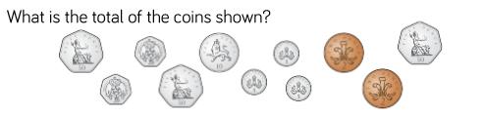
£2.19

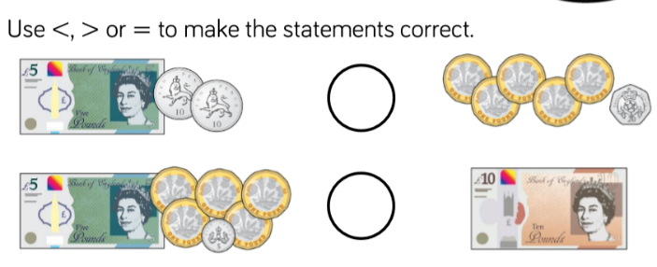
=
>

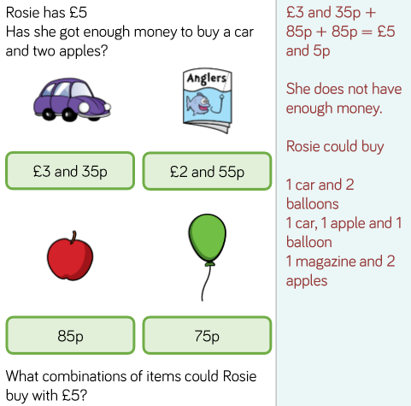

Extra challenge:
Sometimes when I am paying for something that costs £6 I pay with a £10 and a £1 coin. Why might I do this?
This gives £5 change, which may save the shopkeeper from having to find change using coins

Maths Plan
Year 3 Thursday 14th May 2020

Rapid Recap
- 12p = 2p + 10p
- 2p + 5p + 5p = 12p
- 20p = 10p + 10p
- 50p + 10p = 60p
- 10p + 5p = 15p
- 50p = 20p + 20p + 10p
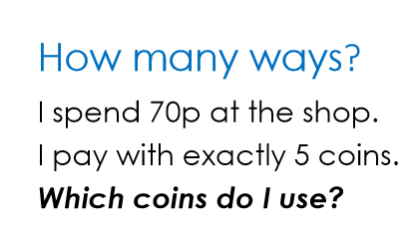
Three possible answers:
50p and four 5ps
three 20ps and two 5ps
two 20ps and three 10ps
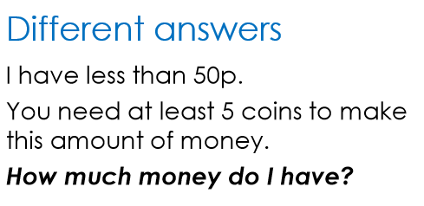
Four possible answers:
38p, 39p, 48p, 49p

Extra Challenge
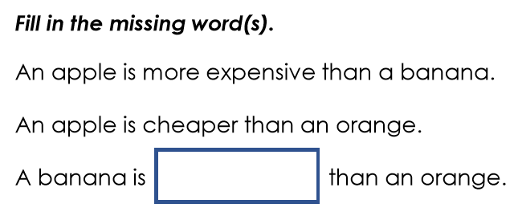

cheaper than

Maths Plan
Year 3 Friday 15th May 2020

Rapid Recap
- 4 x 3 = 12
- 5 x 8 = 40
- 3 x 9 = 27
- 12 ÷ 4 = 3
- 18 ÷ 3 = 6
- 45 ÷ 5 = 9

https://www.topmarks.co.uk/money/toy-shop-money
You can set this game to the level you are confident with to start with and then make it a little bit more challenging by changing the types of coins you use and the amounts.
Challenge
Use mixed coins and have a go at giving change.

