Monday 18th May
Rapid Recap

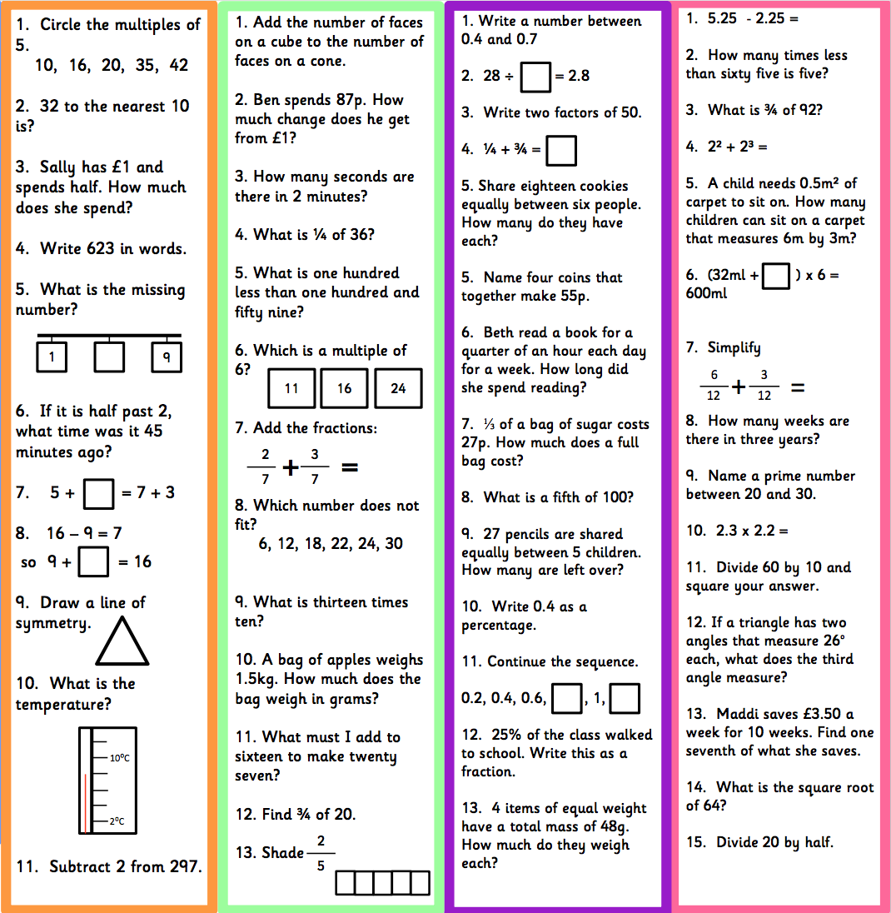

Finding Fractions of amounts – These links demonstrate the method and may help with your home learning or see Mr Francis demonstrate on the Year 5 page.

https://www.youtube.com/watch?v=TXJOIs7vXMs

https://www.bbc.co.uk/bitesize/topics/zsxhfg8/articles/z33csrd

To find the fractions of an amount you must first divide by the denominator and then multiply by the numerator. | 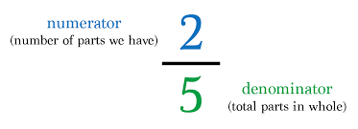
I do demo: 1/5 of 45  You do:  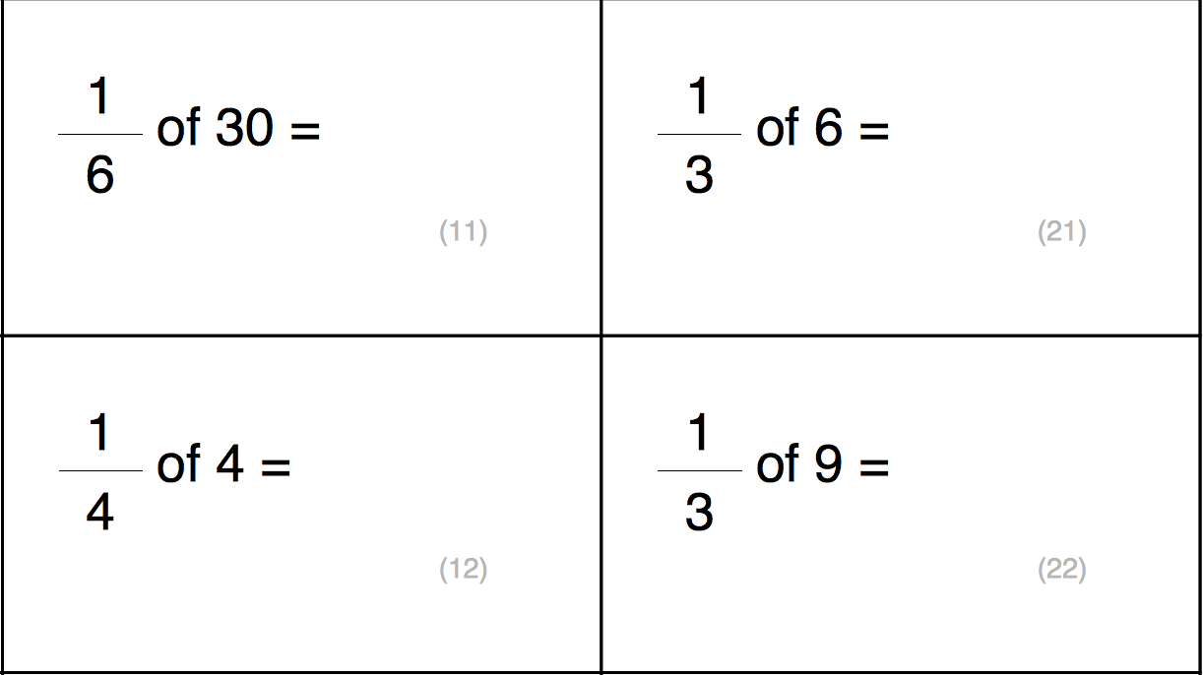 |  | I do demo: 3/8 of 56  You do:  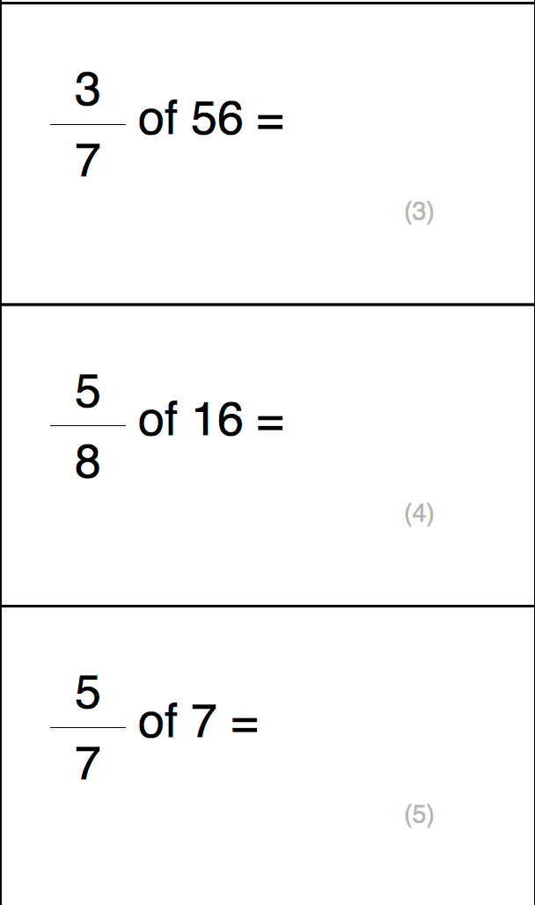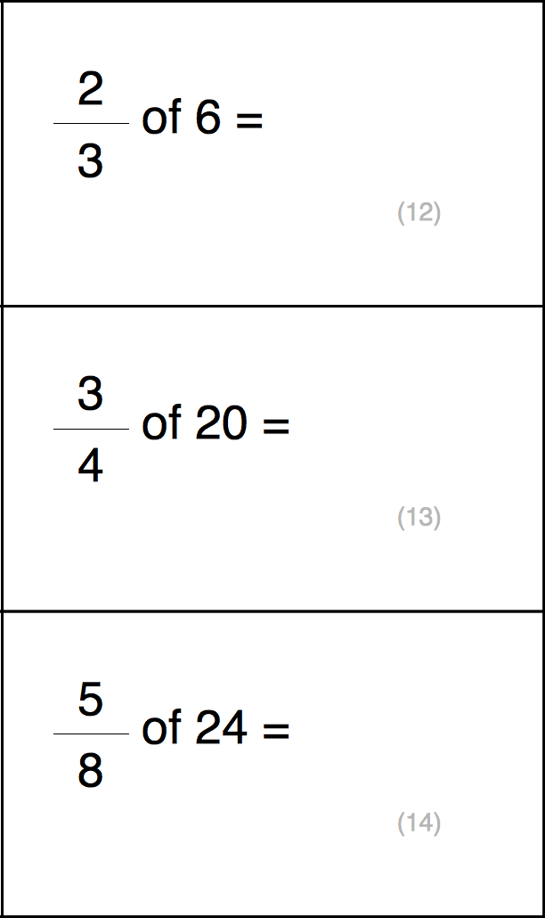
I do demo:
Sarah entered a 100-word story competition. She wrote her story over two evenings. On the 1st evening, she wrote 6/10 and on the second evening she wrote the rest.
- How many words did she write on the first evening?
- How many words did she write on the second evening and what fraction was this?
You do:
- Jane watched a film that was 1 hour long. 5/6 of the way through the film, the doorbell rang. She paused the film to answer the door and it was the postman with a parcel.
  - How many minutes of the film had she watched before the postman arrived?
  - How many minutes of the film did she have left to watch?
- There were 128 school children going on a school residential trip. There were 2 coaches, each carrying 1⁄2 of the children. On coach B, 3/8 of the children had medication with them.
  - How many children were on each coach?
  - How many children had medication on coach B?
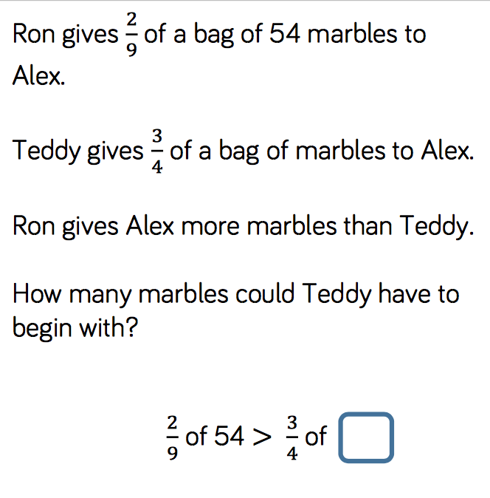 |  | 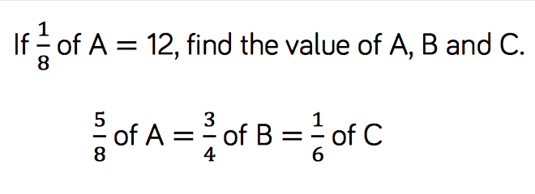
 |  | 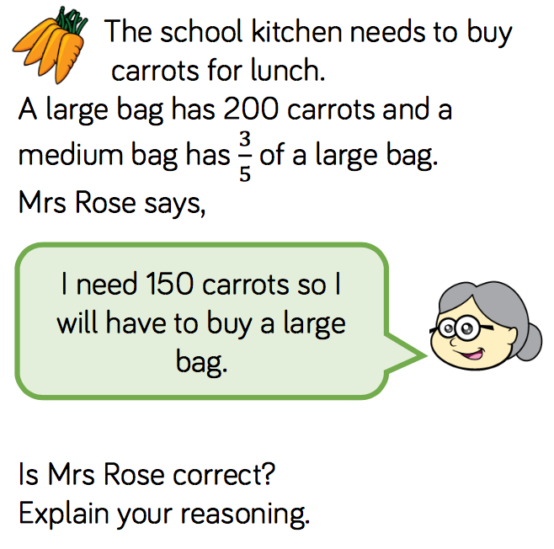

Tuesday 19th May
Rapid Recap

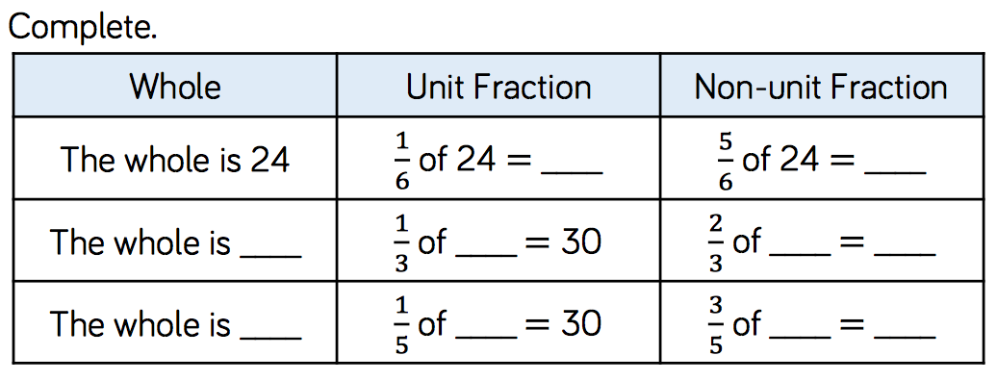
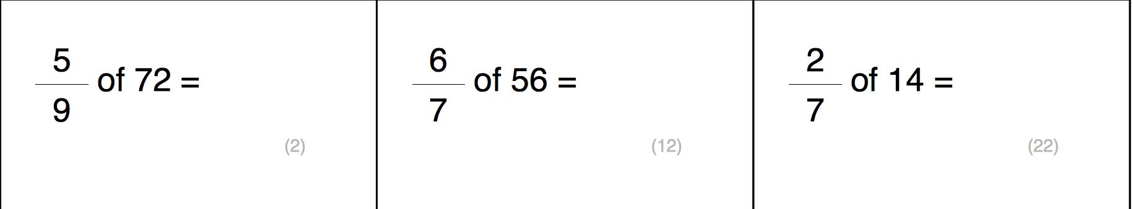
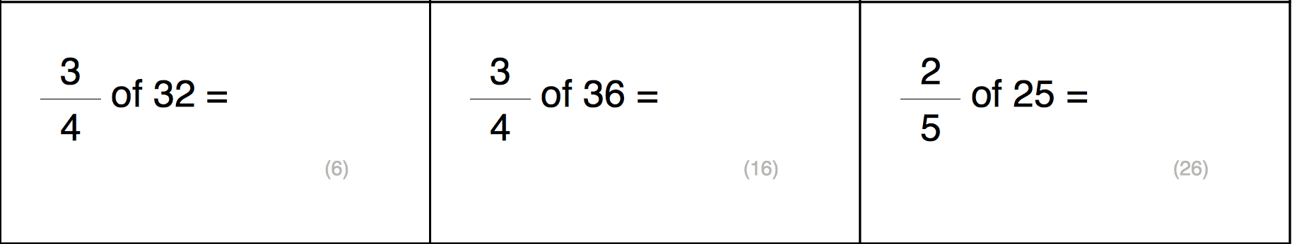

At the county running championships, a school won 12 medals. 1⁄2 of the medals were gold, 1⁄3 of the medals were silver and 1/6 of the medals were bronze.
a. How many medals were gold?
b. How many medals were silver?
c. How many medals were bronze?

Subtract Fractions – These links demonstrate the method and may help with your home learning or see Mr Francis demonstrate on the Year 5 page.

https://www.bbc.co.uk/bitesize/topics/zhdwxnb/articles/z9n4k7h

https://www.youtube.com/watch?v=5juto2ze8Lg

To add or subtract fractions, you must first find a common denominator. You must remember that if you multiply or divide the denominator, you must do the same to the numerator. |  | 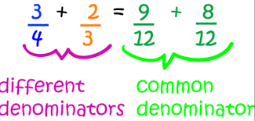
I do demo: ¾ - 5/12  You do:  5/12 – 1/3 9/15 – 1/5  6/8 – 2/4 12/20 – 1/2 |  |  | I do demo: 6/8 – 5/9  You do:  3/4 - 2/6 5/7 – 2/5  1/3 – 4/13 2/6 – 1/4
I do demo:
Anna has to read two books for school. She reads 5/6 of the first book on
Monday and 22/24 of the second book on Tuesday.
How much more does she read on Tuesday?
You do (1 denominator to change):
1. Mia filled 2/3 of her bucket with sand and Jessica filled 10/12 of her bucket with sand.
How much more sand was in Jessica’s bucket?
2. Lilly drove 6/7 of a mile in the morning and 15/21 of a mile in the evening.
How much further did she drive in the morning?
3. Henry eats 3/4 of a chocolate bar and Lisa eats 18/20 of her chocolate bar.
How much more does Lisa eat?
You do (2 denominators to change)
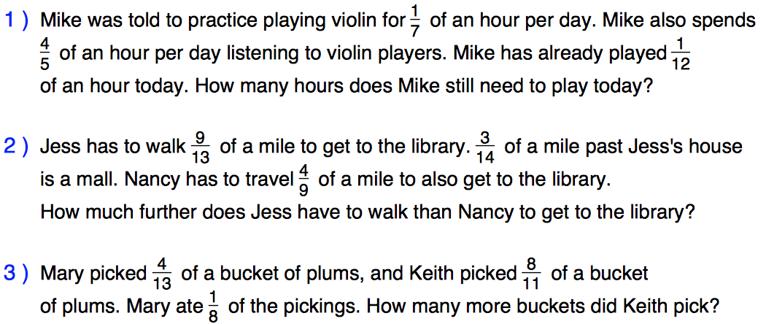

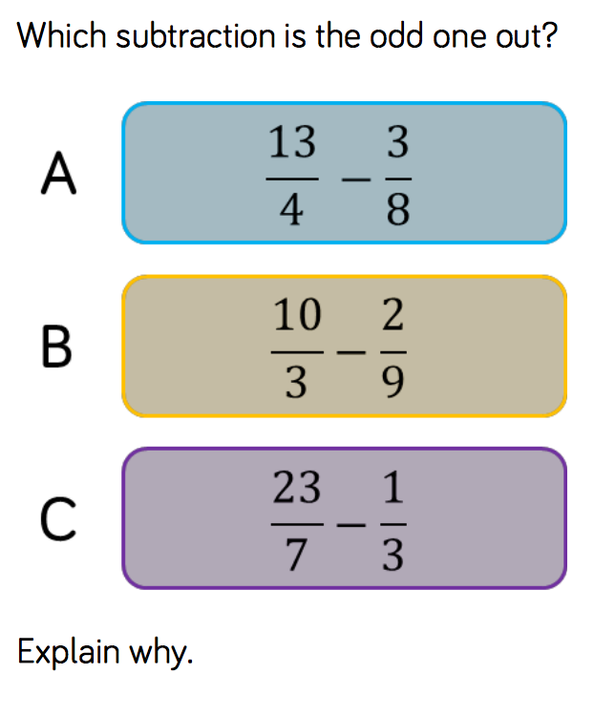 |  |  | 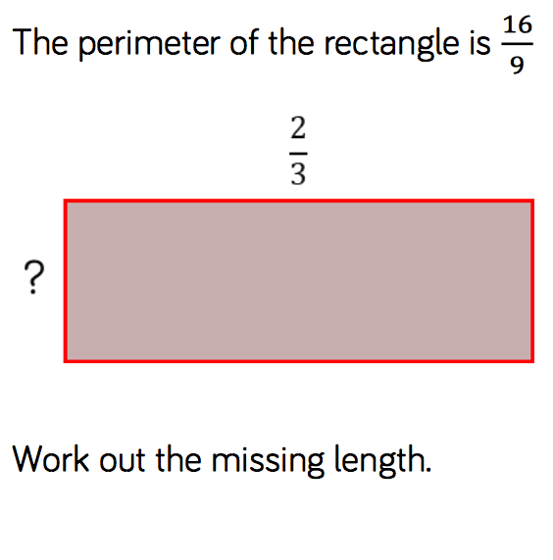

Wednesday 20th
Rapid Recap

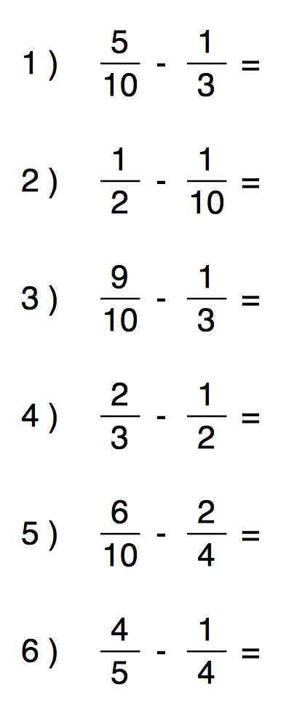 | 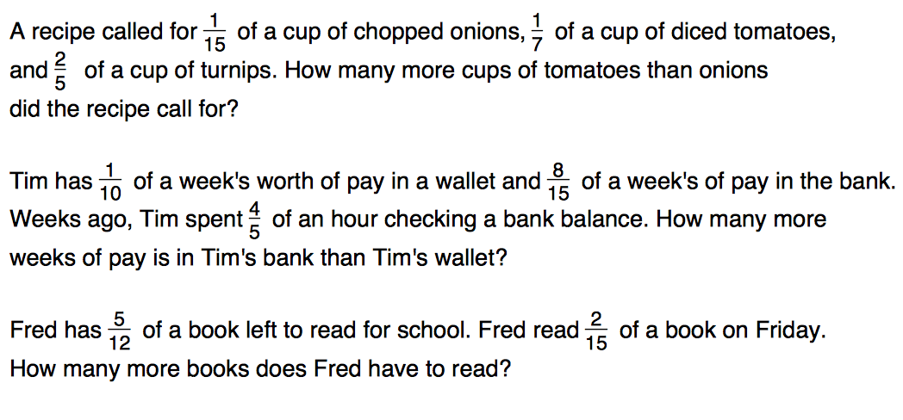

Subtract mixed numbers - These links demonstrate the method and may help with your home learning or see Mr Francis demonstrate on the Year 5 page

https://www.youtube.com/watch?v=RqUPSZLwHH0

To add or subtract fractions, you must first find a common denominator. You must remember that if you multiply or divide the denominator, you must do the same to the numerator. |  | 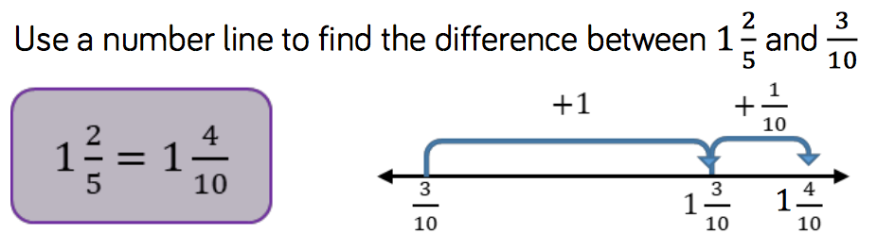
I do demo: 3 _{5/6 – 1/12}  You do:  5 _{5/7 – 3/14} 2 _{7/9 – 11/18}  3 4_{/5 – 4/10} 12 _{16/21 – 2/7} |  |  | I do demo: 5 _{1/3 – 5/12}  You do:  1 _{2/3 – 5/6} 1 ¾ - _{7/8}  2 _{3/8 – 11/16} 5 _{4/12 – 2/3}
I do demo:
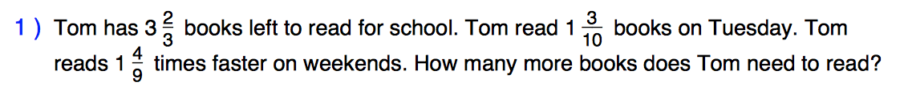
You do:
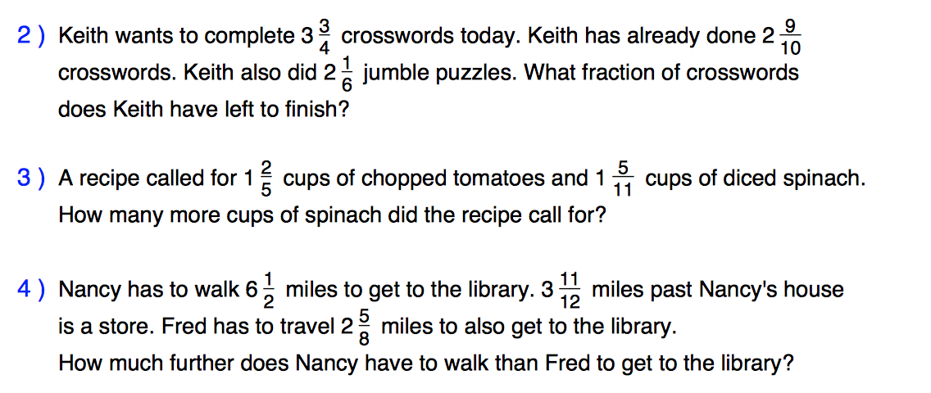
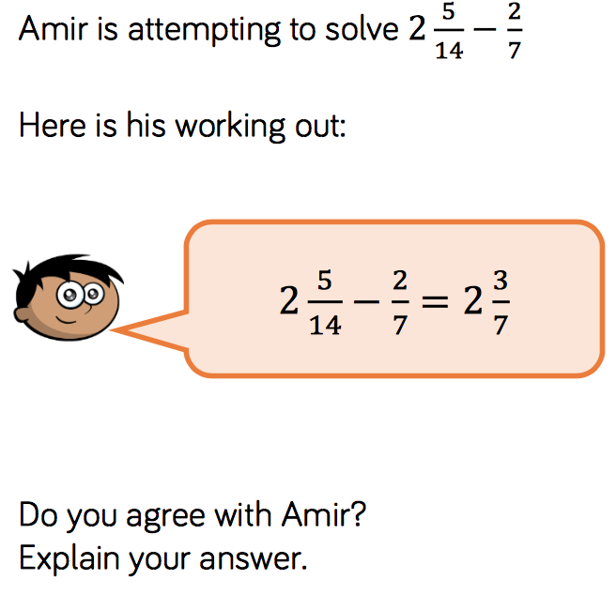 |  |  | 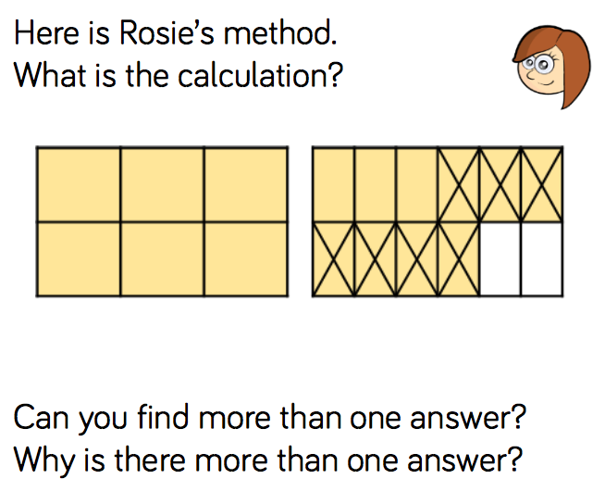

Thursday 21st May

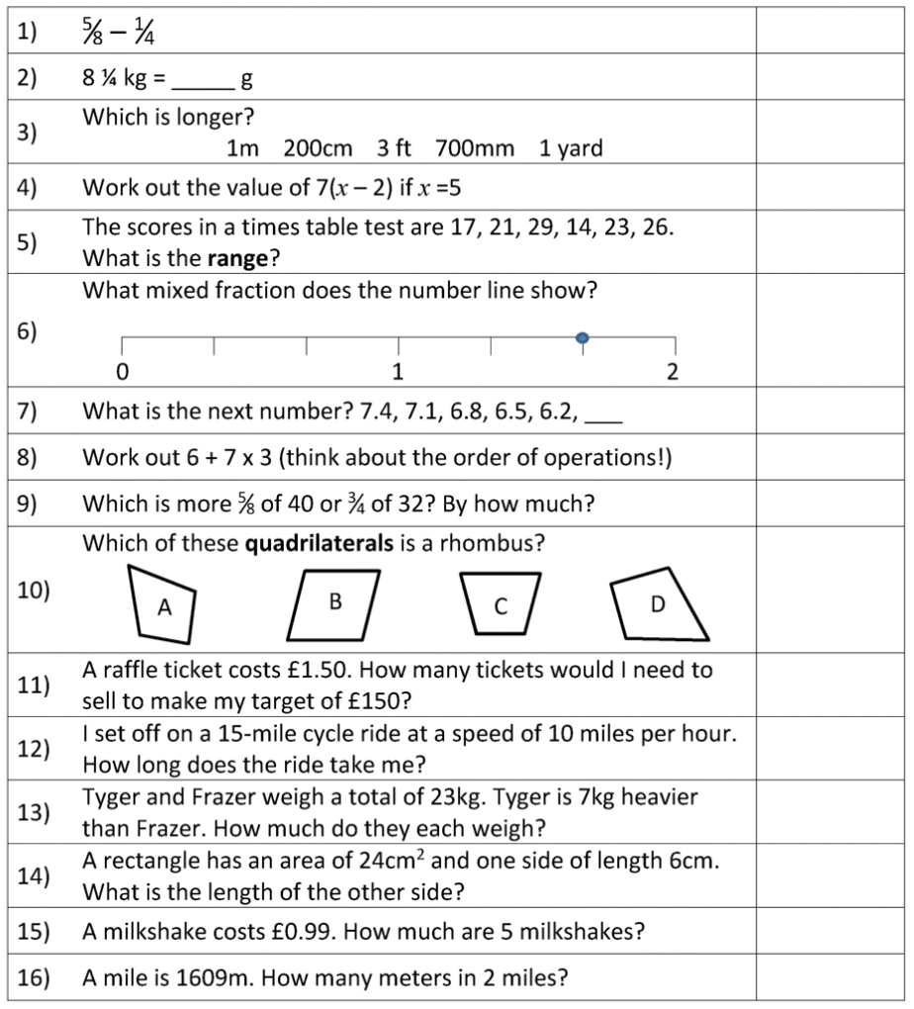

Friday 22nd May

Fraction of a Number Codebreaker
A | B | C | D | E | F | G | H | I | J | K | L | M
12 | 3 | 48 | 6 | 8 | 14 | 24 | 36 | 15 | 28 | 4 | 20 | 18
N | O | P | Q | R | S | T | U | V | W | X | Y | Z
7 | 16 | 2 | 17 | 21 | 30 | 40 | 60 | 10 | 5 | 9 | 13 | 23

Find the fractions of a number, link your answers to the table above to reveal what I said to the man who asked for a lift:
$\frac{1}{2}$ of 26 | $\frac{1}{4}$ of 64 | $\frac{1}{3}$ of 180 | $\frac{3}{4}$ of 16 | $\frac{3}{5}$ of 35 | $\frac{2}{3}$ of 12 | $\frac{2}{7}$ of 42 | $\frac{5}{6}$ of 12
$\frac{1}{7}$ of 56 | $\frac{3}{10}$ of 70 | $\frac{1}{3}$ of 39 | $\frac{8}{11}$ of 55 | $\frac{2}{5}$ of 30 | $\frac{4}{7}$ of 35 | $\frac{2}{7}$ of 28 | $\frac{1}{6}$ of 42
$\frac{8}{15}$ of 75 | $\frac{2}{5}$ of 20 | $\frac{3}{8}$ of 16 | $\frac{1}{9}$ of 27 | $\frac{4}{9}$ of 45 | $\frac{4}{5}$ of 20 | $\frac{2}{11}$ of 22 | $\frac{4}{17}$ of 34

Play TTRockstars – 30 minutes

