Year 3 STONE AGE Knowledge Organiser
Essential Vocabulary  Stone Age – period of human history from 2,000,000 to 2,500 BC  Paleolithic – First period 2,000,000 to 10,000 BCE  Mesolithic – Second period 10,000 to 4, 500 BCE  Neolithic – Third period 4,500 to 2,400 BCE  Historian – a person who researches history  Archaeologist – a person who finds out about the past by finding evidence in the ground.  Early Man/ Neanderthals – early humans  Hunting, Gathering and Foraging – methods of finding food before the start of farming.  Nomadic – people who move around from one place to another – following the seasons to find food.  Tools - tools, such as axes, spears and scrapers were made from stone, wood and bone by early humans.  Flint Knapping – the hitting of stone upon stone to chip bits off to shape the stone into useful shapes  Cave/tent/Roundhouse - the types of homes used in the different periods of the Stone Age  Culture, art and religion – these started in the Stone Age and are signs of the beginning of human societies and civilisations, these are very important to humans today.  Megalith – structure made from huge stones – usually round. Stonehenge in Wiltshire is the remains of a megalith.  Midden – a pile of discarded items such as bones and broken pots – these items can tell archaeologists a lot about the humans who lived there long ago.  Farming – the biggest change in human history – humans learnt how to plant seeds to grow crops so they could grow their own food,  Settlements – once humans learnt how to farm they did not need to move and needed to stay in one place so they could store their grain and seeds for next year. Skara Brae in Scotland is an example of an early settlement. | 1: Palaeolithic (700,000 BCE -10,000 BCE)  There was an ice age during the Stone age and one third of the earth was covered in ice. Archaeologist have discovered that Early humans (Neanderthals and early Homo sapiens) lived at the same time, but Neanderthals became extinct 30,000 years ago.  Early humans arrived in Britain 800,000 years ago. They lived in caves and were nomadic hunter gatherers who moved around seasonally to find food, some hunted animals while others would forage for nuts, berries and shellfish.  They created cave paintings – the Lascaux Caves are famous for hunting scenes and the Cave of Hands for handprints. They developed tools from stone, bone and wood, such as spears and axes, to help with hunting and daily life. Stone tools were made by flint napping stone to make an edge or sharp point.  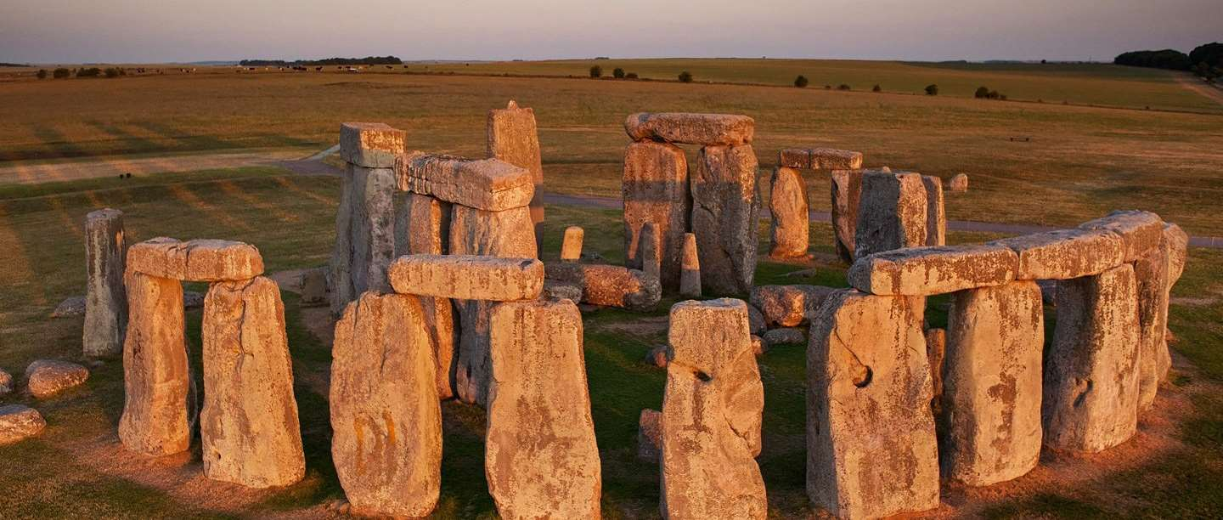 | 2: Mesolithic (10,000 BCE – 4,500 BCE)  During the Mesolithic era, Stone Age people were still nomadic but are thought to have lived in tents made with wood or animal bones and animal skins with a layer of moss, reeds and other soft plant materials for the floor. Fossilised remains of Mesolithic footprints can be seen on the coast of Howick in Northumberland.  3: Neolithic (4,500 BCE– 2,400 BCE)  Farming and the creation of organised settlements was the biggest change in human history. Stone Age people began to settle in villages.  There is evidence of settlements, such as the one at Skara Brae, often made up of simple roundhouses built from stone. They were built into mounds of rubbish known as midden (small stones, shells, mud and animal bones), which would provide stability and insulation. These houses had beds, storage shelves and a fireplace in the middle.  Religion and Trade continued to develop and large round megaliths, like Stonehenge, were built!  https://www.theschoolrun.com/homework-help/the-stone-age

