Maths Week 4 – Year 1
This week’s learning is from Summer Term – Week 2 (w/c 27th April) on https://whiterosemaths.com/homelearning/year-1/

Monday 11th May 2020 - Rapid Recap
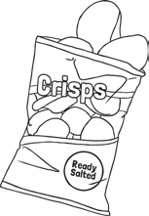
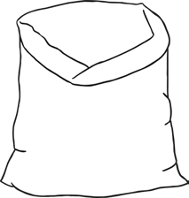
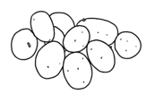
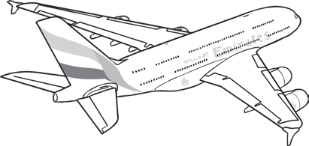
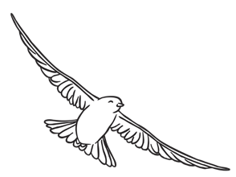
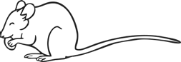
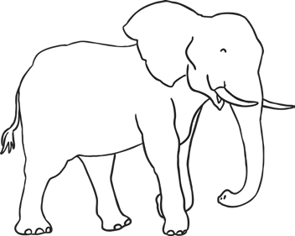
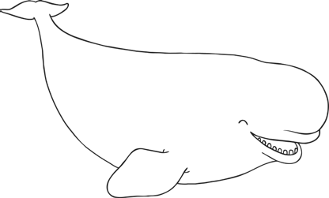
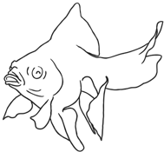
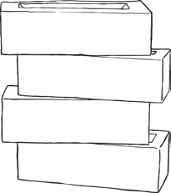
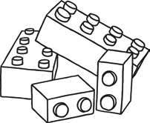
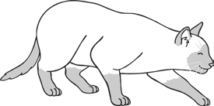
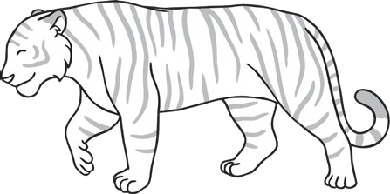
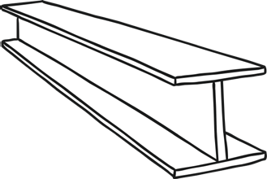
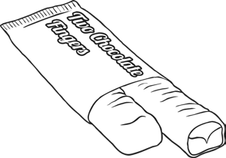
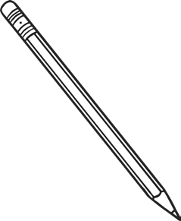
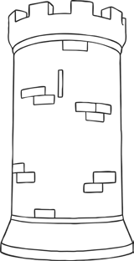
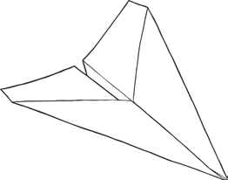
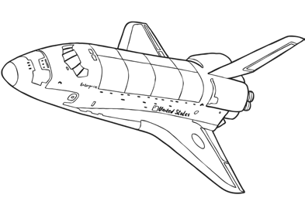
Tick the object that is heaviest

Find a half (2)
Answers for Get the Activity
https://wrm-13b48.kxcdn.com/wp-content/uploads/2020/homelearning/year-1/Lesson-5-Y1-Summer-Block-2-ANS2-Find-a-half-2-2020.pdf

Challenge
Rob says half of 20 is 10, and half of 10 is 5. Is he right? Explain your answer to an adult. Can you use objects to help you explain your thinking?

Rob is correct as half means splitting an object or group into 2 equal groups, 20 divided by 2 is 10 and 10 divided by 2 is 5.

Extension (optional)
If you have been successful, try these activities (Twinkl login and password required):
https://www.twinkl.co.uk/resource/year-1-diving-into-mastery-find-a-half-2-activity-cards-t-m-31862

Tuesday 12th May 2020

Rapid Recap
Which direction does the scales tip for an object that is light, heavy or balanced? Write it them onto the scales below.

heavy
light
light
heavy
balanced
balanced
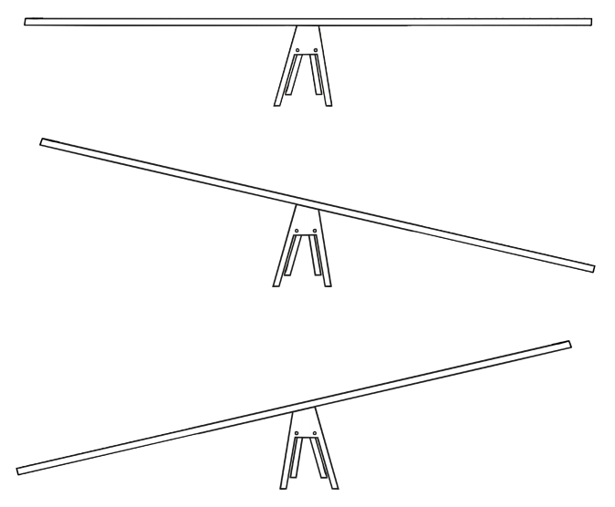
Find a quarter (1)
Answers for Get the Activity
https://wrm-13b48.kxcdn.com/wp-content/uploads/2020/homelearning/year-1/Lesson-2-Y1-Summer-Block-2-ANS3-Find-a-quarter-1-2020.pdf

Challenge
Zoe says that finding a quarter means splitting something into 4 equal parts. Is she right? Explain your answer to an adult. Can you use objects to help you explain your thinking?

Zoe is correct, quarters are 4 equal parts. For example, 24 divided into 4 equal parts is 6.

Extension (optional)
If you have been successful, try these activities (Espresso login and password required):
Watch the video
https://central.espresso.co.uk/espresso/primary_uk/subject/module/video/item883169/grade1/module883167/index.html
Now complete the activity
https://central.espresso.co.uk/espresso/primary_uk/subject/module/activity/item885879/grade1/module883167/index.html

Wednesday 13th May 2020

Rapid Recap
Can you draw a line on each container to show the water level at the correct volume?

half full nearly full nearly empty full

Find a quarter (2)
Answers for Get the Activity
https://wrm-13b48.kxcdn.com/wp-content/uploads/2020/homelearning/year-1/Lesson-3-Y1-Summer-Block-2-ANS4-Find-a-quarter-2-2020.pdf

Challenge
Look around your home for objects that are the same (like counters). Can you put them into quarters? How many different objects can you put into quarters?

Extension (optional)
If you have been successful, try these activities (Espresso login and password required):

Watch the video
https://central.espresso.co.uk/espresso/primary_uk/subject/module/video/item883347/grade1/module883167/index.html

Now complete the activity
https://central.espresso.co.uk/espresso/primary_uk/subject/module/activity/item903522/grade1/module883167/index.html

Thursday 14th May 2020

Rapid Recap
Which container has the smallest capacity? Circle one.
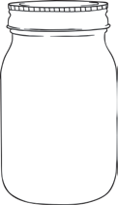

Which container has the greatest capacity? Circle one.
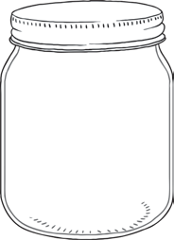
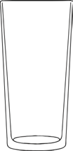

Which container has the greatest capacity? Circle one.
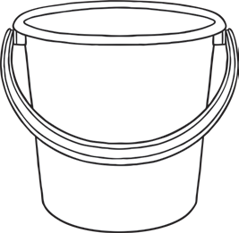
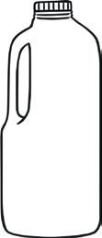
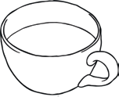

Which container has the smallest capacity? Circle one.
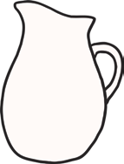
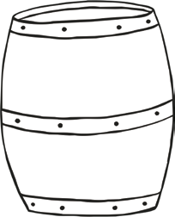
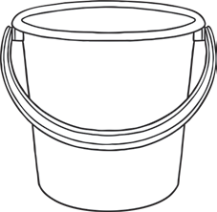

Problem Solving
Answers for Get the Activity
https://wrm-13b48.kxcdn.com/wp-content/uploads/2020/homelearning/year-1/Lesson-4-Answers-Problem-Solving.pdf

Challenge
Solve these word problems using 20 objects and explain your thinking to an adult. You could use scales, containers, and objects to help you.

For example:
- How do you find a quarter of 20? 20 divided by 4
- If 20 objects completely fill a container, what will happen if there are 10 objects? 10 = Half full
- If there are 16 objects on one side of a set of scales, how many would be on the other side? Can you explain to an adult how the scales would tip and why? 4 on the other side which would tip up.

Extension (optional)
If you have been successful, try these activities (Espresso login and password required):
https://central.espresso.co.uk/espresso/modules/m1_problem_solving/activities/act_sunitas_sandwiches_2.html

Friday 15th May 2020

Rapid Recap
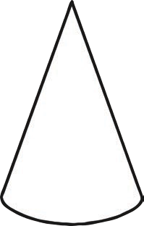
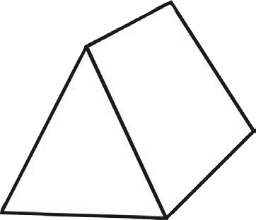
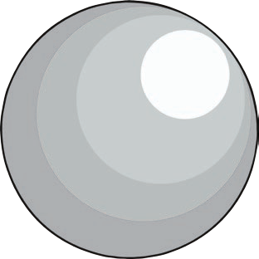
Write the name of the 3D shapes beneath each picture.

Sphere Triangular Prism Cone

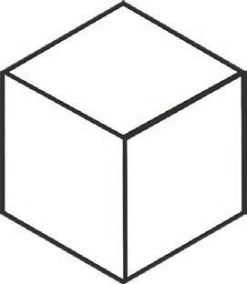
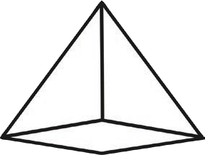
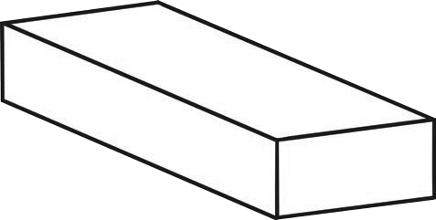

Cuboid Pyramid Cube

Cylinder
Cube Cylinder
Cuboid Cone
Pyramid Triangular prism
Sphere
Friday Maths Challenge
https://wrm-13b48.kxcdn.com/wp-content/uploads/2020/05/Answers-Week-2.pdf

The most suitable questions for Year 1 are 1 & 2 but why don’t you work with your family on the rest of the problems. Do as many as you can! Help each other out.

