Maths Plan
Year 3 Monday 27th April 2020

- 42 + 56 =
- 354 + 87 =
- 367 + 89 =
- 93 - 57 =
- 86 - 39 =
- 676 - 49 =
- 2 X 9 =
- 5 X 0 =
- 10 X 7 =
Extra Challenge
3X30=
4X70=
40X60=
30X90=
70X8=

Maths Plan
Year 3 Tuesday 28th April 2020

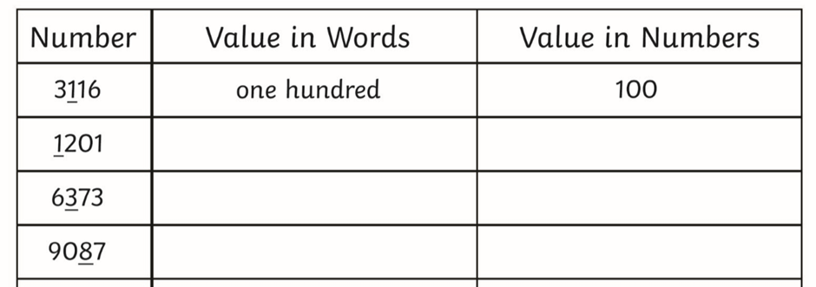
Order the numbers below from smallest to largest.
4353, 4352, 4354, 4361, 4349
_______, ________, _______, ________, ________.
1422, 1427, 1443, 1312, 1323
_______, ________, _______, ________, ________.
2445, 2345, 2371, 2454, 2317
_______, ________, _______, ________, ________.

Maths Plan
Year 3 Wednesday 29th April 2020

Fractions of amounts using non-unit fractions
Remember…the denominator of the fraction tells us how many equal parts the whole will be divided into. E.g. 1/3 means dividing the whole into 3 equal parts. The numerator tells you how many parts of the whole there are. E.g. 2/3 means dividing the whole into 3 equal parts, then counting the amount in 2 of these parts.
More help with this can be found here: https://www.youtube.com/watch?v=-FCj7ED8xxw. The video clearly describes how to find a fraction of an amount.
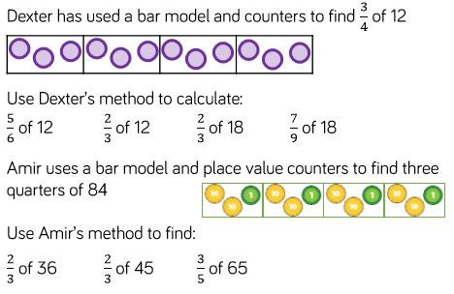

1.

2.

Maths Plan
Year 3 Thursday 30th April 2020

Can you find fractions of amounts?

Challenge 1
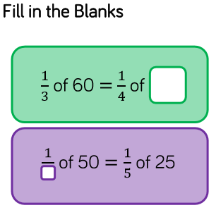

Challenge 2

Whitney has 12 chocolates.
On Friday, she ate ¼ of her chocolates and gave one to her mum.
On Saturday, she ate ½ of her remaining chocolates, and gave one to her brother.
On Sunday, she ate 1/3 of her remaining chocolates.
How many chocolates does Whitney have left?

Challenge 3
Ron has £28
On Friday, he spent 1/4 of his money.
On Saturday, he spent 2/3 of his remaining money and gave £2 to his sister.
On Sunday, he spent 1/5 of his remaining money.
How much money does Ron have left?
What fraction of his original amount is this?

Challenge 4
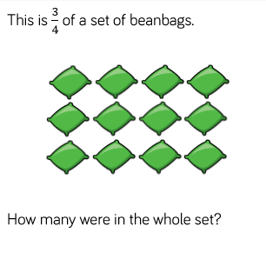

Maths Plan
Year 3 Friday 24th April 2020

Fractions of amounts game

Practise your knowledge of how to find fractions of amounts by using this game.

https://mathsframe.co.uk/en/resources/resource/264/Crystal-crash-fractions-numbers

If you found it tricky last week then choose from 1 - 5. You do not need to play them all.

Remember… finding a fraction of an amount is as simple as dividing.
For example, finding 1/5 of 35 is the same as 35 ÷ 5…

If you did well with the game last week then challenge yourself with games 6-9.
Remember….to find a non-unit fraction of an amount (where the numerator is more than 1) then first divide the amount by the denominator then multiply by the numerator.

If you want to find 3/7 of 42, then you divide 42 by 7 then multiply by 3.

42 ÷ 7 = 6 then 6 x 3 = 18 so 3/7 of 42 = 18

