Monday 20th April 2020
Rapid Recap
Match the numerals to the number written in words.
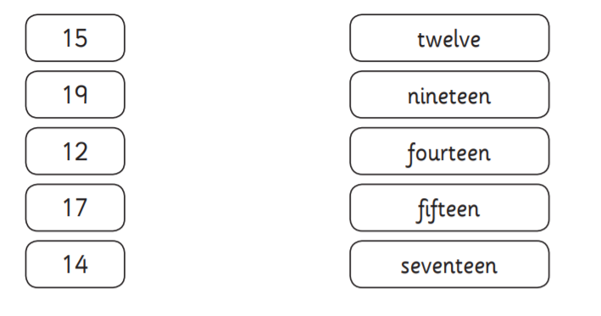

Remember we call them ones rather than units.
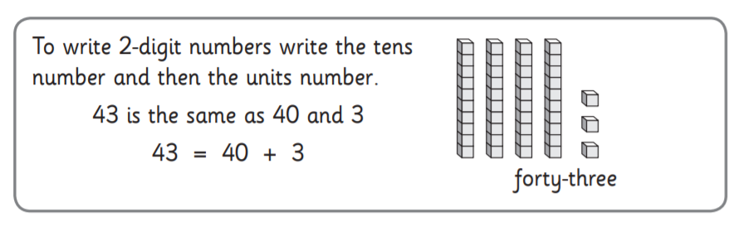

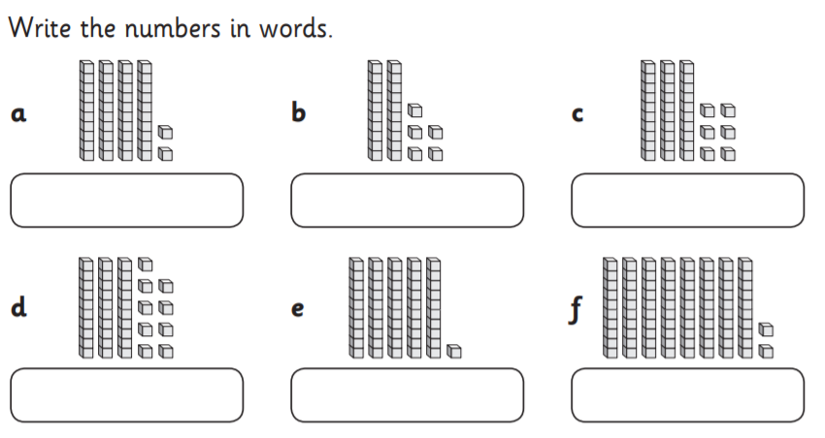

Fluency
I am going to describe some numbers and ask you to write down the number in digits.
- I am thinking of a number that has 5 tens and 2 ones. What is my number?
- My number has 6 ones and 3 tens. What is my number?
- My number has no ones and 5 tens. What is my number?
- My number has 8 tens and 7 ones. What is my number?
- My number has 1 hundred, no tens and 6 ones. What is my number?
Challenge
I am going to describe some numbers and ask you to write the number in digits and words. (Some of you may even wish to write an addition sentence. For example, if I am describing the number 25, your addition sentence would be 25= 20 + 5 or 25=5+20)

- I am thinking of a number that has 7 lots of tens and 5 lots of ones.
- My number has 9 lots of ones and 3 tens.
- My number has eight lots of tens and no ones.
- My number has one lot of ten and 6 ones.
- My number has 1 hundred, no tens and 3 ones.

Extension
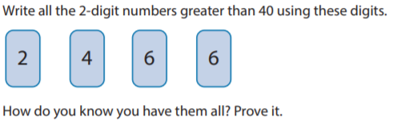

Tuesday 21st April 2020
Rapid Recap
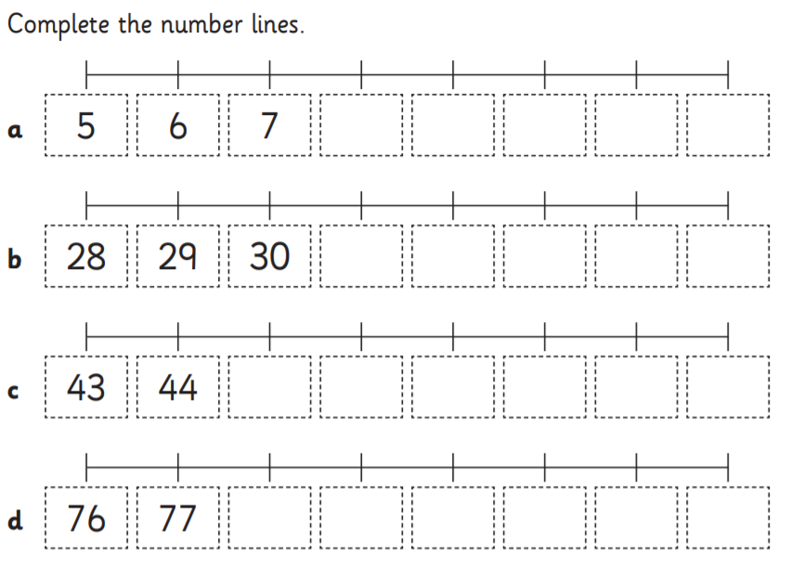

(If you can not print this, simply write the numbers on paper)
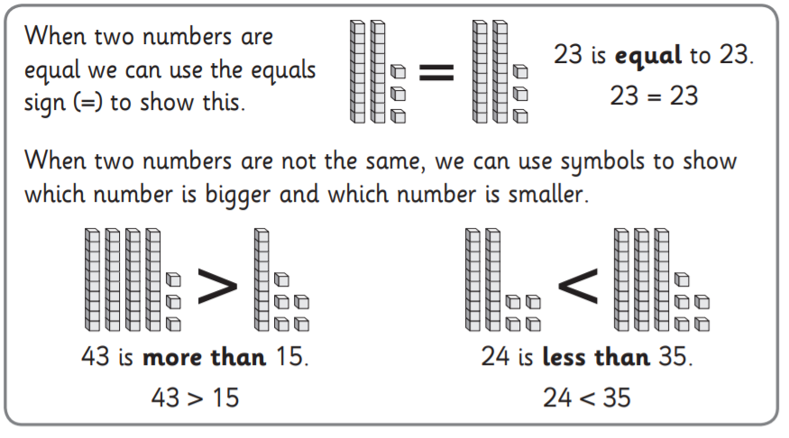

Fluency
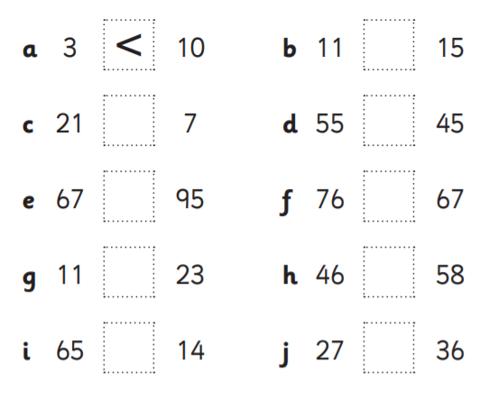
Look at the pairs of numbers below. Put a < or > to show which number in the pair is greater. The first one has been done for you.
Challenge
a 15 51 b 23 32

Explain to your adult what is the same and what is different about these numbers.

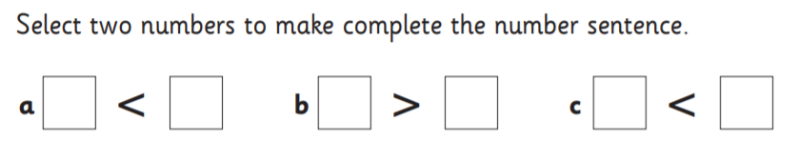

Extension
Place the number 47 on each of these number lines and explain your reasoning to your adult.
(If you can’t print, you can draw these lines on paper)

Wednesday 23rd April 2020
Rapid Recap
Sorry Monkey Class! A cat has just walked over our hundred square. Please write down the numbers he’s left his paw print on. Rewrite any numbers that you reversed.
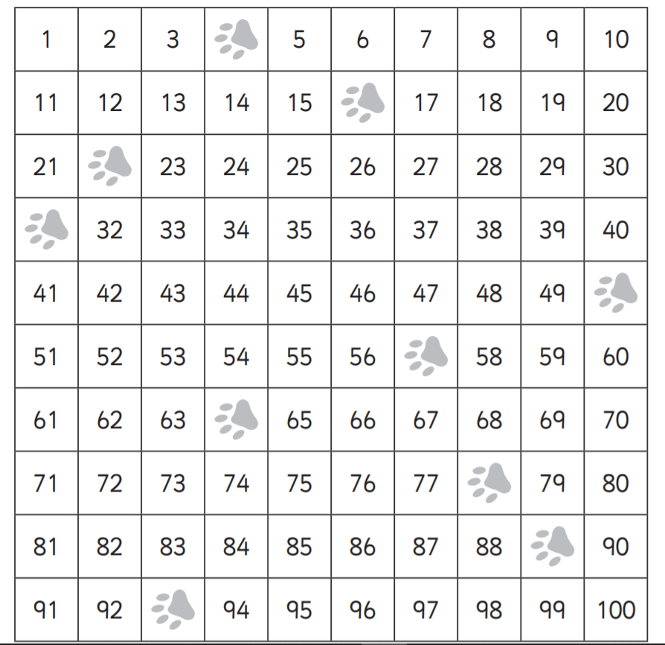

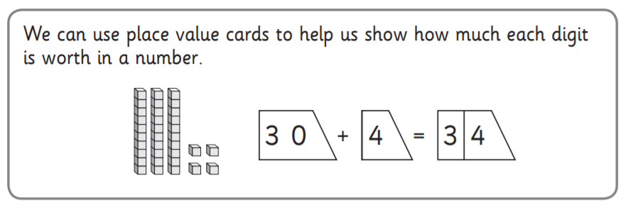

Fluency

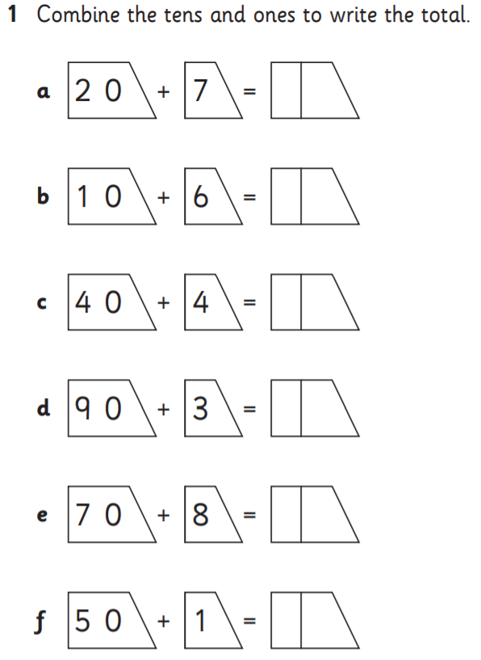

Challenge
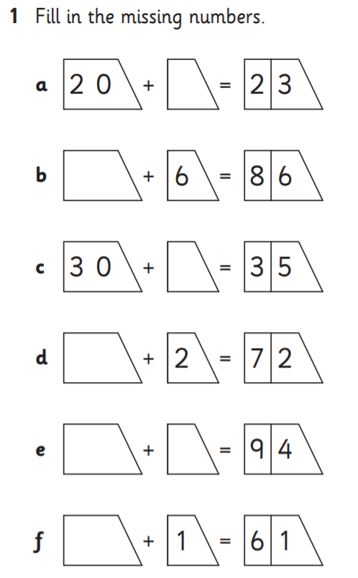

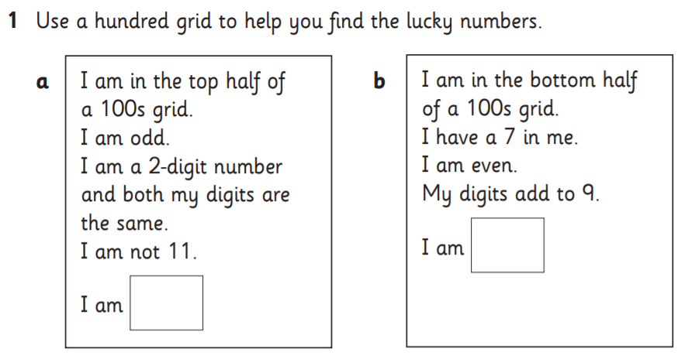
Extension (Use the hundred square from our rapid recap)

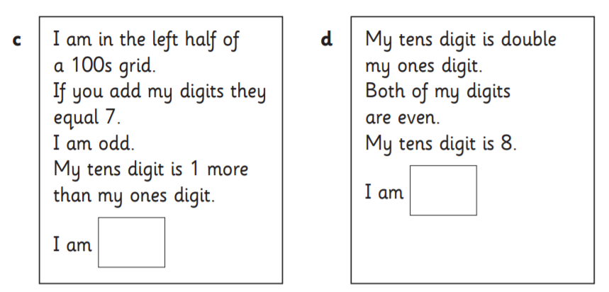

Thursday 24th April 2020
Rapid Recap

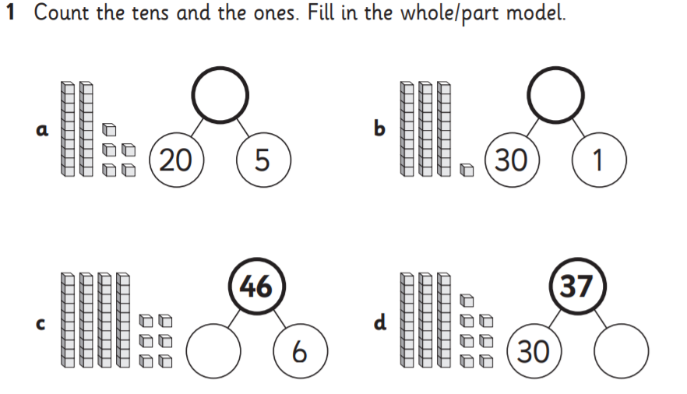
Today will be our last day thinking about place value.

Fluency
Go to this fun link to practice
https://www.topmarks.co.uk/learning-to-count/place-value-basketball

Challenge
- How many numbers less than 100 contain the digit 4? List them all.
- I am thinking of a number between 20 and 50. Its tens digit is more
than its units digit. What numbers could it be?

Extension

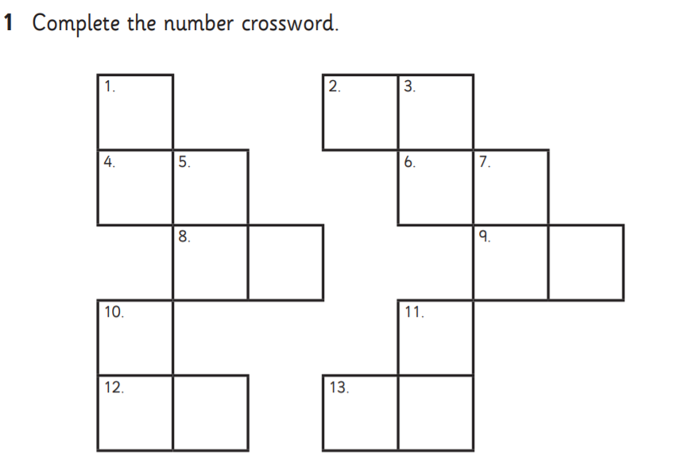

Across
2. One more than 97.
4. One less than 69.
6. Ten less than 59.
8. Ten more than 7.
9. The number before 19.
12. The number after 29.
13. Ten more than 55.
Down
1. The number after 55.
3. The number before 85.
5. Ten more than 71.
7. One less than 92.
10. Ten less than 83.
11. One more than 34.

Friday 25th April 2020
Please visit your Times Table Rockstar Account. Don’t forget its more important to be accurate than fast.

