Monday 27th April 2020
Mental maths
Rapid Recap
Write down all of the number bonds to ten as quick as you can. Ask your grown up to time you.

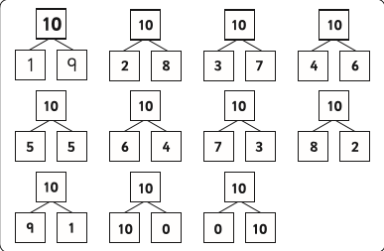

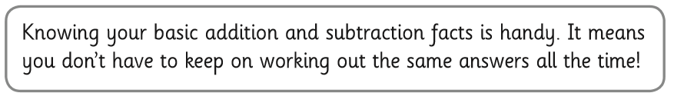

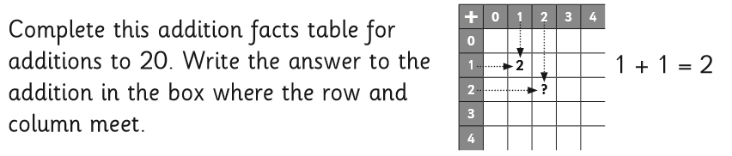

Fluency
Use your fingers or Lego bricks to help you if you get stuck.
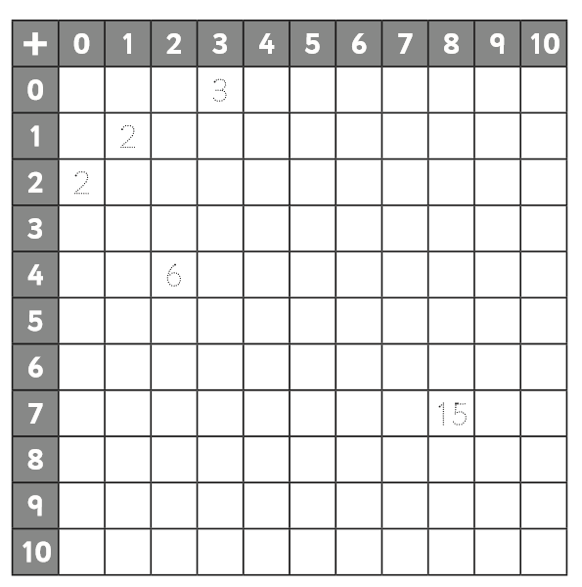
Challenge
Colour in the answers that you know well already. Share your 100 square with your adult and ask them to test you on the ones you don’t know so well. When you think you know a fact well put a circle round it. Come back to the 100 square another day. Can you still remember the addition facts?
Extension
Which do you find easier to do in your head? Explain your method using a drawing.
5+6 or 8+3

Get your adult to check your reasoning. Did you draw a number line or counters? Some of you may have used a part, part, whole model.

Tuesday 28th April 2020
Rapid Recap
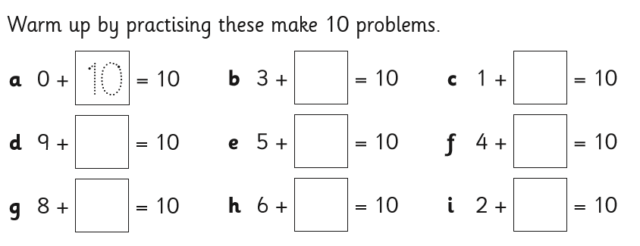

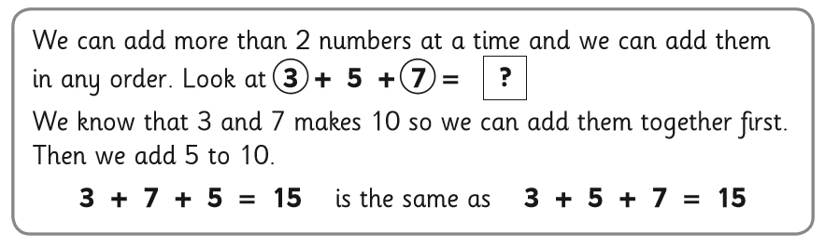
Fluency
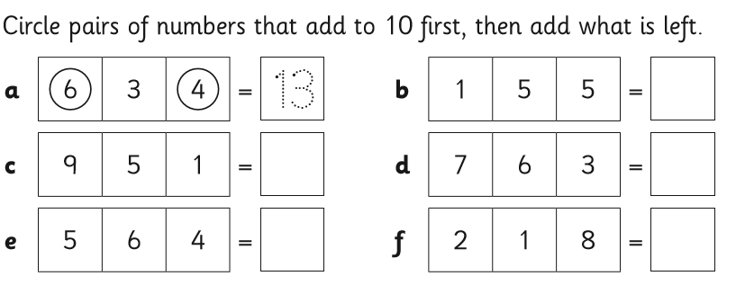
If you got these correct move on to the challenge. If you didn’t try these extra two.

7 + 3+ 8= 8+ 4 + 2 =

Challenge
Work out the missing numbers using your knowledge of number bonds to 10.

a 4 + 7 + __ = 17 b ___ + 5 + 2= 15

c 5 + ___ + 2 = 12 d 9+9+ ___= 19

e 14 = ____ + 3 + 4

Extension
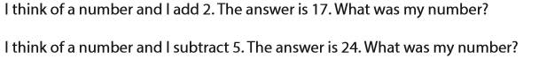

Wednesday 23rd April 2020
We had a few ideas sent in for this game, firstly from Arran, Alec, Martin, Tom and Saul at St. Nicholas Junior School in Newbury:

Subtract counters to make 3 on your opponent’s last go because then if they take 2, you take 1 and win and if they take 1 you take 2 and win!
The first person needs to take one counter to win. Also, if you are playing a good opponent, you need to go first and take 1. Then if they take 1, you take 2 leaving 3 and you win, but if they take 2 on their first go, you take 1 leaving 3 again and you can win.
If your opponent is not as experienced as you and they go first and take 1, then you are done for unless they make a mistake! If they take 2 on their first go, then you can take 2 leaving 3 and you will win!

We tried playing Nim-10 using 10 counters and found that the number you have to get to is 6 and before that 9 and then you’ll win.

We looked at taking more counters e.g. 1, 2 or 3 and the number of counters that you need to leave on your opponent’s last go is always the next number from the most counters that you are allowed to pick up. For example, if you can take 1, 2 or 3 counters, then the number of counters to leave is 4.

Thank you for that excellent subission. You have included a really good explanation.
Then Tom and Jack who are from Canberra Grammar School in Australia sent in this table of their results from playing:

They go on to say;

When the starter takes takes two then you win.

Rebekah (helped by her dad) sent in this:

The first player can always win:
- on the first turn she should take one counter
- on the next turn she should take enough counters to reduce the pile to three
- the other player will be unable to stop her taking the last counter.

In general, with N counters we think that:
a. if N is a multiple of three the second player can always win
b. otherwise the first player can always win

The winning strategy is always to reduce the remaining pile to a multiple of three (3, 6, 9, etc.).

In case (b) the first player can always get to a multiple of three by taking one or two. Then the second player will not be able to get to a multiple of three.
Since zero is a multiple of three (!) the first player can get there and win.

What a great explanation. I like the way you have thought about the game no matter how many counters you have in total. Generalising like that is what maths is all about!

Thursday 24th April 2020
Rapid Recap
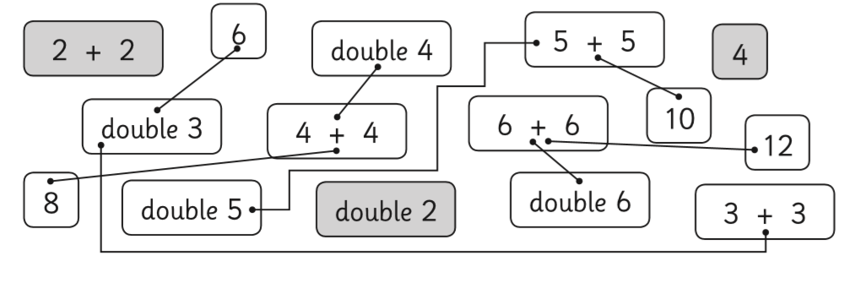

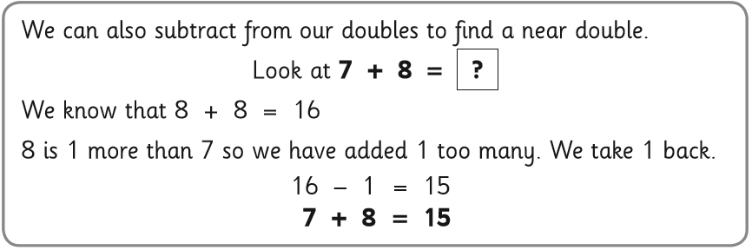
Today we will be adding near doubles.

Fluency
Draw lines to match the facts (on the left) with their strategies (on the right). Then finish the calculations.

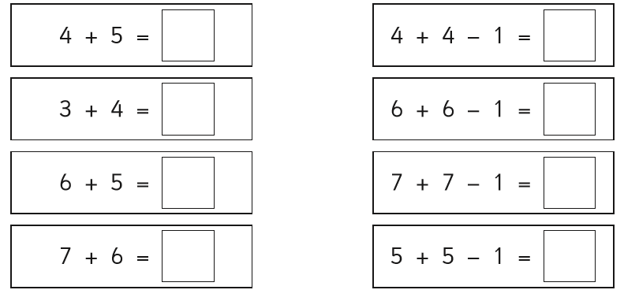
Challenge
Use near doubles to solve these. Make sure you show your working out and answer the question in words.
a Maria has £7. She earns £6 more. How much money does she have now?
7+7-1= 13 Maria has £13.

b Cameron buys 4 books. Then he buys 5 more books. How many books does Cameron have now?
5+5-1= 9 Cameron has 9 books.

c Tom builds 8 Lego models. His sister builds 9 Lego models. How many did they build altogether?
9+9-1
They build 17 models altogether.

d Gemma had 4 sunflowers growing on Monday. On Wednesday, she saw 7 sunflowers growing. How many sunflowers did she plant on Tuesday?
4+ 4-1= 7 I know Gemma has 1 less than 4 on Tuesday so she must have planted 3 sunflowers.

Answer: She planted 3 sunflowers.
Extension
Answer = 5 hens.
5 hens would have 10 feet.
3 sheep would have 12 feet.
10+12= 22
Penny and Laura from Wellesworth Junior School in Canada wrote;
Each head represents an animal. We varied the number of legs under each animal until we got the number 22. Our final number is 5 hens in all.
Rowan from Ludgvan School, Cornwall sent in the following;
My dad helped with the pictures and photos.
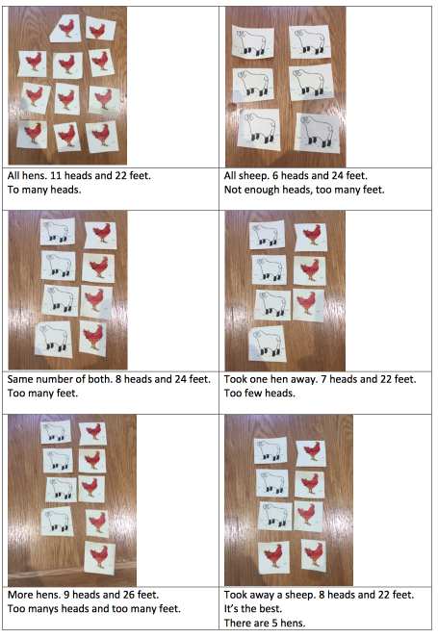
Georgina Rothney from Brockton Primary School wrote;
Heads and feet.
If there are 8 heads and 22 feet then there are 5 hens = 10 feet.
There are 3 sheep = 12 feet.
5+3 heads = 8 heads
10+12 feet =22 feet
Leyi from Belvedere Infant school wrote;
I think it is 5 hens and 3 sheep because I used my 2 and 4 times tables
(5x2)+(3x4)= 10 +12=22 feet
then I made sure that they belong to 8 animals 5+3=8 heads or animals
Thanks for all your solutions!

Friday 25th April 2020
Please visit your Times Table Rockstar Account. Don’t forget its more important to be accurate than fast. I will be setting up a new battle this week.

