Monday 27th April 2020
Mental maths
Rapid Recap
Write down all of the number bonds to ten as quick as you can. Ask your grown up to time you.
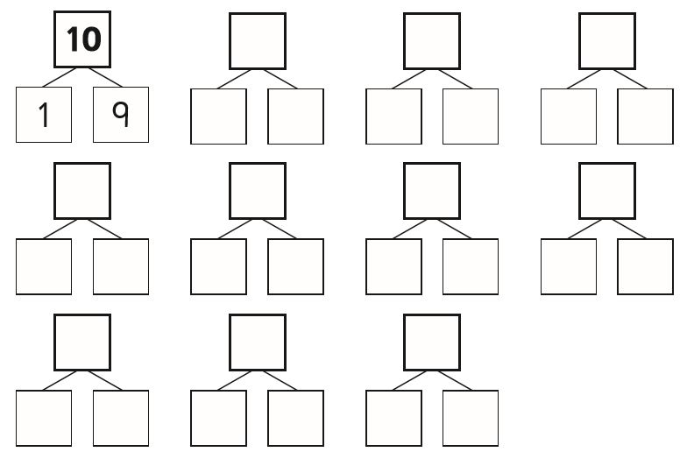

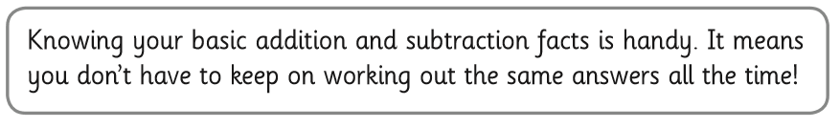

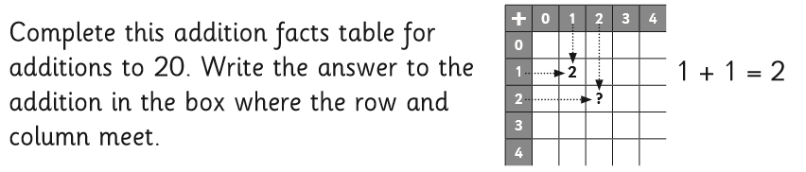

Fluency
Use your fingers or Lego bricks to help you if you get stuck.
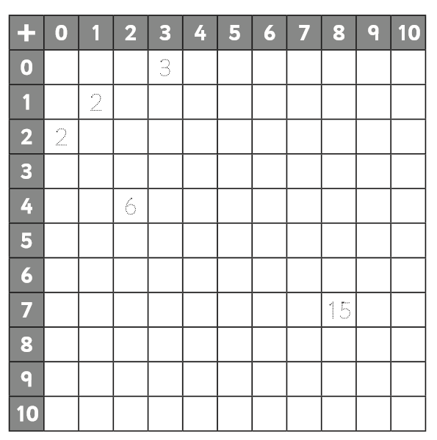
Challenge
Colour in the answers that you know well already. Share your 100 square with your adult and ask them to test you on the ones you don’t know so well. When you think you know a fact well put a circle round it. Come back to the 100 square another day. Can you still remember the addition facts?
Extension
Which do you find easier to do in your head? Explain your method using a drawing.
5+6 or 8+3

Tuesday 28th April 2020
Rapid Recap
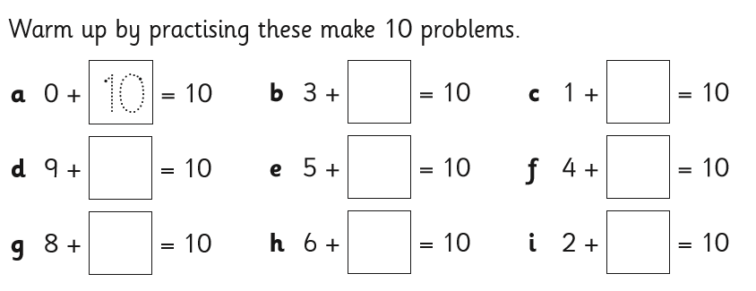

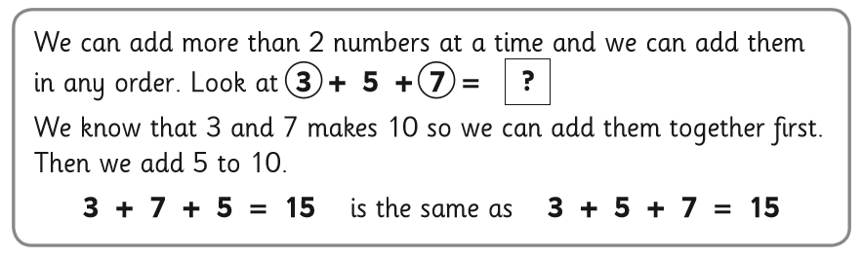
Fluency
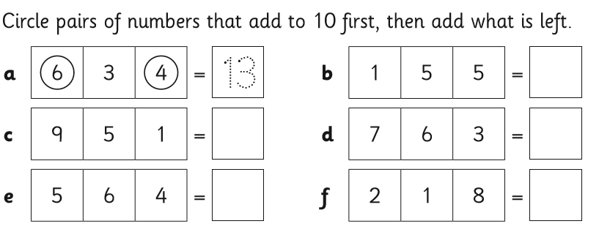
If you got these correct move on to the challenge. If you didn’t try these extra two.

7 + 3+ 8= 8+ 4 + 2 =

Challenge
Work out the missing numbers using your knowledge of number bonds to 10.

a 4 + 7 + __ = 17 b ___ + 5 + 2= 15

c 5 + ___ + 2 = 12 d 9+9+ ___= 19

e 14 = ____ + 3 + 4

Extension
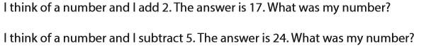

Wednesday 23rd April 2020
Have a go at some problem solving with your grown up. Don’t forget to email me to let me know how you found a solution.

Here is a game to play with an adult! This is a basic form of the ancient game of Nim.

How do you play?
You will need an adult to play with.
You will also need seven objects, such as counters, bottle tops or blocks.

Place the 7 counters in a pile and starting with the adult, take turns to take away either one or two counters.
The person who takes the last counter wins.
Swap who goes first and keep playing until you work out a winning strategy.

Does it matter who has the first turn?
What happens when there are three counters left?
How can you win at this game?
What happens when you start the game with more counters?

Notes for adults
This game offers a motivating context in which children can improve their logical thinking skills. It is a low threshold high ceiling game. This means that new users, including those who have never played before, should find it easy to get started, and 'no ceiling' (or 'high-ceiling') means the games language shouldn't be limiting for advanced users.

Easier version: record a game and look back together at key moments.
Harder version: try starting the game with different numbers of counters.

Repeat the game, aiming to find a winning strategy, then talk together about how it was found.

Thursday 24th April 2020
Rapid Recap
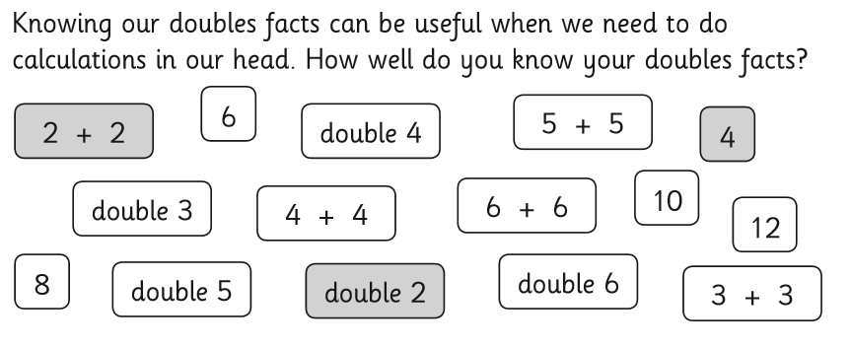

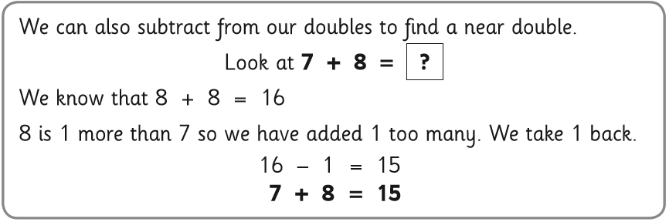
Today we will be adding near doubles.

Fluency
Draw lines to match the facts (on the left) with their strategies (on the right). Then finish the calculations.

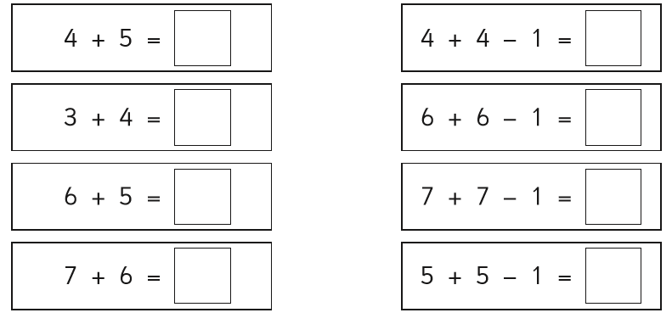
Challenge
Use near doubles to solve these. Make sure you show your working out and answer the question in words.
a Maria has £7. She earns £6 more. How much money does she have now?

b Cameron buys 4 books. Then he buys 5 more books. How many books does Cameron have now?

c Tom builds 8 Lego models. His sister builds 9 Lego models. How many did they build altogether?

d Gemma had 3 sunflowers growing on Monday. On Wednesday, she saw 7 sunflowers growing. How many sunflowers did she plant on Tuesday?

Extension

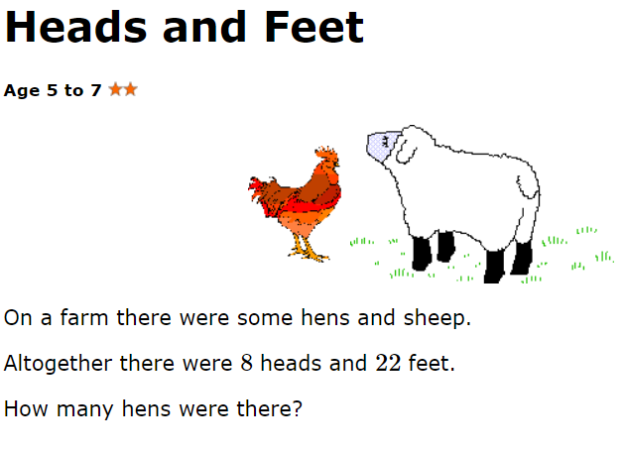

How many legs would eight hens have?
How many legs would eight sheep have?
What could you try next?

For some pupils a few models to represent the animals may be helpful, for example counters for the heads and lolly sticks for legs. You could draw pictures or use plastic animals if you are lucky enough to have them.

Friday 25th April 2020
Please visit your Times Table Rockstar Account. Don’t forget its more important to be accurate than fast. I will be setting up a new battle this week.

