Maths Plan
Year 4 Monday 4th May 2020

1. 7
2. 12
3. 12
4. 9
1. £3.23 2. £2.40 3. £6.53 4. £8.73 5. £9.01 6. £34.23 7. £73.64
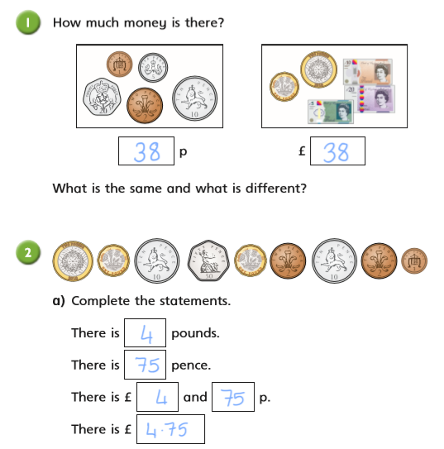8. 478p 9. 201p 10. 767p 11. 510p 12. 1345p 13. 2501p 14. 5000p
15.

16.

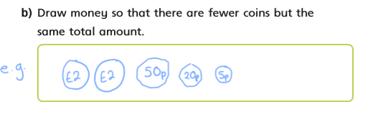

Extra daily challenge
One side of a square is 12cm. All sides of a square are equal, so all sides would be 12cm each. A square has 4 sides. So the perimeter is 12x4= 48cm

Maths Plan
Year 4 Tuesday 5th May 2020

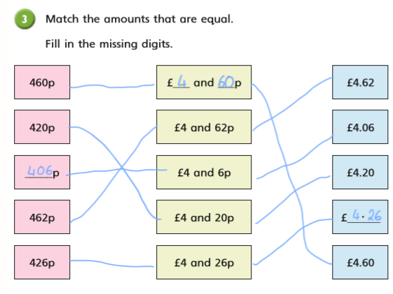1.

2. B- £6.10
3.

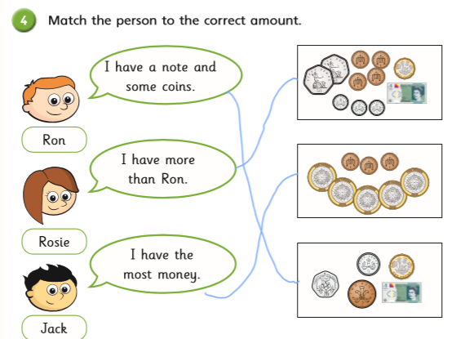

4. Rosie is correct. Whitney has not written the 6 p in the correct column. Teddy has not understood how many pence there are in a pound, therefore his place value is incorrect.
Extra daily challenge:
Twice as many means double, so double 31 = 31+31 = 31x2= 62. Dan has 62 marbles

Maths Plan
Year 3Wednesday 6th May 2020

1. 34x10= 340 2. 76x10= 760 3. 4230= 423x10 4. 6540= 10x654 5. 10x 756= 7560 6. 3000= 300x10

7. 60÷10=6 8. 60=600÷10 9. 78=780÷10 10. 340÷10= 34 11. 67÷10=6.7 12. 3.4=34÷10
1. A £1.61 and 161p, B £1.80 and 180p
2. £1.40
3.

4.

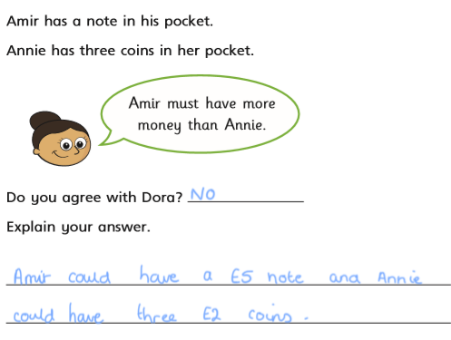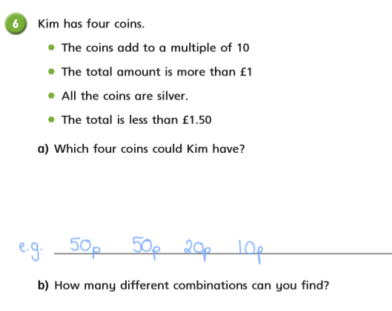Extra Challenge
85 minutes is the same as an hour and 25 minutes, and 85 minutes later than 2.20 would be 3.45.

Maths Plan
Year 4 Thursday 7th May 2020

1. 45x100= 4500 2. 3200=32x100 3. 100x54= 5400 4.6600 =100x66 5. 70x100= 7000 6. 12,100=121x100
7. 500÷100=5 8. 6500÷100=65 9. 78=7800÷100 10.60 =6000÷100
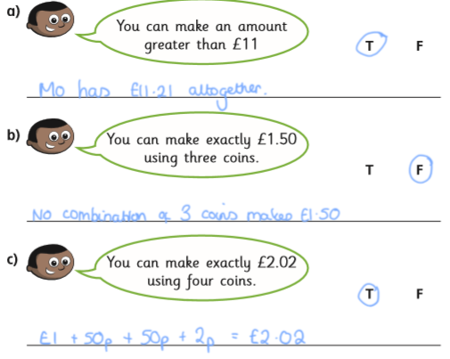11. 580÷100= 5.8 12. 8.7=870÷100
1.

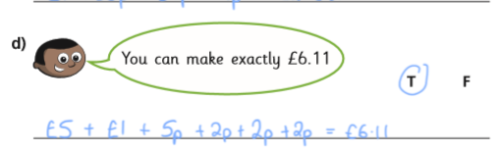

2.

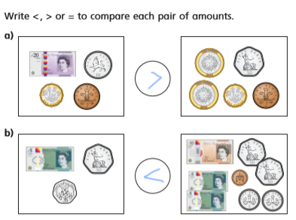3.

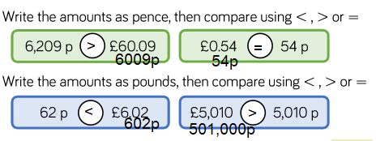

4.

Extra Challenge
75 ÷3= 25. You could have used the bus stop method to help you work this out.

Maths Plan
Year 4 Friday 8th May 2020

1. 3x1000= 3000 2. 34,000=1000x34 3. 46,000=46x1000 4. 1000x55=55,000 5. 676x1000= 676,000 6. 535,000=1000x535

7. 5000÷1000= 5 8. 9=9000÷1000 9. 12,000÷1000=12 10. 1300÷1000=1.3 11.8.7 =8700÷1000
1.
a. 3578p > anything smaller than 3578p / £35.78
b. £65.98 < anything bigger than £65.98/ 6598p
c. 6789p < anything bigger than 6789p /£67.89
d. £89.87 > anything smaller than £89.87/ 8987p

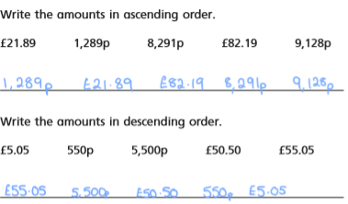2.

3. £3.24, £3.26 £3.42, £3.46 £3.62, £3.64 £4.23, £4.26 £4.32, £4.36 £4.62, £4.63
4. I would rather have five 50 p coins because 50 × 5 = 250p/£2.50 but 20 × 12 = 240p/£2.40

Extra Challenge
When we have half of something we divide it by 2. So 58÷2= 29. Jade has got 29 marbles.

